Constipation
Children’s Ward
Patient Information Leaflet

Introduction
This leaflet is for people who have constipation. It gives information on what it is and how it can be treated.

What is constipation?
Constipation is a very common problem that affects all ages. For most people, constipation is when you pass hard stools (poo), less frequently than you would normally.
If you are unable to have at least three poos a week, it is likely that you have constipation.
Constipation can also cause your stools to be hard and lumpy, as well as unusually large or small.
Sometimes, if your child has been constipated for a long time, they can have accidents and soil their underwear. This is called overflow soiling, and this happens because the build-up of stool in the bowel has become compacted. Softer stool will leak around the hard stool and into the underwear.
Constipation varies from person to person. Many people only have constipation for a short time. However, others have it for a long time and it can cause pain and discomfort that affects their life.

What are the symptoms of constipation?
You may have one or a combination of the following:
- You pass poo less often.
- You are not hungry.
- You feel more tired than usual.
- Your poo changes either shape, size, amount or hardness.
- You are pushing hard/straining to pass a poo.
- You have pain in your tummy or back passage.
- You have staining of blood or poo in your underwear.

What causes constipation?
The causes of constipation are often different from person to person. It can be caused by:
- Not eating enough healthy foods such as fruit and vegetables.
- Not drinking enough.
- Not doing enough exercise.
There are some other causes of constipation that are quite rare, such as:
- Some conditions that affect the nervous system.
- An underactive thyroid gland.
- Cystic fibrosis.
- Rare diseases affecting the development of the bowel, such as Hirschsprung’s disease.
- A side effect of a medication that you are taking.

What is the treatment?
You will be given a medication to help with the constipation and to get your bowels moving again. This type of medicine is sometimes called a laxative.
- Movicol paediatric comes in sachets that you will need to mix with water.
- If this does not work after a couple of weeks, your doctor might also give you a medication called Senna.

You will also be given advice to:
- Make sure you are drinking enough. The recommended amount of fluid is roughly 1.5 litres of sugar free squash or water.

- Eating a healthy diet is very important for everyone but especially for people with constipation. The following are some of the recommended foods:

  - Wholemeal bread, chapatti and naan
  - Digestive biscuits
  - Brown pasta or rice
  - Jacket potatoes, potato skins or wedges with skins on
  - Vegetables such as peas and sweetcorn
  - Fresh and dried fruit
  - Weetabix, Shredded Wheat, porridge, Ready Brek
  - Lentils
  - Beans such as kidney beans
  - Baked beans

- Exercising is also very important to help get your bowels moving. Try to get involved in activities such as riding a bike, football, netball, tennis, going swimming, dancing, walking etc.

What should I do when I get home from hospital?
Once you are at home, you should check the medications that the doctor has given you are working properly. If they are working:
- You should start going to the toilet more often.
- You should sit on the toilet 15 minutes after eating for a maximum of 5 minutes.
- Your poo should be softer and come out easier.
If you develop any of the following symptoms, you should go to see your usual family doctor:
- Weakness in your legs.
- Your tummy becomes swollen or bloated and you start being sick.

How long does it take to get better?
There is not a specific time frame for each patient as every individual is different and it can take different amounts of time for constipation to go away completely. If the medication and other changes do not work immediately, it does not mean that they will not work in the long term.

Can I find out more?
The NHS Choices website has more information about constipation:
http://www.nhs.uk/Conditions/Constipation/Pages/Introduction.aspx
https://www.eric.org.uk

If you have any questions, or if there is anything you do not understand about this leaflet, please contact:
Children’s Ward on 01384 244271
Russells Hall Hospital switchboard number: 01384 456111
This leaflet can be downloaded or printed from:
http://dgft.nhs.uk/services-and-wards/paediatrics-and-neonatology/
If you have any feedback on this patient information leaflet, please email dgft.patient.information@nhs.net

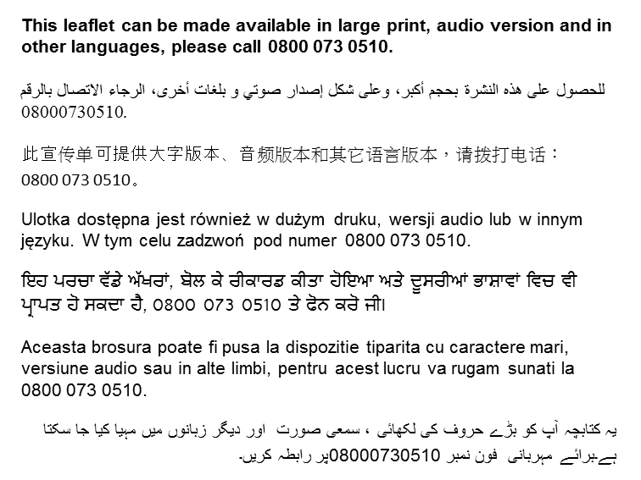
Originator: Julie Taylor. Date reviewed: December 2022. Next review date: September 2025. Version: 3. DGH ref: DGH/PIL/00793TN.

