

**INFECTION PREVENTION AND CONTROL ANNUAL REPORT**

**2018/19**

**CONTENTS**

|  |  |  |
| --- | --- | --- |
| **Section** |  | **Page Number** |
|  | List of Abbreviations | **3** |
| 1.0 | Executive Summary | **4** |
| 2.0 | Introduction | **4** |
| 3.0 | Infection Prevention and Control Arrangements | **6** |
| 4.0 | The Infection Prevention and Control Group | **7** |
| 5.0 | Surveillance (MRSA / C-Diff) | **8** |
| 6.0 | Surgical Site Surveillance | **11** |
| 7.0 | Outbreaks / Period of Increased Incidence (PII) | **12** |
| 8.0 | Infection Control Link Workers | **12** |
| 9.0 | Audit – Saving Lives | **13** |
| 10.0 | Ward audits | 15 |
| 11.0 | Estates and Facilities | **16** |
| 12.0 | Antibiotic Stewardship | 19 |
| 13.0 | NHSi Infection Control Visit | **30** |
| 14.0 | Education and Training | **30** |
| 15.0 | Influenza Vaccination Programme | **31** |
| 16.0 | Policies | 31 |
| 16.0 | Conclusion | 31 |

**LIST OF ABBREVIATIONS**

**C.diff** Clostridium difficile

**CQC** The Care Quality Commission – the integrated regulator of health and adult social care

**DH** Department of Health

**D** and/or **V** Diarrhoea and/or Vomiting

**DIPC** Director of Infection Prevention and Control. An individual with overall responsibility for infection control and accountable to the registered provider

**E-Coli** Escherichia coli

**ESBL** Extended-Spectrum Beta-Lactamases (ESBLs) are enzymes that can be produced by bacteria making them resistant to cephalosporins e.g. cefuroxime, cefotaxime and ceftazidime - which are the most widely used antibiotics in many hospitals

**GQC** Governance and Quality Committee

**GRE** Glycopeptide-Resistant Enterococci

**HCAI** Health Care Associated Infections

**IPC** Infection Prevention and Control

**IPCC** Infection Prevention and Control Committee

**IPCLN** Infection Prevention and Control Lead Nurse

**IPCT** Infection Prevention and Control Team

**MRSA** Meticillin-resistant Staphylococcus aureus

**MSSA** Meticillin-sensitive Staphylococcus aureus

**OHD** Occupational Health Department

**PLACE** Patient Led Assessment of the Care Environment

**PPE** Personal Protective Equipment

**SLA** Service Level Agreement

**UTI** Urinary Tract Infection

1. **EXECUTIVE SUMMARY**

The Dudley Group NHS Foundation Trust is committed to ensuring that a robust infection prevention and control function operates within all clinical areas of the

organisation which supports the delivery of high quality healthcare and protects the health of its service users and staff. Effective prevention and control of infection must be part of everyday practice and applied consistently by everyone.

The report provides assurance that systems are in place and working effectively to minimise and avoid hospital acquired infection and that the Trust is compliant with the Hygiene Code.

1. **INTRODUCTION**

The Dudley Group NHS Trust continuously strives to improve infection prevention and control practice and has engaged with other organisations and partners to ensure there are robust infection prevention plans, policies and capacity to reduce healthcare associated infections (HCAI) across the healthcare community. Infection prevention and control is the responsibility of everyone in the healthcare community and is only truly successful when everyone works together. The Infection Prevention Team (IPT) continues to develop innovative ways of delivering important messages across to our staff, patients and visitors. The work programme is aligned with the Hygiene Code.

The Health and Social Care Act 2008 (2015): *Code of practice for the prevention and control of healthcare associated infections (Hygiene Code)* details 10 compliance criteria to which the Trust must adhere to in relation to preventing and controlling the risk of avoidable healthcare associated infections (HCAIs).

The criteria are listed below against which is the Trust’s assurance that it meets the requirements as stated in the Hygiene Code.

|  |  |  |
| --- | --- | --- |
| **Compliance Criterion** | **What the registered provider will need to demonstrate** | **RAG rating** |
| 1 | Systems to manage and monitor the prevention and control of infection. These systems use risk assessments and consider the susceptibility of service users and any risks that their environment and other users may post to them. |  |
| **Assurance:** A risk log of all infection prevention risks identified across the Trust is maintained and updated regularly. | | |
| 2 | Provide and maintain a clean and appropriate environment in managed premises that facilitates the prevention and control of infections. | Cleaning is actively audited and any deficiencies are rectified within 1 hr. |
| **Assurance:** A Cleaning Policy and associated environmental audits provide assurance that a clean and appropriate environment is maintained. | | |
| 3 | Ensure appropriate antimicrobial use to optimise patient outcomes and to reduce the risk of adverse event and antimicrobial resistance. | Antimicrobial CQUIN – the elements regarding reduction high risk antimicrobial usage has been met. |
| **Assurance:** There is an Antimicrobial Policy in place with appropriate stewardship recommendations. Audits demonstrate compliance with policy. | | |
| 4 | Provide suitable accurate information on infections to service users, their visitors and any person concerned with providing further support or nursing / medical care in a timely fashion. |  |
| **Assurance:** Patient and visitor information is available for a variety of healthcare associated infection issues on the website. Patients identified with infections in hospital are visited and provided with information leaflets including contact information for further support. | | |
| 5 | Ensure prompt identification of people who have or are at risk of developing an infection so that they receive timely and appropriate treatment to reduce the risk of transmitting infection to other people. | MRSA elective screening 96.4% compliance and emergency screening 94.2% compliance for April |
| **Assurance**: Patient records are flagged with information about previous healthcare associated infections. Patient admission documentation includes screening questions to identify patients at risk. | | |
| 6 | Systems to ensure that all care workers (including contractors and volunteers) are aware of and discharge their responsibilities in the process of preventing and controlling infection. | Mandatory IC training has moved to an annual programme for clinical staff. Work is being undertaken to achieve compliance by June 2019. |
| **Assurance:** Staff are provided with mandatory infection control training to ensure they are aware of their responsibilities for the prevention and control of infection. | | |
| 7 | Provide or secure adequate isolation facilities. | A business case for the isolation pods for critical care areas has been created and funding the for the ITU pod secured. |
| **Assurance:** There is a policy in place to ensure that patients are isolated appropriately. 25% of the inpatient beds take the form of single ensuite rooms. | | |
| 8 | Secure adequate access to laboratory support as appropriate. |  |
| **Assurance:** The Trust has access to a CPA/UKAS accredited Microbiology and Virology laboratory. | | |
| 9 | Have adherence to policies, designed for the individuals’ care and provider organisations that will help to prevent and control infections. | Trustwide scores all green to present. |
| **Assurance:** All policies, as recommended in the Hygiene Code, are in place. Audit data confirms compliance with policies and identifies areas for improvement. | | |
| 10 | Providers have a system in place to manage the occupational health needs and obligations of staff in relation to infection. |  |
| **Assurance:** There is in house provision of Staff Health and Wellbeing. There are regular reports to the Infection Prevention and Control Forum detailing any issues raised within this system. | | |

1. **INFECTION PREVENTION AND CONTROL ARRANGEMENTS**

Within the Trust the DIPC role is within the portfolio of the Consultant Microbiologist / Infection Control Doctor. A key responsibility of the DIPC is to produce an annual report. Additional support is provided by the antimicrobial pharmacists and Matron for Infection Prevention and Control.

The role and function of the IPC Service is to provide specialist knowledge, advice and education for staff, service users and visitors. All work undertaken by the service supports the Trust with the full implementation of and on-going compliance to the Code.

**INFECTION PREVENTION & CONTROL TEAM**

|  |  |  |  |  |  |  |  |  |  |  |  |  |  |  |  |  |  |  |
| --- | --- | --- | --- | --- | --- | --- | --- | --- | --- | --- | --- | --- | --- | --- | --- | --- | --- | --- |
| INFECTION PREVENTION & CONTROL TEAM   |  |  |  | | --- | --- | --- | | SYED GILANI  (SPECIALIST ANTIMICROBIAL & CRITICAL CARE PHARMACIST) | DR ELIZABETH REES  (DIRECTOR) | LISA WHITE  (P.A. TO DR REES) |   HARSHNA CHHAYA  (ANTIMICROBIAL PHARMACIST)   |  |  |  | | --- | --- | --- | | ASHLEY KNIGHT  CHRIS WHORTON  (TEAM HPV TECHNICIAN) | ANGELA MURRAY  (MATRON) | ALISON PAINTER  (TEAM SECRETARY) |  |  |  |  |  |  | | --- | --- | --- | --- | --- | | KIM JARRETT  (CLINICAL NURSE PECIALIST)  ( |  | TIMEA VIG  (CLINICAL NURSE SPECIALIST) |  | SARAH GAME  (CLINICAL NURSE SPECIALIST) |  |  |  |  |  |  |  |  | | --- | --- | --- | --- | --- | --- | --- | | KAY NOCK  (NURSE) |  |  | DIANE GARFIELD  (NURSE) |  |  | NICO PICCHIO  (NURSE) | |

**4.0 THE INFECTION PREVENTION AND CONTROL GROUP**

The Infection Prevention and Control Group meet monthly and is chaired by the DIPC.

The purpose of the forum is to oversee compliance of the Health Act 2008 Code of Practice for the Prevention and Control of Healthcare Associated Infections. The Forum provides assurance that risks are appropriately managed and that appropriate arrangements are in place to achieve a safe clinical environment. The IPCG reports to the Clinical Quality, Safety and Patient Experience Committee and is required to comply with any reporting requirements set by the Clinical Quality, Safety and Patient Experience Committee as to format and frequency

The membership of the forum is multidisciplinary and also includes representatives from The Office of Public Health at Dudley Metropolitan Borough Council and Public Health England. This forum provides assurance to The Board that the infrastructure for infection prevention and control is in place. In addition to this there is representation from the Trusts private finance initiative partners.

The Group is responsible for:

a) Reviewing and monitoring the progress of the annual programme and assisting and affecting implementation.

b) Developing relevant policies, procedures, care pathways and clinical guidelines.

c) Assessing the impact of all existing and new relevant plans and policies on infection prevention and control and make recommendations for change.

d) Ensuring, through the DIPC, that the Chief Executive and associated committees are advised of any significant issues relating to infection control.

1. To receive the Annual Infection Prevention and Control Report.
2. **SURVEILLANCE**

The Department of Health requires mandatory surveillance of:

1. MRSA positive blood cultures (bacteraemia)

*2. Clostridium difficile* toxin positive results

3. MSSA positive blood cultures (bacteraemia)

4. E-coli positive blood cultures (bacteraemia)

The above are reported monthly via HCAI data capture system which is managed by Public Health England and signed off on behalf of the Chief Executive.

**5.1 MRSA Bacteraemia**

The NHS has set a zero tolerance approach to MRSA bloodstream infections. For the purposes of this report **1** case has been attributed to The Trust in the last year.

A root cause analysis was undertaken utilising the national audit tool. The outcomes of the RCA were presented and discussed at a multidisciplinary meeting chaired by the CEO and included representatives from the Dudley Office of Public Health and Dudley CCG. Many areas of good practice were identified and fed back to the clinical team.

Recommendations from the RCA were:

* All patients to be screened for MRSA as per local policy. The results to be followed up by clinical staff.
* MRSA treatment to be commenced on receipt of a positive result regardless of the culture site
* Ensure that all staff members collecting blood cultures are following local guidelines to reduce the risk of obtaining a contaminated sample.

Learning outcomes to be shared at ward level via staff meeting/huddle board and with the wider trust through divisional meetings and the infection prevention group.

* 1. **Clostridium difficile**

The Trust reports all cases of Clostridium difficile toxin positive disease identified in the hospital laboratory. For this financial year we have reported a total of 28 cases of Clostridium difficile of which 20 have been recognised as being due to a lapse of care and attributed to the Trust. Lapses in care were identified as being associated with failure to meet the mandatory training compliance, reduced environmental scores, antimicrobial stewardship and bowel habit not recorded on admission.

The Trust objective was to have no more than 28 cases where a lapse in care was identified. All cases were scrutinised using a robust root cause analysis process in conjunction with the Office of Public Health Dudley Metropolitan Borough Council and Dudley CCG. The learning from these cases was shared across the organisation in order to improve practice.

The table below demonstrates the number of Clostridium difficilepositive cases identified at The Dudley Group NHS Foundation Trust for this reporting period.

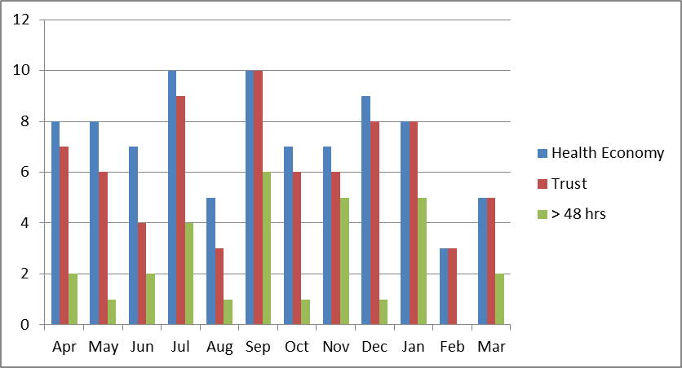

|  |  |  |  |  |  |  |  |  |  |  |  |  |
| --- | --- | --- | --- | --- | --- | --- | --- | --- | --- | --- | --- | --- |
|  | Apr | May | Jun | Jul | Aug | Sep | Oct | Nov | Dec | Jan | Feb | Mar |
| Health Economy | 8 | 8 | 7 | 10 | 5 | 10 | 7 | 7 | 9 | 8 | 3 | 5 |
| Trust | 7 | 6 | 4 | 9 | 3 | 10 | 6 | 6 | 8 | 8 | 3 | 5 |
| > 48 hrs | 2 | 1 | 2 | 4 | 1 | 6 | 1 | 5 | 1 | 5 | 0 | 2 |

### Escherichia Coli Bacteraemia

*Escherichia coli* (commonly referred to as *E. coli*) is also found in the gut and is part of the normal flora. The commonest infection caused by *E. coli* is infection of the urinary tract. Invasion from the primary infection site, such as the urinary tract, to the bloodstream leads to blood stream infection (*E. coli* bacteraemia). Antibiotic resistance has increased in recent years with some *E.coli* able to produce enzymes that confer resistance to multiple antibiotics. The aim of the surveillance is to allow more accurate determination of possible interventions to prevent avoidable bacteraemia.

There is work ongoing that is part of the national agenda for health and social care economies to reduce the number of Gram-negative bloodstream infections (BSIs) with an initial focus on Escherichia coli (E.coli). To date this has focused on the management of patients with long term urinary catheters. Across the Dudley health economy a catheter ‘passport’ has been agreed and approved and builds upon the catheter bundle that is already in use across the Trust. The passport was launched at the end of August 2018 and also been launched across the Health Economy.

The table below demonstrates the number of E. coli positive cases identified at The Dudley Group NHS Foundation Trust for this reporting period. The Trust undertook enhanced surveillance of E. coli bacteraemia as part of a whole health economy ambition to reduce Gram-negative bloodstream infections. Themes identified as sources of bacteraemia were urinary tract and hepatobiliary infection which is in line with national data.

* 1. **Meticillin Sensitive Staphylococcus aureus (MSSA) Bacteraemia.**

Mandatory reporting of all MSSA bacteraemia commenced in January 2011. A total of 111 MSSA bacteraemia cases were reported during 2018/2019. Of these, 22 were trust apportioned (i.e. occurred 48 hours or more after admission). There is currently no target associated with MSSA bacteraemia incidence. The Trust continues to fulfil its mandatory requirement and contributes to this enhanced national surveillance scheme. No themes were identified for this reporting period, however education, training and support was provided to drive improvements in practice in invasive devices insertion, management and documentation of ongoing care. No reduction trajectory for MSSA has been set nationally.

1. **SURGICAL SITE SURVEILLANCE**

Surgical site infections (SSIs) are an important cause of Healthcare Associated Infections (HCAI), accounting for 20% of all HCAIs, and have serious consequences for both the patient and the Healthcare organisation.

Surveillance of surgical site infection following orthopaedic surgery has been included in the mandatory healthcare-associated infection surveillance system in England since April 2004. The National Surveillance Scheme enables hospitals in England to undertake surveillance of healthcare associated infection, compare their results and national aggregated data, and use the information to improve patient outcomes.

All NHS Trusts where orthopaedic surgical procedures are performed are expected to carry out a minimum of three months surveillance in at least one of four orthopaedic categories:

* Total hip replacements
* Knee replacements
* Repair of neck of femur
* Reduction of long bone fracture

Summary of Orthopaedic SSI rates April to June 2018

The data has been submitted to Public Health England and the official reports are now available to view on the PHE Surgical Site Surveillance database. The results of the surveillance are detailed in the table below. This includes the trust percentage for the period of surveillance undertaken by DGH and also the national average over the last 5 years.

|  |  |  |  |  |
| --- | --- | --- | --- | --- |
| Surgery | Total  operations | Inpatient/  readmission  SSIs | Trust  Rate % | National  Average % |
| Hip replacement | 104 | 0 | 0% | 0.9% |
| *Knee replacement | 90 | 1 | 1.1% | 1.3% |

The Surgical site infection that was identified is detailed below:

Surgical Site Infections

*Knee Replacement (identified post discharge – patient reported only)

**7.0 OUTBREAKS / PERIOD OF INCREASED INCIDENCE (PII)**

Different outbreaks / incidents demand different responses but are managed with collaborative working between the multi-disciplinary teams across the Health Economy.

**Norovirus**

Norovirus is a self – limiting diarrhoea and vomiting bug that usually lasts 48-72 hours and is more prevalent during the winter months

In common with other acute trusts, DGFT managed patients an increasing number of patients who presented with diarrhoea and /or vomiting which required restrictions to the movements of patients. The IPCT actively managed and monitored these patients providing advice to ward staff and departments’. This proactive management resulted in the prevention outbreaks within the hospital.

We had no confirmed outbreaks of Norovirus for 2018/19

**Clostridium Difficile**

A period of increased incidence of *clostridium difficile* is defined as 2 cases of toxin positive Clostridium *difficile*, acquired post 48 hours, on the same ward, within a period of 28 days.

We identified 1 period of increased incidence of Clostridium *difficile* in March 2019 this occurred on our Gastroenterology ward. A meeting was held, ward audits were conducted, and cleaning scores reviewed and typing of specimens was requested. Investigation concluded that ribotype of each case was different, confirming that the cases were not linked. No further cases were identified.

Influenza Campaign

The Policy for the Management of Patients with Influenza and guidance on treatment was revised in accordance with national guidance and actions were implemented to support staff in clinical areas. The microbiology laboratory introduced a rapid test method to increase turn-around time for flu test results. This allowed all patients to be given a specific diagnosis on the day of testing and enabled improved prescribing of influenza treatment. The prompt identification of positive patients enbled rapid isolation of patients reducing the risk of outbreaks in hospital. In addition the IPC Nurses provide an on-site presence at week-ends.

1. **INFECTION PREVENTION LINK WORKERS**

The IPC Link workers continue to support the function of the IPC team and are an important and effective means of disseminating information and good practice. Link workers act as visible role models and local and advocate high standards of IPC. They provide a link between their colleagues and the IPC team in order to facilitate good practice and improve standards within their teams.. There is a link worker in every department both inpatient and community areas. Link workers meet with the IPCT bi-monthly to discuss best practice and share their learning and experience.

1. **AUDIT**

**Saving Lives Audit**

The Saving Lives programme (DH, 2008) was introduced to support healthcare providers in reducing healthcare associated infections. The Saving Lives Audit within the Trust is undertaken on a monthly basis. As of the 1st April 2018 the new version of the Saving Lives released in November 2017 has been implemented. High Impact Interventions relate to key clinical procedures or care processes based on evidence based approach

This system can be accessed by Heads of Nursing, Matrons and Lead Nurses enabling users to review and monitor individual performance.

Areas that submit scores of less than 95% are required to complete an action plan to identify how they will rectify the overall score and how this will be cascaded across the areas.

The updated HIIs audits include:

* HII No 1 Ventilator associated pneumonia
* HII No 2a Peripheral Vascular Access Devices – Insertion
* HII No 2b Peripheral Vascular Access Devices – Ongoing Care
* HII No 3a Central Venous Access Devices – Insertion
* HII No 3b Central Venous Access Devices – Ongoing Care
* HII No 4a Surgical Site Infection Prevention – Preoperative
* HII No 4b Surgical Site Infection Prevention – Intraoperative actions
* HII No 5 Infection Prevention in Chronic Wounds
* HII No 6a Urinary Catheter Insertion
* HII No 6b Urinary Catheter – Maintenance and assessment

The graph below demonstrates overall Trust compliance with Saving Lives Audits for the year April 2018 to March 2019.

**Hand Hygiene Audit**

It is well recognised that hand hygiene is the single most important factor in reducing and preventing avoidable illnesses, e.g. healthcare associated infections. All staff within healthcare settings in particular must recognise this and perform hand hygiene effectively and in a timely fashion. Audit is one of a number of in healthcare settings.

Hands can only be decontaminated effectively by ensuring that the correct technique is used which encompasses the wrists and therefore it is imperative that staff comply with ‘Bare Below the Elbow’ in order to facilitate this. Monthly audits are undertaken in all areas across the Trust. Audits are undertaken by Link Workers and supplemented by unannounced spot-check audits by the Infection Prevention and Control Team. The results for this year demonstrate high standards of infection control practice across the organisation.

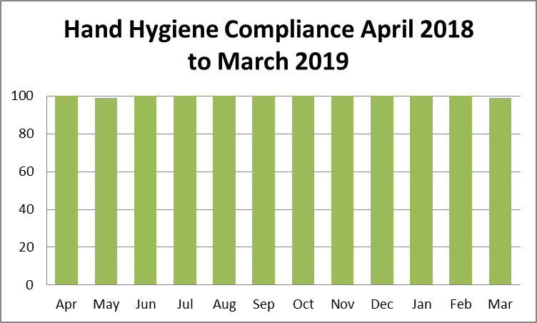

**Hand Hygiene Products**

A review of the hand hygiene products used within the organisation concluded that there was no single supplier of hand hygiene products and that skin moisturiser was not readily available therefore increasing the risk of dermatitis to staff. Following this report the Trust supported the move to a single supplier of hand hygiene products including availability of hand moisturiser for staff. A new supplier for soap, hand sanitiser and moisturiser has now been sourced and completed on the Russells Hall Site. Work is planned to install across Corbett and Guest. Ongoing skin surveillance is being undertaken by Staff Health and Wellbeing.

**Commode Audit**

Monthly commode audits are undertaken by clinical areas to ensure the condition and the cleanliness of commodes are monitored. Broken commodes are removed and replaced as necessary.

The graph below demonstrates overall Trust compliance for commode audits for the year April 2018 to March 2019.

The audit highlighted a reduced compliance score for February 2019. The issues identified were due failure to follow procedure for labelling equipment that has been cleaned. This issue was addressed immediately.

1. **WARD AUDITS**

An audit of clinical areas has been undertaken utilising the Infection Prevention Society audit tool, prioritising areas with poor environmental scores, low MRSA admission screening rates, poor or lacking High impact intervention scores, high Clostridium difficile rates and NHSI/CQC feedback.

All of the inpatient areas, admission wards, day case units, imaging departments were audited. In addition the majority of clinics and outpatient areas were visited.

The aim of the auditing process is to:

* make wards aware of shortfalls in practice and compliance with IPC policies
* escalate environmental concerns which might compromise patient, visitor and staff safety to the relevant departments/teams (environment, water safety, ventilation, domestic and nursing cleaning scores)
* provide Lead nurses, matrons and link practitioners with the expected IPC standards

The infection Control Team completed a baseline audit for all the inpatient and majority of the outpatient areas during the first quarter on the current financial year. Good practice was noted and feedback was provided to the audited areas. Shortfalls were also noted and the most common themes identified were:

* + Infection control: inappropriate use and disposal of Personal Protective Equipment (PPE), noncompliance with the isolation policy, lack of cleaning schedules for equipment and toys.
  + Housekeeping: lime scale on taps, mould on seal around sinks, dirty macerator seal and rim, low and high dust in places
  + Estates: holes in the sink back panels, sink seals damaged/discoloured, wall paint damaged/discoloured, ceiling tiles looking dusty, plugs on chains on some hand wash sinks

A new cleaning schedule was devised and disseminated to all clinical areas, providing assurance that all the equipment in use is cleaned, reducing the risk of cross contamination.

A Cleaning and Disinfection Guidance for Foam Mattresses, Static Air Mattresses and Bedframes poster was designed following the NHSI visit from March 2018.

1. **ESTATES & FACILITIES**
   1. **Environmental Audits**

The Trust recognises its duty to provide safe and clean environments where patients, staff and other visitors can expect to be protected from the risk of Infection. The environmental cleaning service is provided by Interserve (Facilities Management) Ltd (IFM) as part of the Trusts PFI contract with Summit Healthcare (Dudley) Ltd (Summit). The contract is managed by the Trust’s Facilities and Property Development Department. Environmental audits are undertaken by the Trust Auditors in partnership with IFM and clinical staff.

The table below outlines the cleaning scores for The Trust for this reporting period.

Cleaning scores across the Trust have plateaued over the past 12 months. In the main, Corbett and Guest Hospital continue to achieve above the 95% threshold on a monthly basis. However, Russells Hall has not achieved 95% in any month but is achieving in excess of 90% and for the past 2 months in excess of 94%. The Trust has continued to audit all areas of the hospital as outlined in the Trust’s Cleaning and Disinfection policy and continued to apply the performance management mechanisms within the PFI contract throughout this period. The Trust’s Facilities Team has worked closely with Summit and IFM during this time.

In collaboration with Summit Healthcare, a service review of the cleaning service has taken place by Delia Cannings, Director from Environmental Excellence Training & Development Ltd, who is also a member of the Association of Healthcare Cleaning Professionals. Whilst it was felt that the service being delivered was of an acceptable standard, a number of recommendations have also been identified within the final report. Progress is now being made to agree the way forward with IFM and Summit.

A Trust cleaning manual has been developed with support from Infection Control and a copy issued to all wards for reference. A copy is also available on The Hub. This manual includes supporting documentation such as authorised cleaning and disinfection products, colour coding, cleaning schedules, cleaning risk categories, cleaning frequencies, cleaning responsibilities, element standards used for auditing etc.

Following the implementation of the Trust’s revised Cleaning & Disinfection Policy, updated cleaning schedules have been issued to all wards and are in place on the entrance to each clinical department.

It is expected that during 2019 NHS Improvement will issue the new National Standards for Healthcare Cleanliness, although this should not affect Interserve’s contractual obligations.

* 1. **PLACE 2018**

Patient-Led Assessments of the Care Environment (PLACE) is the national system of assessing how the environment supports the provision of clinical care. All Trusts are required to undertake these inspections annually to a prescribed timescale.

PLACE teams consist of both Patient and Staff Assessors. As a minimum, Patient Assessors should make up 50% of the assessing team. There were 13 Trust and Interserve representatives and 13 Patient Assessors from local Healthwatch and also Trust Governors. The number of areas to be visited across the site are set out within the guidelines of PLACE and the inspection covers wards, out-patient areas, communal areas and external areas, as well as the Emergency Department and generates scores for the following:

* Cleanliness
* The quality and availability of food and drinks
* How well the environment protects people’s privacy, dignity and wellbeing
* Condition, appearance and maintenance of the buildings (inside and out)
* How the premises are equipped to meet the needs of patients with disability and dementia

PLACE by its very nature is a snap shot of one day and does not rely on the application of any technical or scientific tools, it can be influenced either way by what is seen on the day. At the end of the assessment period, Patient Assessors are required to complete their own assessment form on how the overall assessment has been undertaken. This includes questions such as were their views taken on board and was sufficient time given to undertake the assessment etc.

The PLACE Scores for 2015 / 2016 / 2017 / 2018 were as follows;

|  |  |  |  |  |
| --- | --- | --- | --- | --- |
|  | **2015** | **2016** | **2017** | **2018** |
| Cleanliness | 99.06% | 99.14% | 98.09% | 98.85% |
| Food (Combined) | 86.08% | 80.74% | 88.76% | 83.95% |
| Food (Organisational) | 75.19% | 83.46% | 87.04% | 92.18% |
| Food (Ward) | 88.47% | 80.01% | 89.21% | 82.02% |
| Privacy, Dignity and Wellbeing | 85.87% | 84.01% | 88.89% | 88.64% |
| Condition, Appearance and Maintenance | 94.97% | 96.59% | 93.35% | 96.35% |
| Dementia | 74.13% | 80.95% | 77.60% | 85.45% |
| Disability | - | - | 83.99% | 92.28% |

The Dudley Group NHS FT were shown to be better than the national average in six of the eight categories including; Cleanliness, Organisational food, Privacy, dignity & wellbeing, Condition, appearance and maintenance, Disability and Dementia. As food was an area for concern for the Trust based on the PLACE scores and also patient feedback, an action plan was developed in order to address the issues identified, this has included Interserve changing to a new food supplier, Apetito, and a new patient menu being implemented in December 2018, as well as the purchase of new food regeneration trolleys for all wards.

In February 2018 the Trust commenced a programme of mini-PLACE assessments to assess the patient environment. In addition to Trust and IFM/Summit involvement, these assessments are supported by Patient Assessors including Trust Governors, local Healthwatch and also the Trust’s volunteers. Actions arising from each of the assessments are recorded and monitored via the Patient Experience Improvement Group (PEIG).

Hydrogen Peroxide Vaporisation (HPV) is a method of environmental bio-decontamination whereby a machine creates a fine vapour which is released into the atmosphere of a sealed space (i.e. room on a ward).  The vapour will circulate and settle on surfaces, providing a highly effectively means of surface disinfection and decontamination.

HPV decontamination is advised whenever the spread of infection is considered a risk.  It is highly recommended that HPV decontamination of single or multi-bedded rooms is undertaken where patients have been known to have had infections that are easily transmitted.

The HPV business case approved funds for a service for 6 months in order to obtain robust information regarding the number HPV cleans required against those delivered in order to review the effectiveness of the service. The service is to provide an adjunct to terminal cleans for specific alert organisms and to deliver a rolling programme of equipment decontamination in high risk areas of the Trust. The service offered is: Monday to Friday 9am – 7pm and Saturday to Sunday 11am – 7pm. The team commenced employment and training on 6th August 2018.

Operators visit the wards each morning and later in morning, and throughout day to see if any patients are planned to be discharged and advise staff to arrange ‘fogging ‘ of room. However, the trend appears to be that patients are discharged out of HPV operators hours (most likely due to waits for TTO’s, transport) and rooms are not always fogged. However as many areas and side rooms as possible have been fogged throughout each month. HPV operators have successfully fogged (as part of a rolling programme) all bathrooms on most wards.

Due to the success of the trial we have now appointed to 2 substantive posts to ensure the rolling programme of HPV cleaning to bathrooms, equipment and side rooms continues. We also have a part time vacancy which we plan to appoint to very soon

**12.0 ANTIBIOTIC STEWARDSHIP**

**Antimicrobial Stewardship Report 2018-19**

This paper provides an update and an assurance of compliance with standards set out by Health and Social care IPC code of practice for Antimicrobial stewardship, Department of Health “Start Smart then Focus” and NICE NG15 (2015) Antimicrobial Stewardship: systems and processes for effective antimicrobial medicines use.

**CQUIN: Reducing the impact of serious infections (Antimicrobial Resistance and Sepsis)**

For 2018-19 Dudley participated in the national CQUIN: Reducing the impact of serious infections. The antimicrobial team took responsibility for part C and D. The goal of this CQUIN was to reduce antibiotic consumption with a focus on antimicrobial stewardship and ensuring antibiotic review within 72 hours. Indiscriminate and inappropriate antibiotic prescribing has been identified as a key driver for antibiotic resistance, therefore the CQUIN aimed to reduce total antibiotic usage, usage of key broad-spectrum antibiotics and ensure antibiotics are appropriately reviewed after initiation.

**Part 2c of CQUIN**: **Antibiotic review between 24-72 hours of initiation in patients with sepsis who are still inpatients at 72 hours.**

Dudley achieved all four milestones for antibiotic review within 72 hours, with a final result of ***94.3% (Q4)*** for antibiotic prescriptions (sepsis patients) receiving a review within 72 hours.

In order to further the excellent achievements to date, the Trust has recruited additional sepsis nurses and an antimicrobial pharmacist to support initiatives to improve sepsis outcomes and stewardship.

An online sepsis tool has been created for antimicrobial/sepsis teams based on e-obs which allows identification of patients who are flagged as septic. The tool facilitated review of those patients within 72 hours by the antimicrobial team which helped in achieving the quarter 4 target of 90% for antibiotic review.

This successful strategy was showcased at West Midlands Innovation day as a poster and was highly commended.

**Part 2d Antimicrobial Consumption**

Part 2d of the CQUIN is further divided into 3 individual targets,

1. Reduce total antibiotics consumption by 2%.
2. Reduce carbepenem consumption by 2%.
3. Increase access list antibiotics proportion to 55% of the total antibiotics consumption.

When compared with national consumption data reported on Public Health England Fingertips, Dudley falls in the 2nd lowest percentile for total antibiotic usage (5069 Defined Daily Doses (DDDs)/1000 admissions vs. 4945 DDDs/1000 admissions for Dudley and national average, respectively).

The antibiotic consumption targets and local achievements are detailed in table 1.

Table 1

|  |  |  |  |
| --- | --- | --- | --- |
| **Measure** | **Baseline** | **Target** | **End of year** |
| Total ABX | 4048.4 | 3967.4 | +33.1% |
| Access group ABX >55% of consumption | 55% | 55% | 56.50% |
| Carbepenem | 133.1 | 130.4 | -39.4 % |

**Quarterly summary is as following:**

**Q1** total antibiotic consumption DDDs/1000 admissions= 5141.6***(+30.5%)***

**Q1**Carbapenem consumption DDDs/1000 admissions= 82 *(****-30.9%)***

**Q1** Access list proportion consumption = ***52.37%***

**Q2** total antibiotic consumption DDDs/1000 admissions= 5141.6***(+27%)***

**Q2**Carbapenem consumption DDDs/1000 admissions= 82 *(****-39.1%)***

**Q2** Access list proportion consumption = ***56.00%***

**Q3** total antibiotic consumption DDDs/1000 admissions= 5674.5***(+30%)***

**Q3**Carbapenem consumption DDDs/1000 admissions= 79 *(****-38.6%)***

**Q3** Access list proportion consumption = ***59.02%***

**Q4** total antibiotic consumption DDDs/1000 admissions= *(****+33.1%)***

**Q4**Carbapenem consumption DDDs/1000 admissions= ***(-39.4%)***

**Q4** Access list proportion consumption = ***56.5%***

Compared to similar Trusts, Dudley performed well in reducing Carbapenem and Pip/Taz usage however, because of the switch to triple therapy i.e. 3 narrow spectrum antibiotics rather than one broad spectrum antibiotic and other factors such as change in admission data during 2017/18 the total antibiotic consumption figure has significantly increased.

Learning from 2017/2018 we reviewed all our antibiotic guidelines individually and changed guidelines based on national recommendations and local resistance patterns.

The following Figures (1, 2, 3 &4) are from Define benchmarking software:

**Figure 1, Total antibiotic consumption (DDDs/1000 admissions) compared to similar Trusts**

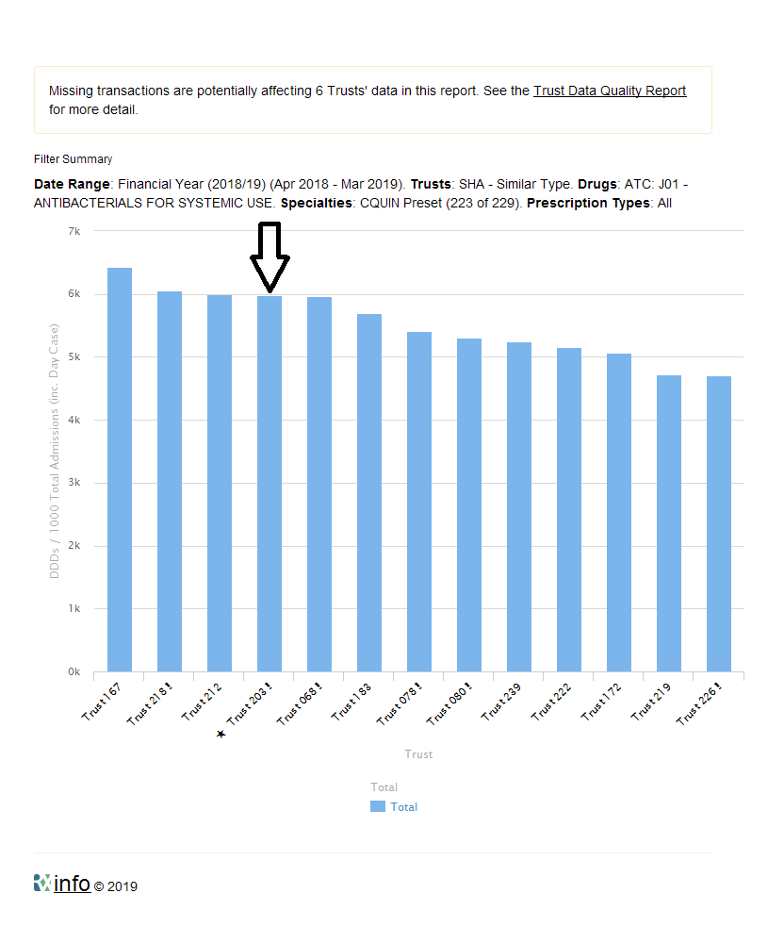

**Figure 2, Total Carbapenem Consumption (DDDs/1000 admission) compared to similar Trusts.**

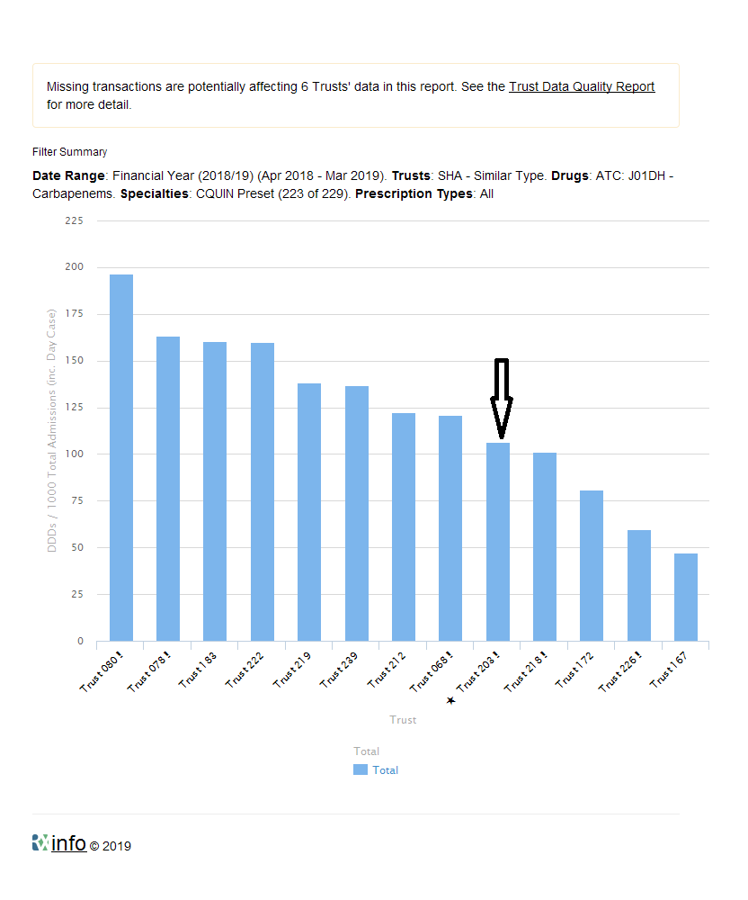

**Figure 3, Total Pip/Taz consumption (DDDs/1000 admission) compared to similar Trusts**

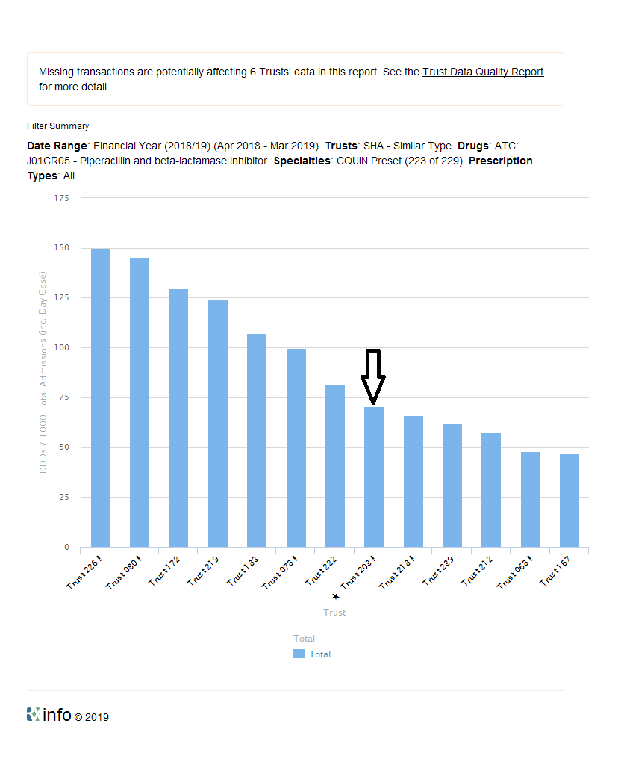

**Figure 4, Proportion of Access list antibiotics DDDs per 1000 admissions**

The Dudley Group NHS Foundation Trust is in the 75th percentile to best nationally for using access list antibiotics.

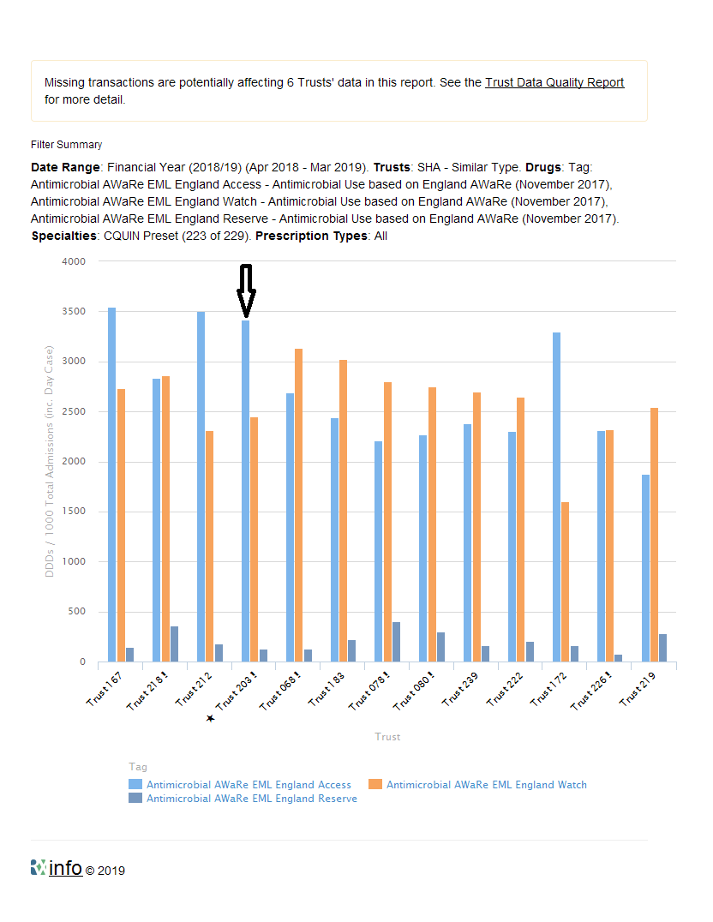

**Antimicrobial Prescribing snap shot audit**

Antimicrobial snap shot audits were carried out during 2018/19. The results are summarised in the following tables:

**April 2018**



**September 2018**



**February 2019**



All the results from the snapshot audits carried out over the last year shows significant improvement.

The audit tool has been modified to collect more useful information i.e. indication and compliance with Trust guidelines. Nature of allergy is further clarified during the medicines reconciliation process by ward pharmacy teams when needed.

The documentation of stop/review date seems low however, data collected within the snapshot audit is limited to prescription charts and does not include documentation od stop/review in the medical notes.

Patients on restricted antibiotics e.g. meropenem & piperacillin/tazobactam (which are not recommended in the Trust guidelines or approved by microbiology) are referred to the antimicrobial pharmacists.

The pharmacy team monitor and raise awareness at ward level on how to correctly document allergy status on drug charts. A pre-registration pharmacist has recently completed an audit regarding documentation of drug allergies and the data is being analysed.

**Interventions over past 12 months to improve Antimicrobial Stewardship at DGH**

The targets were achieved with the help of multiple initiatives i.e.

* Project group formed including medical director, chief pharmacist, AMS team, Sepsis leads and service improvement
* IV to oral (IV2PO) switch stickers.
* Collaboration with sepsis team.
* Feedback to the divisions provided via ASG
* Executive level reporting to influence change.
* Antibiotic review section on drug chart.
* Referrals to antimicrobial pharmacists.
* Review of OPAT use of IV antibiotics
* Complete review of antibiotic treatment guideline choices, reducing a large proportion of pip/taz use.
* Course lengths in antibiotic guidelines rationalised
* Teaching with pharmacists to empower challenge of prescriptions
* AMS ward rounds started initially on critical care and then extended to medical and surgical high dependency units and acute medicine wards.
* Developed a new sepsis tool based on e-obs to identify sepsis patients (presented poster at west midland innovation day).
* Monthly CQUIN report compiled.
* ITU stewardship ward rounds started 3 times a week.
* Surgical prophylaxis guidelines updated.
* Endocarditis guidelines updated.
* Sinusitis guidelines updated.
* C diff guidelines updated.
* Junior Drs antimicrobial prescribing audit analysed and reported.
* Vancomycin/Gentamicin dialysis prescriptions updated.
* Communication to highlight the criteria for the new CQUIN part c and antimicrobial stewardship completed –
* Communication message published on HUB highlighting importance of 72 hours review.
* Medical/surgical representation in Antimicrobial stewardship group.
* Awareness session for pharmacists on sepsis and antimicrobial review has been delivered.
* Antimicrobial snapshot audits completed.
* Guidelines for (HAP, CAP, Aspiration pneumonia and Cholecystitis) updated to include more access group antibiotics.
* Hub Communication around guidelines changes.
* Antimicrobial stewardship talk to OPAT sisters delivered (prescribers).
* Antimicrobial stewardship update at Grand round in July 2018.
* Antimicrobial pharmacist’s referrals started for ward pharmacists.
* Communication (antibiotics aware theme) to all clinicians/prescribers from (Medical director/Chief Pharmacist/DIPC ) in form of email completed on 1/8/18
* Pip/Taz removed from ward stock lists with a few exceptions i.e. acute medicine, oncology/haematology wards for neutropenic sepsis.
* Teaching session for acute medicine directorate completed.
* Antimicrobial prescribing session for FY1s completed.
* Antimicrobial prescribing session for FY2s completed.
* Antimicrobial prescribing session for CMTs completed.
* Extended antimicrobial stewardship ward rounds started covering MHDU and acute medical wards.
* Snap shot audit of acute medicines ward completed along with consultant microbiologists.
* Influenza Guidelines updated.
* Raised awareness around AWaRe list of antibiotics provided by Public Health England.
* Antimicrobial awareness week from 12th November to 18th November.
* Directorate meetings and feedback to Clinicians on standards of antimicrobial prescribing in their areas was provided.

**Education and Training**

Mandatory training for clinicians in antimicrobial prescribing and stewardship continues to take place. All doctors new to the Trust are provided with antimicrobial training at induction. Better Training Better Care for FY1 and FY2 doctors in Antimicrobial Prescribing received excellent feedback from the participants. Additional training sessions have also been carried out through the year when guideline changes have occurred.

Pharmacists receive regular feedback on antimicrobial prescribing in their clinical areas after the snapshot audits, pharmacist prescribers’ complete online modules on antimicrobial prescribing.

Feedback is provided to clinicians after every RCA for C. diff infections. The newly recruited band 7 Specialist Antimicrobial Pharmacist is enrolled onto an independent pharmacist prescribing course which will further strengthen the antimicrobial stewardship activities across the Trust.

**Research**

The antimicrobial stewardship team has applied to be a part of the national research project ARK and is awaiting response from the project recruiters.

ARK is developing and testing a bundle of strategies – the ‘**A**ntibiotic **R**eview **K**it’ – to help doctors, nurses, pharmacists and patients stop antibiotics in hospital when they are no longer needed.

**Current Challenges**

* Encouraging already stretched clinicians to represent their areas at ASG meetings.
* Capacity of AMS team is limited therefore ward presence is low. Currently 1 x Consultant Microbiologist vacancy with one substantive and one Locum in post. This limits pro-active monitoring through limited ward visits.
* Antibiotic shortages are unpredictable and require frequent guidance changes leading to prescriber confusion.
* Lack of e-PMA to support real time tracking of antibiotic consumption, guidance compliance and improved data reporting / time management on reporting. Roll out of chosen e-PMA (Sunrise – Allscripts)
* In the absence of live prescribing system it will be challenging to capture the data for new CQUINs i.e. prescribing for lower UTIs in over 65s and prophylactic antibiotics in elective colorectal surgeries.

**Plans for 2019/2020**

* Develop a strategy for achieving 2019/20 national CQUIN targets around antimicrobial stewardship i.e.

*Part CCG1a: Improving the management of lower urinary tract infections in older people*

*Part CCG1b: Improving surgical prophylaxis in elective colorectal surgery*

|  |
| --- |
|  |

* Review guidelines in view of new NICE guidance issued lately.
* Continue working as a part of sepsis work streams: created “Sepsis team” (4x sepsis nurse practitioners band 7s + 2 x antimicrobial pharmacists+ Consultant Physician)
* Focus on drive for IV2PO switch – septic patients flagged to antimicrobial team. Reinforce the need for a high standard antimicrobial stewardship at pharmacist clinical huddles.
* Training sessions with all pharmacists to highlight the changes and rationale.
* Engage clinicians from medical and surgical divisions to attend ASG meetings and feedback to respective directorates.
* Regular snap shot audits to assess antimicrobial prescribing.
* Increase the frequency of AMS ward rounds currently 3 days a week on critical care, 1 day a week on Medical HDU and 1 day a week on acute medical wards.
* Regular communication in the form of patient safety alerts, screen savers, trust wide communication emails on changes in processes and guidance.
* Develop antimicrobial review page on upcoming electronic prescribing system (sunrise) to help achieve required standards of antimicrobial review.
* Scope development of antifungal stewardship.
* Support postgraduate diploma pharmacists in conducting clinical audits as part of their infectious disease module.
* Support 2019/20 pre-registration pharmacists with antimicrobial audits if required.
* Patient safety bulletin around diagnosis and management of lower UTIs in over 65 patients (as per NICE guidance)
* Liaise with Acute medicine Consultants and Colorectal Surgeons to bring them on board for 2019/20 CQUIN.
* Organise and promote Antibiotic awareness week 2019.
* Identify opportunities for research and development around antimicrobial stewardship.

**13.0 NHSi Infection Control Visit**

A visit by Dr Adams**,** Senior Infection Prevention and Control Advisor NHSi was conducted on 18th July 2018 to visit and review infection control arrangements and practice within the hospital. This was a follow up visit from and earlier inspection where some failings were identified with basic practices. Following the visit, the trust was rated green on the NHSI IPC escalation matrix. No future visits were scheduled

**14.0 EDUCATION AND TRAINING**

Infection Prevention and Control is identified as a Priority 1 mandatory core subject that all employees are required to receive. As of March 2018 Infection Prevention and Control Training for Clinical Staff was required to be completed on an annual basis with a KPI of 90%. The training for non-clinical staff continues to be required 3 yearly. A report is published each month by Learning and Development identifying compliance across the 4 divisions.

The Infection Prevention and Control Team delivers training sessions during Trust induction and Mandatory refresher training each month to various staff groups across the Trust. Following the session there is a requirement for all staff to complete a competency test, and the pass rate for this is 80%.

Staff also have access to an eLearning module for Infection Prevention and Control which can be located on the Learning and Development Page of the hub. It is also necessary for staff to complete a competency test if they choose to complete the session via this route and again the pass rate is 80%.

The table below indicates the mandatory training figures for Infection Prevention and Control the period 2018/2019, broken down by division.

|  |  |  |
| --- | --- | --- |
| Division | **Infection Control –**  **Clinical** | **Infection Control –**  **Non Clinical** |
| Clinical Support | 83% | 98% |
| Corporate | 85% | 95% |
| Medicine & Integrated Care | 88% | 96% |
| Surgery | 86% | 94% |
| **Trust Compliance** | **87%** | **96%** |

In order to reach 90% compliance trajectory for IC mandatory training for clinical staff the plan, to ensure outstanding staff are trained, is to identify these staff via their appraisal, during the current 3-month appraisal window, with the intention that all outstanding staff will be compliant with IC training by the end of this 3 month period.

**15.0 INFLUENZA VACCINATION PROGRAMME**

This year the Trust made excellent progress with regard to the 2018/19 flu vaccine campaign having achieved **77%** of front line staff vaccinated. The CQUIN target was therefore achieved. Peer vaccinators were identified in all ward areas and departments to increase the number of opportunities for staff to receive the vaccination along with additional sessions held at the Health Hub.

**16.0 POLICIES**

The IPCT recognises the importance of providing staff with easy access to a full range of IPC policies and guidelines. Throughout 2018-18 the IPCT continued to review and revise these documents to take account of the latest IPC best practices.

Polices for IPC are reviewed and monitored collaboratively with. Public Health England, the Office of Public Health in Dudley and Dudley CCG. Consideration of new national guidance such as National Institute for Clinical Excellence (NICE) Quality Standards, Department of Health directives and developments in practice for IPC are considered for inclusion.

There is an ongoing programme of policy review and for new policies to be added as required. All policies subject to consultation through the Infection Prevention and Control Group prior to submission to the Trust’s Guidelines Group.

**17.0CONCLUSION**

Eliminating avoidable healthcare associated infection has remained a top priority for the public, patients and staff. In response, a robust annual programme of work has been implemented over the last year which has been led by an experienced and highly motivated Infection Prevention and Control Team and supported by colleagues at all levels of the organisation. The successes over the last year have only been possible due to the commitment for infection prevention and control that is demonstrated at all levels within the organisation. High standards of infection prevention and control and antimicrobial stewardship will remain crucial to minimise the risk of infection and limit the emergence and spread of multi-drug resistant organisms.