If you have any questions, or if there is anything you do not understand about this leaflet, please contact:
Breast Care Nurses on 01384 244165 (8.30am to 8pm, Monday to Friday)

This leaflet can be made available in large print, audio versions and in other languages, please call 0800 0730510

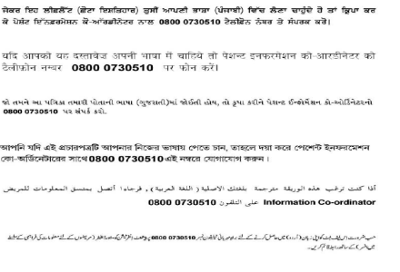

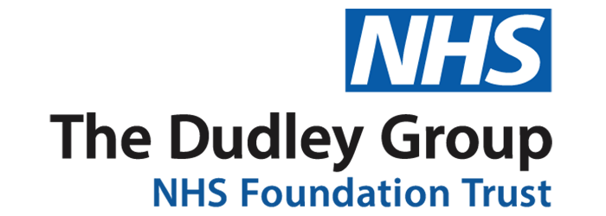
Breast Screening assessment
Breast Care Team
Patient Information leaflet
Why have I been asked to come back for another appointment?
Some women may be asked to return to a breast screening assessment clinic because an area on their original mammogram
(X-ray) needs to be checked more closely.

What Happens at the clinic?
Everyone is different and assessments vary depending on the person. You will have one or more of the following assessments:
Further mammograms
We often repeat your original X-rays
Clinical examination
Most women have their breast examined by the specialist in the clinic
Ultrasound
This is another way of looking at the breasts using sound waves and is completely painless

Needle (core) biopsy
Some women will require a needle biopsy. This is carried out to obtain a sample of breast tissue for diagnosis. A small amount of tissue is taken, using local anaesthetic to numb the skin. You should feel fine after the biopsy and be able to carry on as usual afterwards.

Fine needle aspiration (FNA)
We sometimes need to take a sample of cells for diagnosis using a small needle. Most women attending this clinic are found to have no serious abnormalities in these tests.
The visit can take up to three hours. You are welcome to bring your partner, a friend or relative with you. However, they may not be able to stay with you during your assessment examinations due to a lack of space in the room. They can, however, remain in the waiting area.

Who will I see at the clinic?
At the assessment clinic you will meet some of the specialist Breast Care Team. These may include advanced practitioners, radiographers, radiologists, and breast care nurses. Please note that not all the health professionals you meet will be female.
The staff will explain the procedures and answer any questions you may have both before and during the assessment.
You will be given the contact detail of a breast care nurse in case you wish to contact anyone after your assessment appointment.

When will I get the results?
Where possible the results of your assessment will be given to you before you leave the clinic. However, this will not be possible if you have had a needle biopsy or FNA. Results can take up to three weeks and are given at a subsequent clinic appointment.
We sometimes have to repeat a biopsy and occasionally we may need to change an appointment, in either of these cases, you will be contacted by telephone or letter.
Additional information

- Please do not use spray deodorants or talc before you come to the appointment. Roll-on deodorants can be used
- You may find it more convenient to dress in separate tops and bottoms
- If you have a needle biopsy or FNA, you will be given information about his and aftercare instructions.
- If you are claiming any benefits, you may be entitled to travelling expenses so please ask when you arrive.

