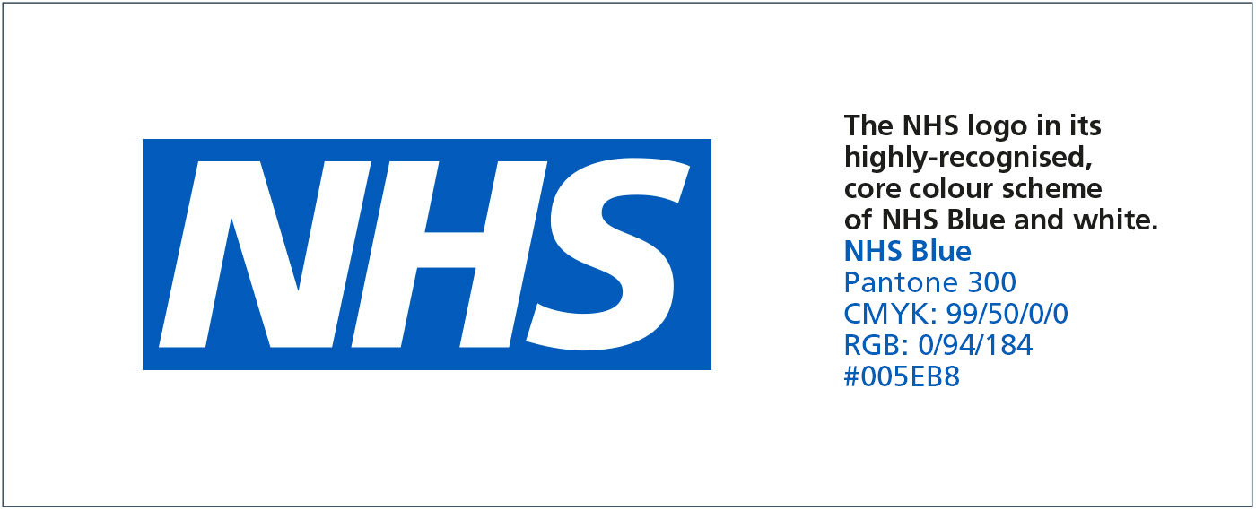

The Dudley Group
NHS Foundation Trust
Patient Information

Understanding under-breast soreness (Intertrigo)

Symptoms and treatment
Intertrigo is very common. This leaflet is designed to raise awareness of the condition and to aid self-help treatment.
What causes under-breast soreness?
Intertrigo is an infection caused by a yeast condition called Candida. It comes from the same family of yeast infections that cause athletes foot, jock itch and nappy rash.
Under-breast soreness usually occurs in women who are larger breasted or very sporty.
The main causes are sweat rash, ‘skin to skin’ rubbing and the growth of yeast, which appears as a rash in the skin fold, under the breast, commonly known as intertrigo.
If untreated, intertrigo can spread to other parts of the body or worsen. In some cases it can lead to creamy coloured discharge and omit a pungent smell.

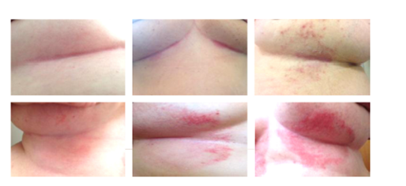

What are the symptoms of intertrigo?
The main symptoms are:
• Inflammation
• Soreness / discomfort
• Split skin
• Spots
• Itching
• Discharge (often pungent)

What is the most effective treatment?
The most effective treatment for under-breast soreness is to:
• Wash the affected area morning and night and pat dry, rather than rub dry. Wear good supportive bras (cotton is known to be effective). This will help stop the ‘skin to skin’ rubbing (nylon bras are known to make the condition worse).
• Do not share flannels or towels, to avoid the spread of infection.
• In cases where the skin is very red and/or very inflamed and sore, ask your pharmacist for a *hydrocortisone cream. Do not apply to broken skin.
• In cases where the skin is red, sore or itchy, ask your pharmacist for an *anti-fungal cream or powder.
• Once the infection has cleared, it may be advisable to use a *barrier cream (ie zinc and castor oil) to help stop the infection returning.
• If none of the above treatments help or your symptoms worsen, make an appointment to see your doctor
*Hydrocortisone, anti-fungal creams/powders and barrier creams are all available over the counter from a pharmacy. Please follow the instructions on the pack. For further information or advice contact your local doctor, pharmacy or breast screening unit.
Contact information
Breast Screening Unit: Telephone 01384 244177 / 01543 576235, open 8.00am – 5.00pm Monday to Friday

Reproduced with permission from the Breast Screening Unit, Queen Elizabeth Hospital, King’s Lynn, Norfolk. Thanks to the staff for their help and support.

