Brockmoor & Pensnett community engagement

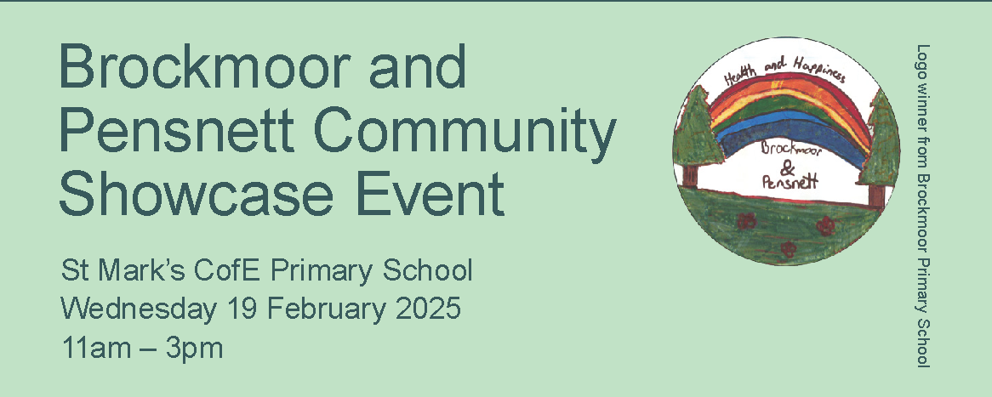

This report evaluates and summaries the findings from this event, including residents and organisation, community groups, services and provider responses

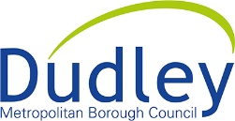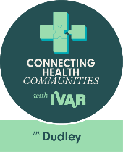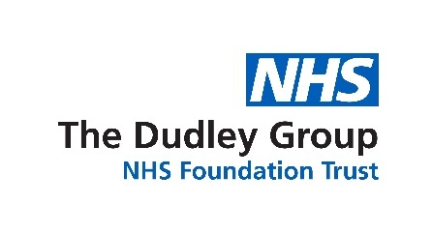

Table of Contents
Brockmoor and Pensnett Community Innovation project 3
Background 3
Why Brockmoor and Pensnett? 3
Who’s involved so far? 3
What’s happened so far? 3
Brockmoor and Pensnett Community Event 19th February 2025 4
Event Promotion 5
Community Champion Programme 5
Did the event meet its objectives? 5
Residents Feedback 6
Organisations, Local Community Groups, Services and Provider Feeback 8
Images of community groups, organisations, providers and services in attendance at the event (this is just a sample) 10
Funding 11
Partner quotes & Press Release 11
Reflections & Questions 12
Next steps – looking ahead 12
Thank you 12
Appendix 1 - Feedback from organisations/community groups, providers and services 13

Brockmoor and Pensnett Community Innovation project

Background
The Brockmoor and Pensnett Community Innovation Project aims to bring people who live and work in the area together, supported by local organisations and Dudley Council. The project is particularly looking at improving health across the Brockmoor and Pensnett ward, empowering the community to take action to support and enhance their own health and wellbeing, strengthen connections and shape their local area.
The project looks to bring services, local organisations and local people together to look at:
- What additional services could be provided in this community?
- What can communities and professionals do differently together to provide more of what people need?
- What people in communities can do to improve their own and their community’s health and happiness and overcome barriers to making positive changes?

Why Brockmoor and Pensnett?
We know that Brockmoor and Pensnett has a higher proportion of young people than the rest of Dudley, and a vibrant sense of community. There are fantastic local groups, community centres and schools.
While there are lots of opportunities in the area, we also know that many people struggle with their health and wellbeing for a variety of reasons. Many people in Brockmoor and Pensnett have health-related needs that are not being fully supported at the moment. This project is trying to change that by:
- Helping those who struggle most to be able to get support
- Encouraging more connections between health and community organisations
- Developing ways that local people and communities can be empowered to play a role in creating a healthier Brockmoor and Pensnett

Who’s involved so far?
A project steering group was formed which includes ward councillors, partners from health, council and voluntary sector services, school leaders and others rooted in the community. The objective is to make a plan for better health for the local community. The group started off by engaging with a wide range of other people in the area to find out more about what it is like to live in Brockmoor and Pensnett and how the local community stays healthy, well and happy.

The project is being supported by a national organisation called IVAR (the Institute for Voluntary Action Research) and has some funding from the National Lottery Community Fund to try and make a difference over the next year.

What’s happened so far?
We have already been busy working with local groups and charities, local residents, local schools and children and families at various events, finding out what’s important to people and how they want to be involved.

The group has carried out community conversations, surveys, and workshops in community centres and schools to hear what people think about the area and to co-produce ideas that could help them live healthier, happier lives. We’ve heard fantastic ideas and built some great relationships already. We’ve continued to discuss with community members and seek their thoughts on which aspects of the project they think would work well.

A number of residents shared that they would like more events that the community and families could enjoy and that they would also like more free events to occur locally.

Brockmoor and Pensnett Community Event 19th February 2025
From the various forms of engagement with residents of the ward we repeatedly heard that residents were unaware of the activities, local services and groups that support the area. The purpose of the event was to bring together local community groups, organisations and support services to showcase activities and support and celebrate everything Brockmoor and Pensnett has to offer. We wanted to use this event to improve awareness and access to support in the area for improved health and wellbeing.
The event was jointly organised by Dudley Council, Connecting Health Communities (IVAR), Healthwatch Dudley and the Dudley Group NHS Foundation Trust.
This was a free event for residents hosted by St Mark’s CofE Primary School which took place on 19th February 2025. The event brought together 43 local community groups, services and providers ( a full list is attached at appendix 1) and along with promoting the work they do, the event also provided local organisations, community groups, providers and services the opportunity to network and find out more about the work each of the organisations are doing. This networking has the potential to provide all those organisations present with further knowledge of services in the area, enabling appropriate signposting for residents to other relevant services and support.
The event showcased ways to connect with the community, including volunteering prospects, the opportunity for residents to discover the wide range of activities available, and learn about the support services in their local area. Attendees had the chance to meet representatives from a range of partners including sports clubs, support services and local charities, all dedicated to improving the well-being of residents, and combat health inequalities in the area.
The event also included free activities for residents of all ages to take part in such as:
- sports games
- arts and crafts
- dance to health sessions
- gentle, fun exercises
- play your cards right
- first aid demonstrations
- blood pressure checks (4 people were identified as having high blood pressure and will now be contacted by their doctor to check this and review)
The event also showcased previous engagement work that has taken place with the community and voluntary groups, working with local children to better their understanding of health, wellbeing and lifestyle choices.

Event Promotion
We wanted to ensure that we promoted the event as far and wide as possible and used a number of ways to share the messaging including social media, leaflet drops, advertising outside the venue, through the school channels (DOJO), via the local GP practice and other businesses and through local newsletters and existing Council networks. The event was also promoted on the Healthy Dudley website using a QR code on the promotional flyer. People could visit the webpage to get more details on what the event was about, what activities were available and times of the sessions. Analytics show that the page was viewed 189 times by 146 users. The average time people were on the page for was 18 seconds. There were peaks in views on the page that correlated to times when promotional activity was carried out.
Supporting organisations also promoted the messaging through their channels including internal and external newsletters enabling a wide reach to attract attendees. In total 159* individuals attended the community event which compares positively to attendance at our first community /stakeholder event in January 2024 where resident attendance was low. (* the total number of residents attending the event was calculated using a headcount on entry to the school, it is likely that numbers of residents attending was actually greater than 159 as during very busy periods it was difficult to identify all new attendees – for future events we will consider a welcome desk or the possibility of handing our wrist bands or free cotton bags).
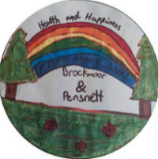
We are also very grateful to the 3 primary schools within the ward who allowed pupils to take part in a logo competition for the event. We received lots of amazing submissions. The winning logo was printed on all the leaflets and posters and the pupil received a certificate for their contribution.

Community Champion Programme
As part of the ongoing health and wellbeing support in Brockmoor and Pensnett, we also took the opportunity to launch our new Community Champions programme to residents in the area. A community champion is someone who is happy to share activities and information with their friends, family, neighbours and/or social media. It can be someone who lives, works, volunteers or has an interest in Brockmoor and Pensnett. Throughout the event, we handed out many leaflets to families and explained about the programme. We had one person express their interest in becoming a Community Champion and details have been noted for further contact. We will continue to promote the programme as the project progresses.

Did the event meet its objectives?
The main purpose of the event was to bring together local community groups, organisations and support services to showcase activities and celebrate everything Brockmoor and Pensnett has to offer. As the event was held in February half-term we had a high attendance from families with children, we also had visitors from a local care home.
The good turnout of residents, some of which we have not reached before, has helped to further raise awareness within the community of what is on offer and available to this ward – the event was an overall success, from feedback we found that both adults and children found it to be a really fun, informative and enjoyable event.

Quotes from attendees:
“can we come next week”
“ I like this play centre”
“I want to say thank you for such an educational and fun day but, more importantly on behalf of the residents of Brockmoor, Pensnett and Bromley can I say thank you for bringing back a sense of community to our ward “ Cllr Alex Dale

We also repeatedly heard from our stakeholders involved that this in-person event also provided an amazing opportunity for networking and forging strong connections.
Organisers of the event felt the day was run smoothly and was well organised. Many highlighted the broad ranges of services present and the programme of activities which provided something for all ages to enjoy.

Residents Feedback
Feedback at the event was gathered by IVAR, who gathered feedback from the children and adult attendees about the community event. We used three different methods to gather information:
1) A graffiti wall that asked ‘What do you love about Brockmoor and Pensnett’
2) Feedback forms asking adults what they enjoyed/ learnt at the event and if there was anything they would have liked more of .
3) Tops (best) or pants (worst) activity to capture feedback from the children about the event.
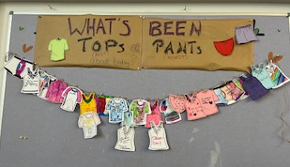

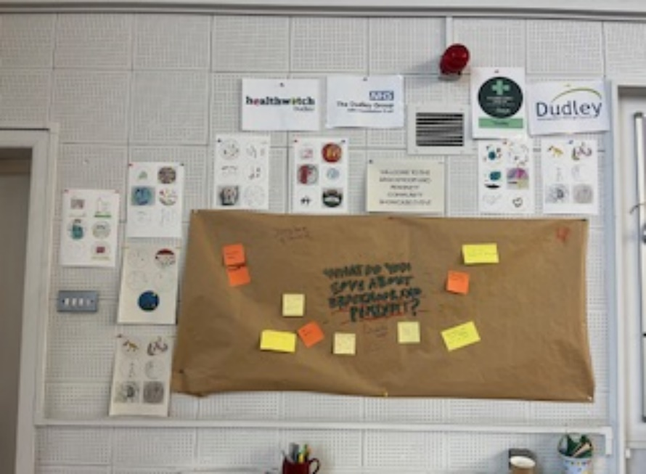
We had 13 responses on what people love about Brockmoor and Pensnett, including:
- Strong sense of community
- The best people <3 [heart]
- Love the People of Pensnett.
- The people are friendly!
- Fens pools walks
- Nature reserve walks.
- The newt
- Like the houses
- The wonderful community
- Walking over Fens Pools (kids love mud).
- Close to a park near the school
- Thats where my mum + dad works and where my school is (which is this school) so close! – Klea <3 [heart]
- The people and community. Diversity continues to grow in the area and people are accepting of different cultures
Key themes from adult attendee feedback
What have you enjoyed about today’s event?
- I have not been to anything like this before. Its great there are things for kids and adults.
- I didn’t know what to expect, I just saw it on the school app and my daughter wanted to come
- It’s something different for the kids to do, not just going to the park.
- Basketball activity, rowing, lots of activities for kids
- Fun and friendly for kids
- Community feeling
- It’s a local event and can come and see the school
Have you learnt anything new from today’s event?
- My daughter learnt what first aid to use in an emergency with St John’s Ambulance. I also found out SJA have an app.
- How many different organisations there are and how little they know about each other/ interact
- There are lots of free groups in the local area
- Found out about local community centres
Is there anything missing? Would have liked to see more of anything?
- Would like to see more smaller groups that might not have the resources/ branding like bigger organisations
- A couple of smaller groups e.g. baby bank, youth clubs
- More space in the venue
- The space felt a bit busy/ overwhelming
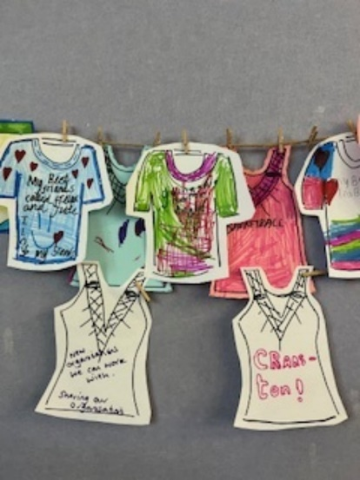
Key themes from children’s feedback (19 responses)
The best things about the day…
- I get to meet new people and discover new organisations
- New organisations we can work with. Sharing our organisation
- Basketball
- Cranston
- Activities
- Today I liked playing with my Bff and coming to the fair
The worst things about the day…
- Bad weather
- Green ball game

Organisations, Local Community Groups, Services and Provider Feeback
To provide a well-rounded evaluation of the event, all organisations, local community groups, services and providers had the opportunity to share post event comments to identify what worked well, any challenges and areas for improvement - please see below some of the really positive comments received.
Community Groups, Services and Provider Feedback
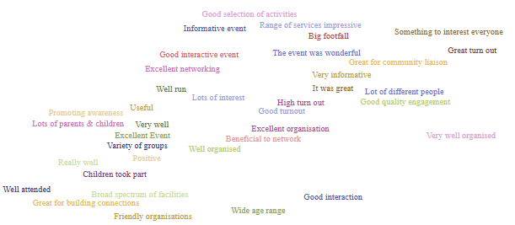
Quotes from organisations, community Groups, Services and Providers
“Thank you, the feedback from my team was that with was really well organised and attended” Carers team
“Great event, thank you” Dudley Stroke Association
“Really excellent event, and very well organised! Thanks for the invite” ACL
“We’ve had a few people who’ve said they’re parents would love to come along to groups” High Oak Youth and Community Centre
“The event was amazing, and I made so many links on the day, it made me reflect on just how many services are locally all supporting local communities” Family Hub

We also asked local community groups, services and providers to share their thoughts, suggestions and insights on anything they would like to see or change at future events. The comments received are key to ensuring the success of future events, gaining resident interest and getting greater attendance at similar events. Below is a snapshot of comments received (the full list is attached at appendix 1). Feedback expressed the need for a larger venue for future events, this is testament to the success of the event and the appetite for local organisations to be engaged and the numbers of residents in attendance:
- More of the younger generation to be involved
- Bring a bag/provide for leaflets
- More room for activities
- A larger venue would be good
- Suggestion to run a “networking bingo” session type of method to encourage residents to visit all stalls?
- More older people to be involved
- More space in stalls – very cramped!
- Before main session started maybe a professional time to look around to talk to different providers
- More signage i.e. posters & banners, advertising and promotion

Images of community groups, organisations, providers and services in attendance at the event (this is just a sample)
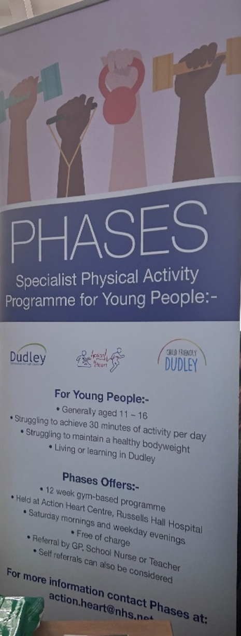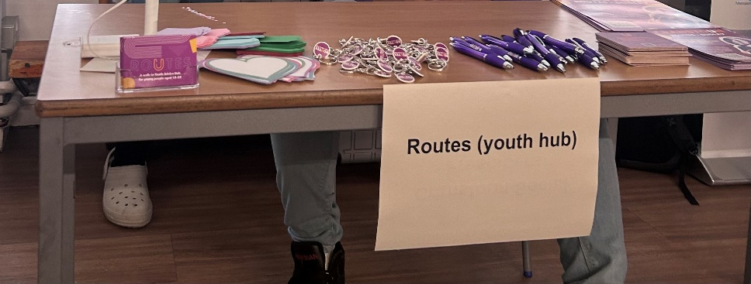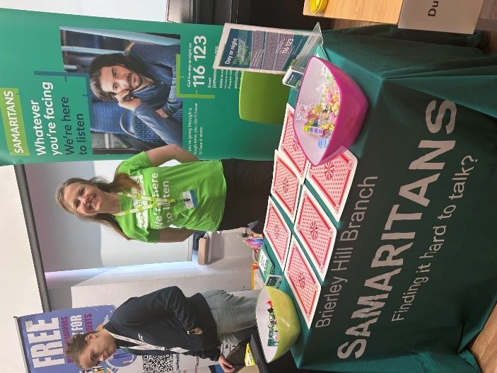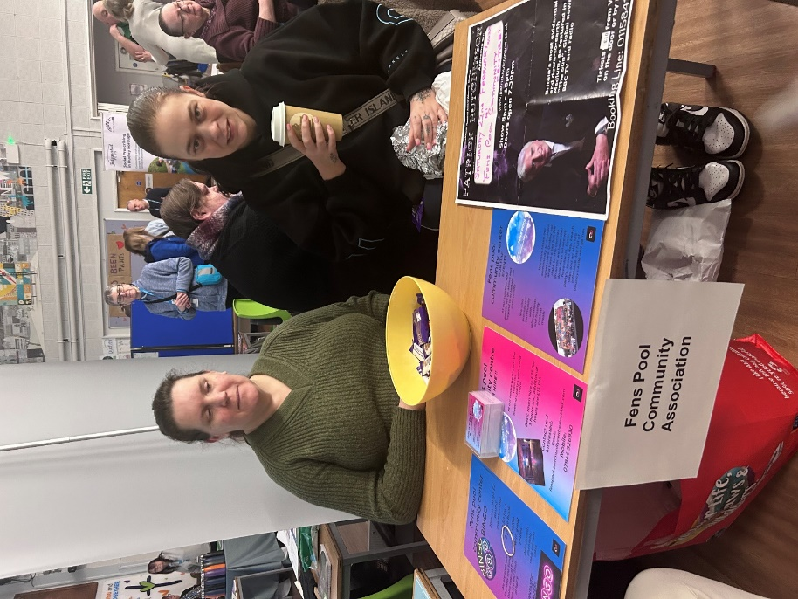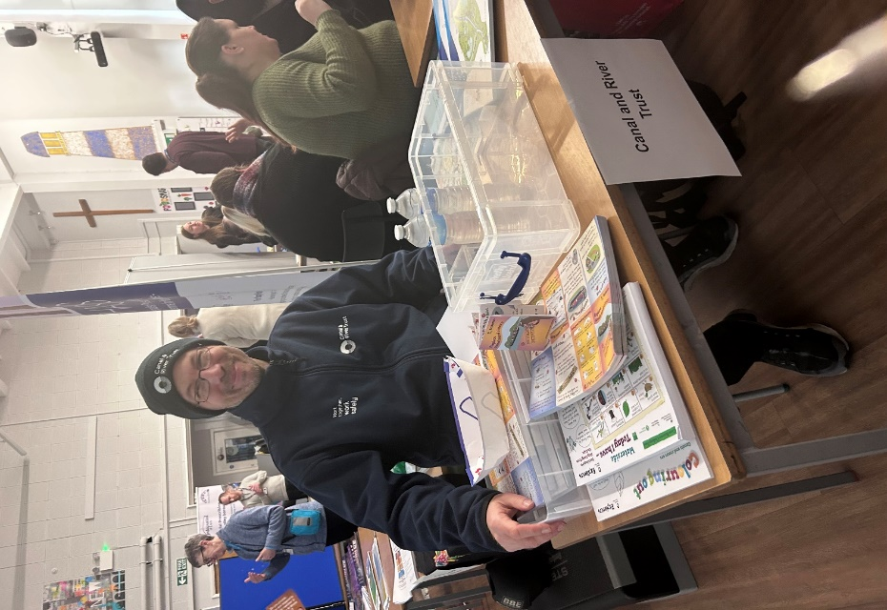
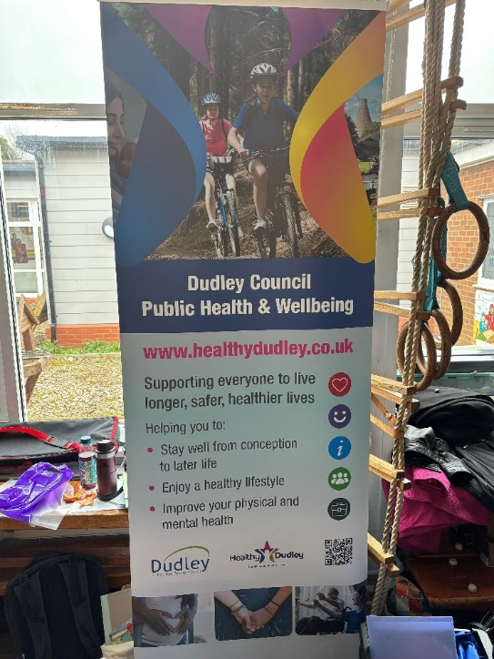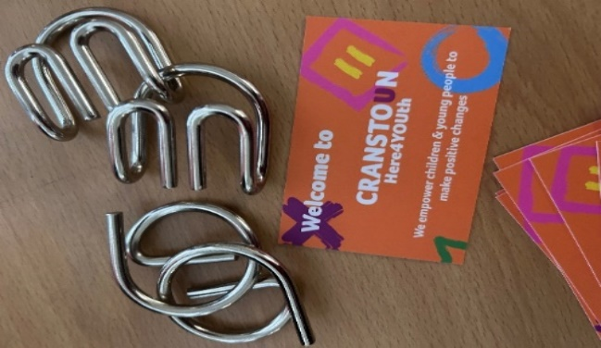
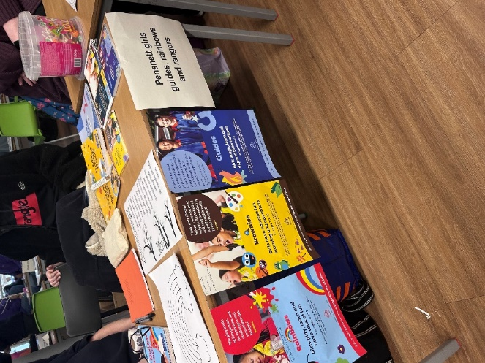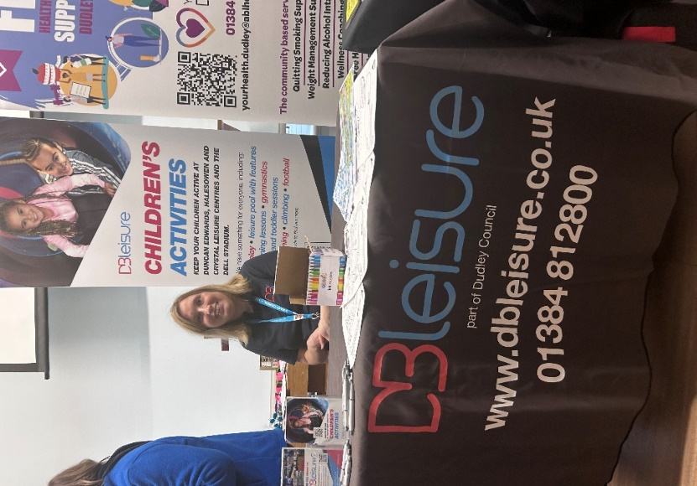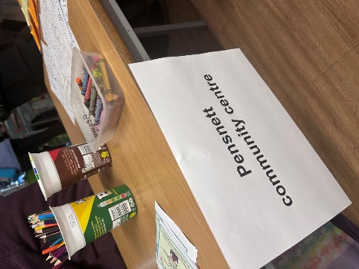

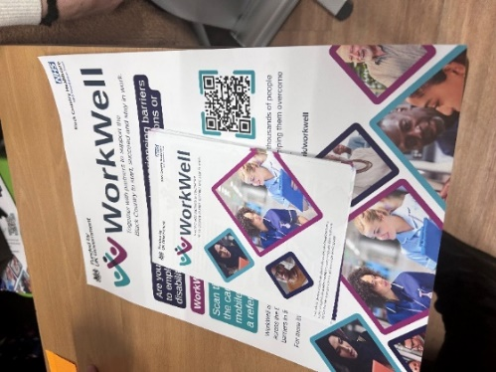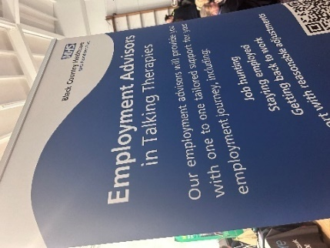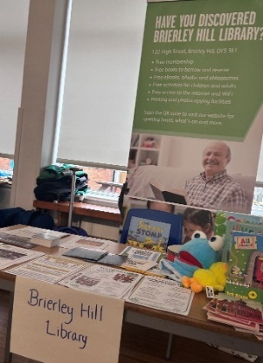
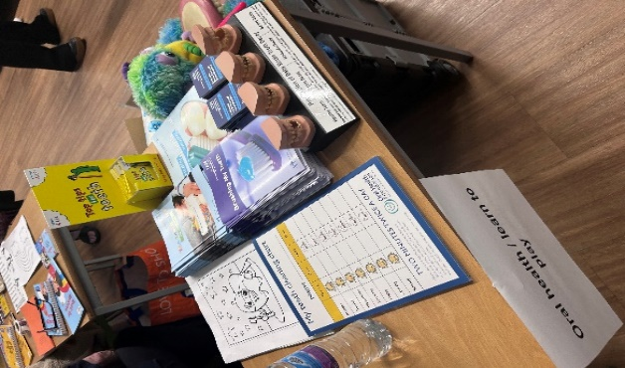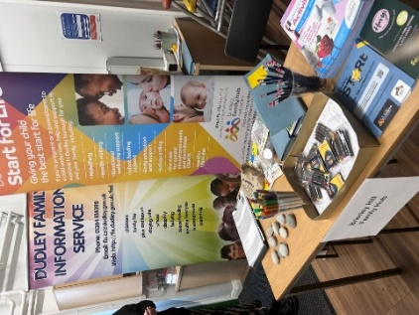

Funding
The event was funded from external funding streams:
- Connecting Health Communities (IVAR)
- the Shared Prosperity fund – communities and place
- Active Black Country (Commonwealth Active Communities) funded the activities specifically for children
- all raffle prizes were donated (with thanks to Dudley Zoo, Cllr Alex Dale, Director of Public Health, IVAR, Asda Brierley Hill).

Partner quotes & Press Release
Councillor James Clinton, the council's cabinet member for public health, said:
“I am delighted that the event was an outstanding success. It is testament to the community and partners that people have come together to showcase what there is to offer to support residents in Brockmoor and Pensnett.”
Diane Wake, chief executive at The Dudley Group NHS Foundation Trust, said:
“It was wonderful to see so many people come together to celebrate what makes our community special. This event has not only introduced residents to valuable resources but has also fostered new connections and partnerships that will benefit the area for years to come.”
Jason Griffiths, chief officer at Healthwatch, said:
“We’re really pleased to be a part of this community event. It is great to see so many local people coming along to share their experiences and hear more about what is available to them.”

Reflections & Questions
- A large number of attendees were families with children attending St Mark’s CofE Primary School.
- What can we do to engage more residents? Recruitment into the community champion role, appreciating it takes time to build trust and nurture relationships
- Do we want to replicate this model of event in other areas, or we do repeat, tag onto an existing community event (such as the Black Country Day)
- What was the most successful part of the day?
- What do we need to do differently next time?
- Do we need to target a different range of people?
- Do we need to change our communications strategy?
- What will we do as a follow up – a directory of the services that were available on the day with signposting to the DCID and access to digital if required?
- Any follow up activities with the schools- what would be their feedback on the work so far?
- Attendance at school fetes/fayres – we know this area is quite multi-generational?
- Which venue would provide a larger space and potentially engage families outside of the school?

Next steps – looking ahead
- We are keen to continue to listen to community members as to what they would like to see happen in the area and how they would like to engage
- Recruitment into the community champion role – the value of community champions should be emphasised as these community members will have a greater understanding of local needs and can provide support to build community resilience
- Community Researcher role to have a regular presence in the community to improve people’s awareness of the project and encourage involvement from the community
- Continue to focus on events to promote health and wellbeing and the support available to the community
- Partners to continue to work together and agree next steps for this innovative project

Thank you
A huge thank you and shoutout to everyone involved with the event. We couldn’t have done it without every individual involved. Thank you for being there, whether you were there to showcase your group or service or there to check them all out! We truly feel thankful to have such amazing support services who helped make this event a huge success!

Appendix 1 - Feedback from organisations/community groups, providers and services

