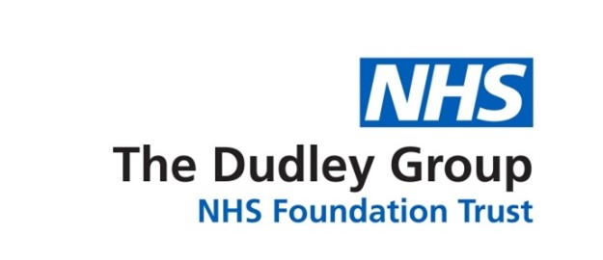

Workforce Disability Equality Standard Annual Report 2025

Definitions
- NHS – National Health Service
- AfC – Agenda for Change
- LTC – Long-term condition
- WDES – Workforce Disability Equality Standard

Introduction
The Workforce Disability Equality Standard (WDES) was launched in 2019 and aims to improve the workplace and career experiences of staff with disabilities in the NHS.
The Workforce Disability Equality Standard is a set of ten specific measures (Metrics) that will enable the Trust to compare the experiences of staff with disabilities and staff without. This information will then be used to develop action plans, allowing the organisation to demonstrate progress against the indicators of disability equality.
The Workforce Disability Equality Standard has been commissioned by the Equality and Diversity Council and mandated through the NHS Standard Contract.
Metrics 2 and 3 are calculated using a ‘times more likely’ formula. This calculation expresses the strength of the relationship between staff with disabilities and staff without. Metrics 5, 6, 7, 8, and 9a are based on staff survey results. As a Trust, we facilitate a full census of all staff; the 2024 staff survey had 49% participation.
One of the challenges in monitoring workforce disability within the NHS is that the definitions of disability used in the NHS Electronic Staff Record (ESR), NHS Staff Survey, and NHS Jobs differ. These definitions also vary from the legal definition of disability, as set out in the Equality Act 2010. Work is ongoing to align definitions of disability with the Equality Act’s definition and set up cross-system, agreed-upon disability question(s).
At The Dudley Group, we have a workforce of circa 6,000 staff. Our Electronic Staff Record (ESR) data shows that 6.4% of our workforce has declared themselves disabled. However, 26% of the workforce has not declared their disability status.
Data from the 2024 staff survey states that 27% of the respondents who completed the survey declared that they have a disability or long-term condition (1%, an increase from 2023). Therefore, ESR monitoring information is inaccurate, and action needs to be taken to encourage this staff to update their information. This is also a national issue.
The report provides an overview of key areas and should direct action; it has been used in previous years to focus on development areas.

Executive Summary
At The Dudley Group NHS Foundation Trust, we are committed to fostering an inclusive culture where all staff, regardless of disability or long-term condition, feel valued, supported, and empowered to thrive. This commitment is central to delivering high-quality care and building a resilient, innovative workforce.
The 2025 Workforce Disability Equality Standard (WDES) results reflect progress and areas requiring continued focus. While we have seen improvements in disability declaration rates, board-level representation, and access to reasonable adjustments, disparities persist in staff experience, particularly around harassment, career progression, and feeling valued.

Key Highlights from 2025:
- Workforce Representation: 6.4% of staff have declared a disability on the Electronic Staff Record (ESR), up from 6.1% in 2024. However, 25.9% of staff have not disclosed their status, indicating a need for continued awareness and trust-building.
- Recruitment: The relative likelihood of appointment for applicants with a disability improved slightly to 1.14, though a gap remains (14% appointment rate for applicants with a disability vs.16% without).
- Capability Process: In 2024, a small number of staff entered the formal capability process, which skewed this metric to the following: Staff with disabilities are 10.63 times more likely to enter the capability process. In context, this only represents 0.12% of staff with disabilities and 0.01% of staff without.
- Harassment and Bullying: Staff with long-term conditions continue to report higher rates of bullying and abuse, particularly from patients and colleagues, compared to those without. However, reporting rates have improved.
- Career Progression: 56.1% of staff with a long-term condition believe they have equal opportunities for progression, narrowing the gap between them and staff without to 4.4%.
- Presenteeism: Fewer staff with a long-term condition reported feeling pressured to work while unwell (28.5%, down from 32%), suggesting progress in wellbeing support.
- Feeling Valued: Only 33.2% of staff with a long-term condition feel valued by the organisation, compared to 43.2% of non-disabled staff, a gap that remains a key concern.
- Reasonable Adjustments: 72.4% of staff with a long-term condition reported receiving reasonable adjustments, maintaining the improvement seen in 2023.
- Board Representation: 9.5% of board members declared a disability in 2025, up from 6% in 2024, reflecting progress in leadership diversity.
These findings underscore the importance of sustained, targeted action. Our refreshed WDES action plan focuses on inclusive leadership, equitable recruitment and development, psychological safety, and a zero-tolerance approach to discrimination and harassment.
We remain steadfast in our mission to create a workplace where every individual, regardless of disability or health condition, can thrive, contribute meaningfully, and feel proud to be part of our organisation.

It is important to note that a short while before the NHS Staff Survey 2023 was due to be published, a potential problem was discovered with the data for some of the questions. Statistical techniques have been used to compensate for the problem results, and the data for question 14 have been modified from those published previously. This means the data comparisons for 2023 are different to the previous published report. For more information, please see Survey Coordination Centres guidance: Survey documents related to conducting the survey | NHS Staff Survey

Annual Submission Measures
The Workforce Disability Equality Standard (WDES) is a set of ten specific measures (metrics) which enable NHS organisations to compare the workplace and career experiences of disabled and non-disabled staff.
The Workforce Disability Equality Standard provides a high-level view, we have therefore completed a more detailed analysis to inform our conclusions and actions plans.
Workforce Disability Equality Standard Metrics:
1. Workforce Representation
2. Recruitment
3. Capability
4. Harassment, Bullying and Abuse from Patients / Public, Managers and other Colleagues
5. Career Progression
6. Feeling pressure to come to work
7. Value of work
8. Adequate Adjustments
9. Engagement score
10. Board Representation

Workforce Disability Equality Standard Overview
Over the past 5 years, we have undertaken a detailed analysis of our Workforce Disability Equality Standard metrics. The chart below summarises our performance and provides a trend analysis from 2020 to 2025 on all ten metrics. Appendix 1 provides this breakdown in an accessible version.
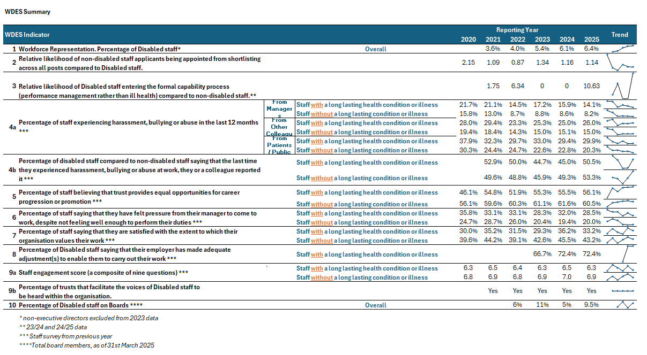
Note: staff survey metrics are 1 year behind submission year; 2025 data shown in this table is 2024 staff survey metrics.

Metric 1 & 9 – Overall Disability Representation
Over the last three years, The Dudley Group has actively promoted the importance of declaring disabilities. The chart below illustrates the increasing number of staff opting to declare their disability on the electronic staff record, rising from 4% in 2021 to 6.4% in 2025. 9.5% of board members declared a disability in 2025, an increase from 6% in 2024
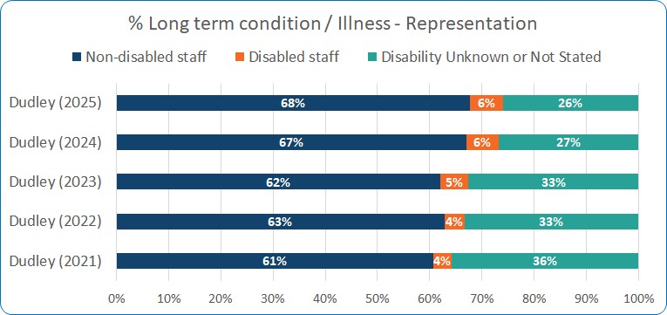

Metric 1 – Disability Representation Across the Workforce
Monitoring disability representation across different pay bands in the NHS is crucial to ensure equitable career progression and opportunities for staff with disabilities. By tracking this data, the organisation can identify any disparities in representation, provide targeted support, and address potential barriers to career advancement at all levels. This analysis is key to fostering an inclusive and fair workplace where all employees, regardless of disability, have equal access to growth and development opportunities.
The graph below highlights the distribution of staff with disabilities across various pay bands within The Dudley Group NHS Foundation Trust (DGFT)
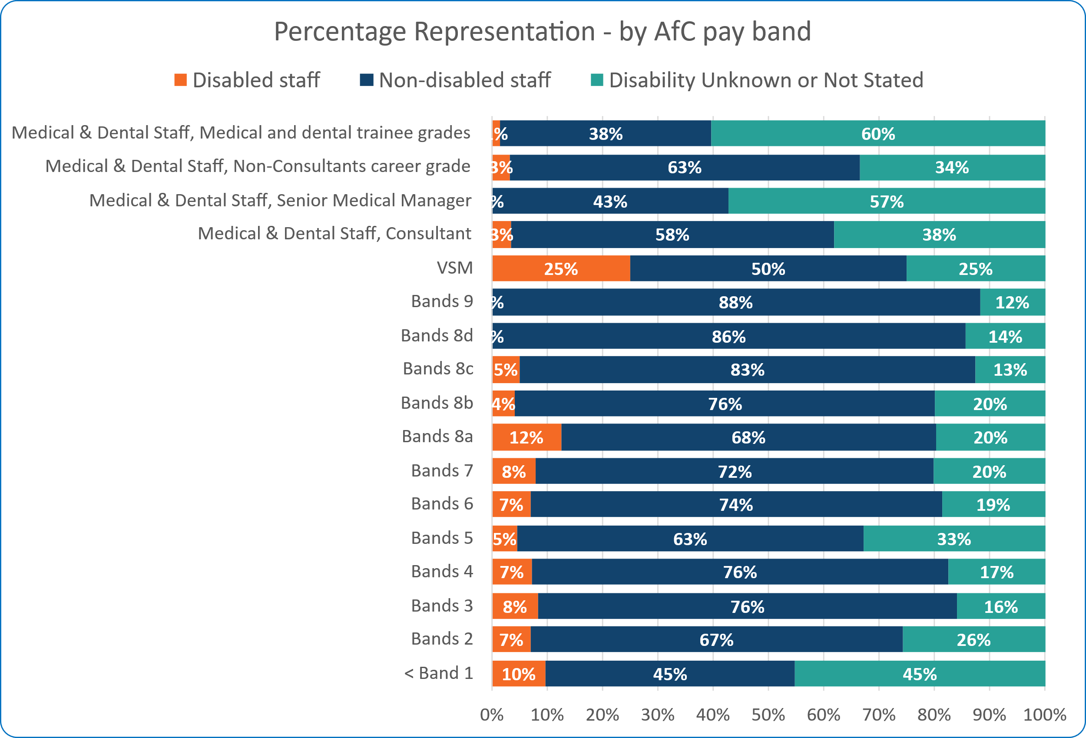

The data reveals a significant disparity in the representation of staff with disabilities across AfC pay bands. While representation is more evident in the lower bands, it declines at senior levels, compounded by a high proportion of 'Not Stated/Unknown' responses at these grades.
This trend indicates a progression gap for staff with disabilities, or a possible reluctance to disclose disability status as individuals move into more senior roles. It highlights the urgent need for targeted action to improve disclosure rates and equity in career development and leadership progression, ensuring that promotion processes are fully inclusive and talented individuals are supported and retained at every level of the organisation.

Metric 2 – Relative likelihood of non-disabled staff being appointed from shortlisting compared to Disabled staff
A value of 1.0 would indicate equal rates of appointment. The relative likelihood of an applicant with a disability being appointed after shortlisting is 1.14, slightly improving from 1.16 in 2024 and 1.34 in 2023. Of the applicants with disabilities, 14% were appointed following shortlisting, compared to 16% without a disability.

Values | Disabled Staff | Non-Disabled Staff | Not Disclosed / Unknown | Grand Total
Number of Shortlisted Applicants | 392 | 4290 | 110 | 4792
Number Appointed from Shortlisting | 54 | 674 | 18 | 746
Relative Likelihood of appointment from shortlisting | 14% | 16% | 16% | 16%
Relative likelihood of non-disabled staff being appointed from shortlisting compared to Disabled staff | 1.14

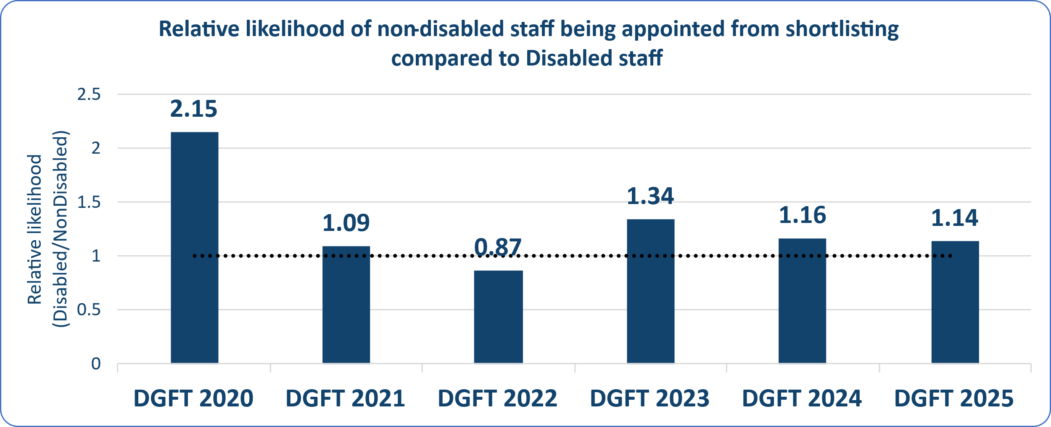

Metric 3 - The relative likelihood of disabled staff entering the formal capability process compared to non-disabled staff
Capability count based on the last 2 years of data.
This metric is usually reported as a ‘times more likely’ calculation to measure if staff with disabilities are more likely than those without to enter the formal capability process.
In 2024, a small number of staff entered the formal capability process, skewing this metric. To understand this measure, we have converted the metric into a percentage: 0.12% of staff with disabilities and 0.01% of staff without disabilities entered the capability procedure.
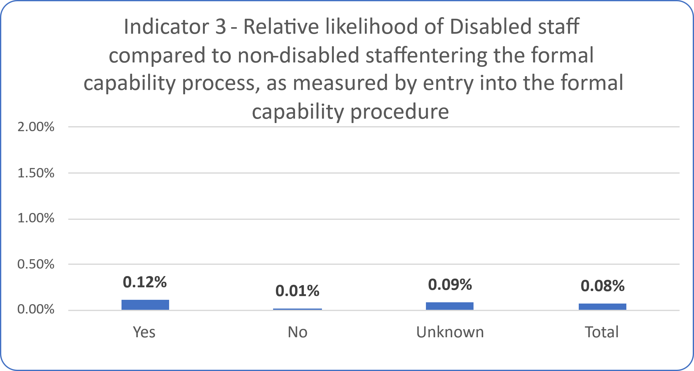

Metric 4 - Percentage of staff experiencing harassment, bullying or abuse from patients/service users, their relative or the public
In 2024, 29.86% of staff with a long-term condition or illness reported experiencing harassment, bullying, or abuse from patients or the public, remaining consistent with the 2023 figures. In comparison, 20.31% of staff without a long-term condition or illness experienced similar incidents, marking a 2.5% decrease from 2023.
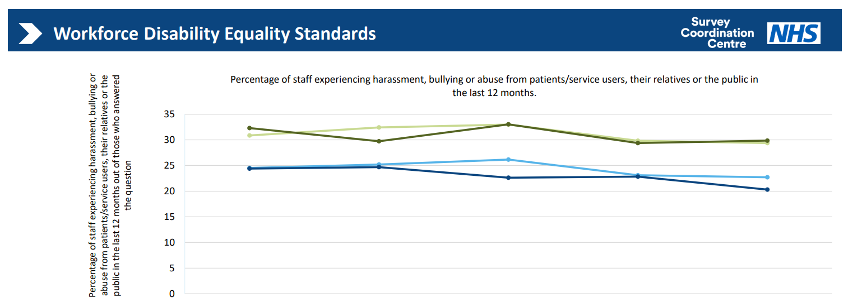

Table 1: Workforce Disability Equality Data for Metric 4 from 2020 to 2024.
Staff group | 2020 | 2021 | 2022 | 2023 | 2024
Staff with a LTC or illness DGFT | 32.30% | 29.73% | 33.02% | 29.38% | 29.86%
Staff without a LTC or illness DGFT | 24.39% | 24.68% | 22.62% | 22.83% | 20.31%
Staff with a LTC or illness average | 30.86% | 32.43% | 32.98% | 29.83% | 29.37%
Staff without a LTC or illness average | 24.53% | 25.19% | 21.16% | 23.11% | 22.71%
Staff with a LTC or illness responses | 418 | 676 | 639 | 676 | 777
Staff without a LTC or Illness responses | 1722 | 2285 | 2078 | 1758 | 2093

Metric 4 - Percentage of staff experiencing harassment, bullying or abuse from managers
Harassment, bullying, or abuse from managers towards staff with a long-term condition or illness has decreased by 1.75% (from 15.87% in 2023 to 14.12% in 2024). The gap between the experiences of staff with long-term conditions and those without has narrowed to 5.9%, compared to 7.6% in 2023.
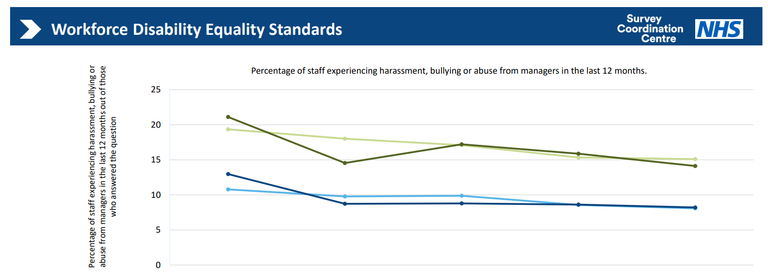

Table 2: Workforce Disability Equality Data for Metric 4 from 2020 to 2024.
Staff group | 2020 | 2021 | 2022 | 2023 | 2024
Staff with a LTC or illness DGFT | 21.10% | 14.54% | 17.21% | 15.87% | 14.12%
Staff without a LTC or illness DGFT | 12.97% | 8.72% | 8.79% | 8.62% | 8.21%
Staff with a LTC or illness average | 19.35% | 18% | 17.09% | 15.33% | 15.10%
Staff without a LTC or illness average | 10.78% | 3.77% | 9.88% | 8.56% | 8.08%
Staff with a LTC or illness responses | 417 | 674 | 639 | 671 | 772
Staff without a LTC or Illness responses | 1720 | 2281 | 2071 | 1740 | 2071

Metric 4 - Percentage of staff experiencing harassment, bullying or abuse from other colleagues
In 2024, 25.95% of staff with a long-term condition or illness reported experiencing harassment, bullying, or abuse from colleagues, maintaining the same level as the previous year. In comparison, 15.03% of staff without a long-term condition or illness faced similar incidents, which remained unchanged from 2023.

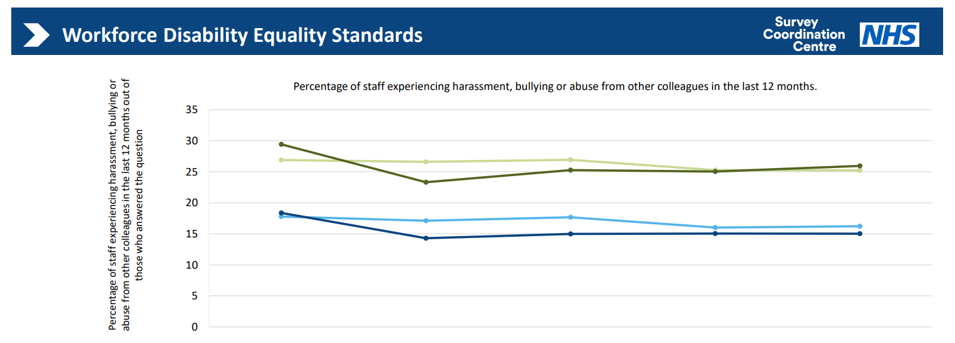
Table 3: Workforce Disability Equality Data for Metric 4 from 2020 to 2024.
Staff group | 2020 | 2021 | 2022 | 2023 | 2024
Staff with a LTC or illness DGFT | 29.43% | 23.32% | 25.28% | 25.04% | 25.95%
Staff without a LTC or illness DGFT | 18.37% | 14.29% | 14.98% | 15.05% | 15.03%
Staff with a LTC or illness average | 26.89% | 26.60% | 26.93% | 25.26% | 25.24%
Staff without a LTC or illness average | 17.79% | 17.11% | 17.67% | 16.01% | 16.22%
Staff with a LTC or illness responses | 418 | 669 | 633 | 665 | 763
Staff without a LTC or Illness responses | 1720 | 2267 | 2063 | 1728 | 2063

Metric 4 - Percentage of staff saying that the last time
they experienced harassment, bullying or abuse at work, they or a colleague reported it
In 2024, 50.46% of staff with a long-term condition or illness reported that they had reported the last incident of harassment, bullying, or abuse they experienced at work, reflecting an increase of 5.5%. Similarly, the reporting rate for staff without a long-term condition or illness also improved by 4%.
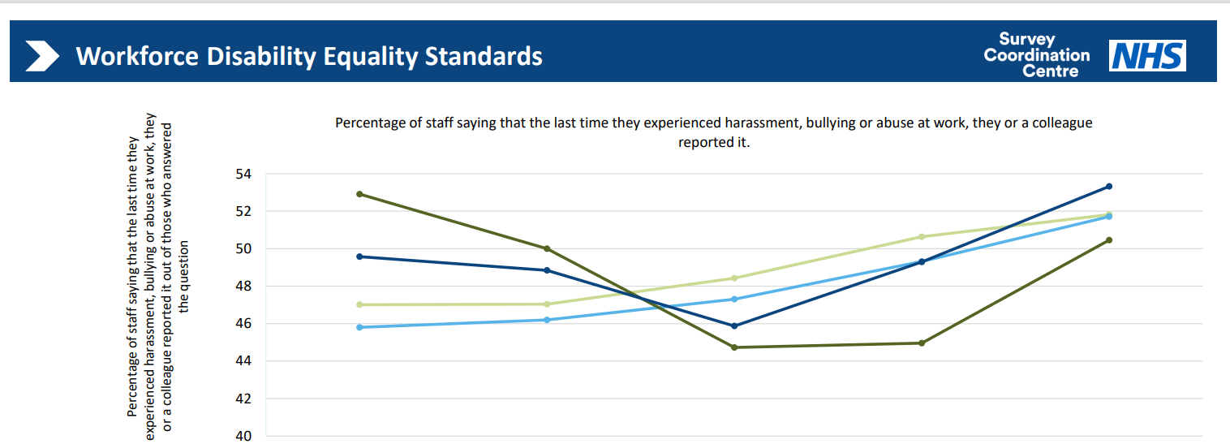
Table 4: Workforce Disability Equality Data for Metric 4 from 2020 to 2024.
Staff group | 2020 | 2021 | 2022 | 2023 | 2024
Staff with a LTC or illness DGFT | 52.91% | 50% | 44.73% | 44.96% | 50.46%
Staff without a LTC or illness DGFT | 49.57% | 48.84% | 45.87% | 49.29% | 53.32%
Staff with a LTC or illness average | 47.01% | 47.03% | 48.43% | 50.64% | 51.82%
Staff without a LTC or illness average | 45.80% | 46.20% | 47.30% | 49.31% | 51.71%
Staff with a LTC or illness responses | 206 | 274 | 275 | 279 | 327
Staff without a LTC or Illness responses | 587 | 692 | 593 | 484 | 557

Metric 5 - Percentage of staff believing that their organisation provides equal opportunities for career progression or promotion.
In 2024, there was a 0.6% improvement in perceptions of equal opportunities for career progression or promotion. Among staff with a long-term condition or illness, 56.10% felt they had equal opportunities, compared to 60.46% of staff without a long-term condition or illness, narrowing the gap between the two groups by 4.36%

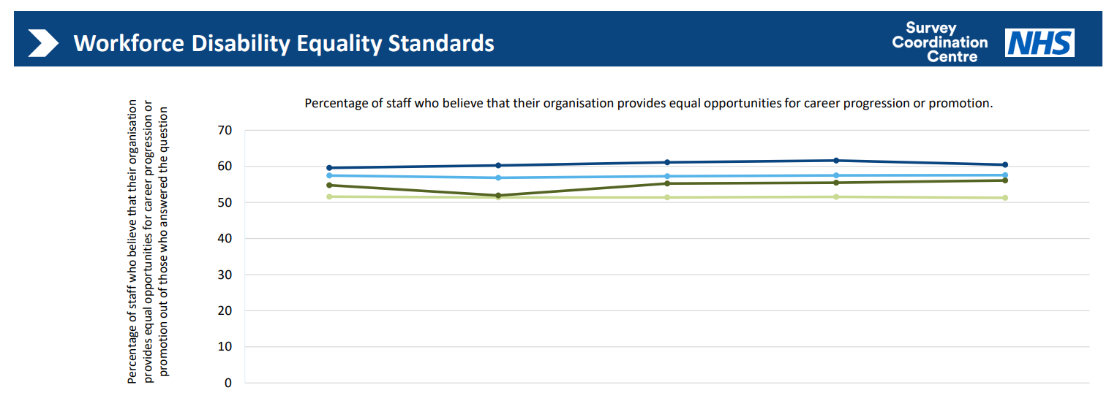
Table 5: Workforce Disability Equality Data for Metric 5 from 2020 to 2024.
Staff group | 2020 | 2021 | 2022 | 2023 | 2024
Staff with a LTC or illness DGFT | 54.78% | 51.95% | 55.26% | 55.48% | 56.10%
Staff without a LTC or illness DGFT | 59.59% | 60.25% | 61.10% | 61.62% | 60.46%
Staff with a LTC or illness average | 51.61% | 51.41% | 51.39% | 51.54% | 51.30%
Staff without a LTC or illness average | 57.45% | 56.84% | 57.25% | 57.52% | 57.57%
Staff with a LTC or illness responses | 429 | 693 | 637 | 721 | 770
Staff without a LTC or Illness responses | 1762 | 2355 | 2077 | 1910 | 2084

Metric 6 - Percentage of staff who have felt pressure from their manager to come to work, despite not feeling well enough to perform their duties.

In the 2024 survey, 28.55% of staff with a long-term condition or illness reported experiencing presenteeism, a decrease from 32% in the previous year. In comparison, 20% of staff without a long-term condition or illness felt pressure from their manager to come to work despite not being well enough, further narrowing the gap by 8.5%.
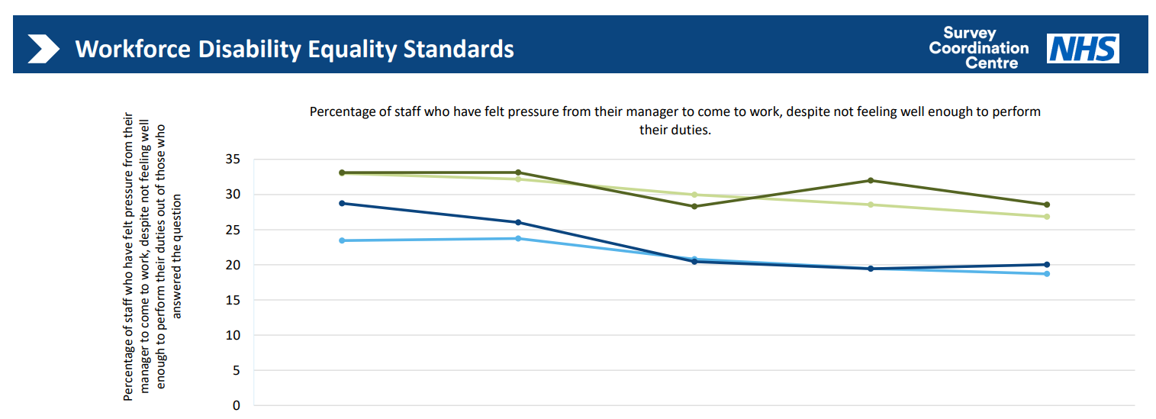

Table 6: Workforce Disability Equality Data for Metric 6 from 2020 to 2024.
Staff group | 2020 | 2021 | 2022 | 2023 | 2024
Staff with a LTC or illness DGFT | 33.11% | 33.13% | 28.30% | 31.98% | 28.55%
Staff without a LTC or illness DGFT | 28.74% | 26.03% | 20.45% | 19.44% | 20.04%
Staff with a LTC or illness average | 33% | 32.18% | 29.97% | 28.55% | 26.85%
Staff without a LTC or illness average | 23.44% | 23.74% | 20.80% | 19.46% | 18.71%
Staff with a LTC or illness responses | 305 | 504 | 470 | 494 | 571
Staff without a LTC or Illness responses | 842 | 1218 | 1076 | 962 | 1058

Metric 7 - Percentage of staff satisfied with the extent to which their organisation values their work.
33.25% of staff with a long-term condition or illness feel valued by the organisation, compared to 43.23% of staff without a long-term condition or illness. Rates for both staff groups have decreased in 2024.
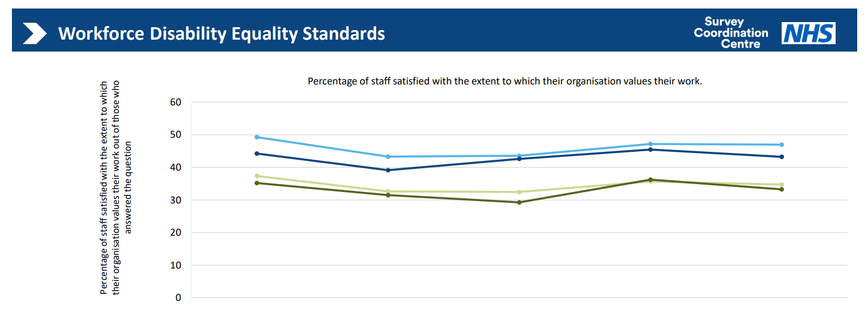
Table 7: Workforce Disability Equality Data for Metric 7 from 2020 to 2024.
Staff group | 2020 | 2021 | 2022 | 2023 | 2024
Staff with a LTC or illness DGFT | 35.19% | 31.47% | 29.26% | 36.24% | 33.25%
Staff without a LTC or illness DGFT | 44.24% | 39.15% | 42.60% | 45.47% | 43.23%
Staff with a LTC or illness average | 37.36% | 32.62% | 32.46% | 35.66% | 34.73%
Staff without a LTC or illness average | 49.27% | 43.30% | 43.56% | 47.19% | 46.98%
Staff with a LTC or illness responses | 432 | 699 | 639 | 723 | 776
Staff without a LTC or Illness responses | 1781 | 2373 | 2087 | 1920 | 2096

Metric 8 - Percentage of staff with a long-lasting health condition or illness saying their employer has made reasonable adjustments to enable them to carry out work.
The percentage of staff with a long-term condition or illness reporting that their employer has made reasonable adjustments to support them in their work has remained steady at 72.45% each year. Notably, there was a significant increase in 2022, rising from 66.7% to 72.4%.
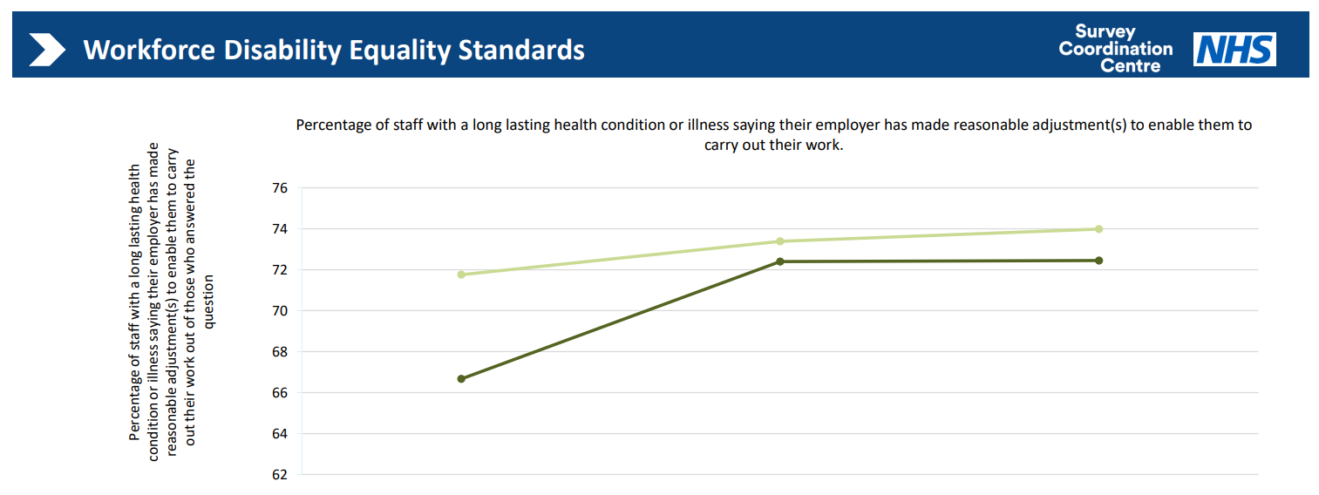

Table 8: Workforce Disability Equality Data for Metric 8 from 2020 to 2024.
Staff group | 2022 | 2023 | 2024
Staff with a LTC or illness DGFT | 66.67% | 72.40% | 72.45%
Staff with a LTC or illness average | 71.76% | 73.38% | 73.98%
Staff with a LTC or illness responses | 381 | 442 | 490

Metric 9a – Staff engagement score (0-10)
The Staff Engagement score has fluctuated slightly over the past 5 years. Both staff groups have seen a decrease in 2024. Staff with a long-term condition or illness is 6.32, whilst staff without a long-term condition or illness is 6.87, a variance of 0.55.

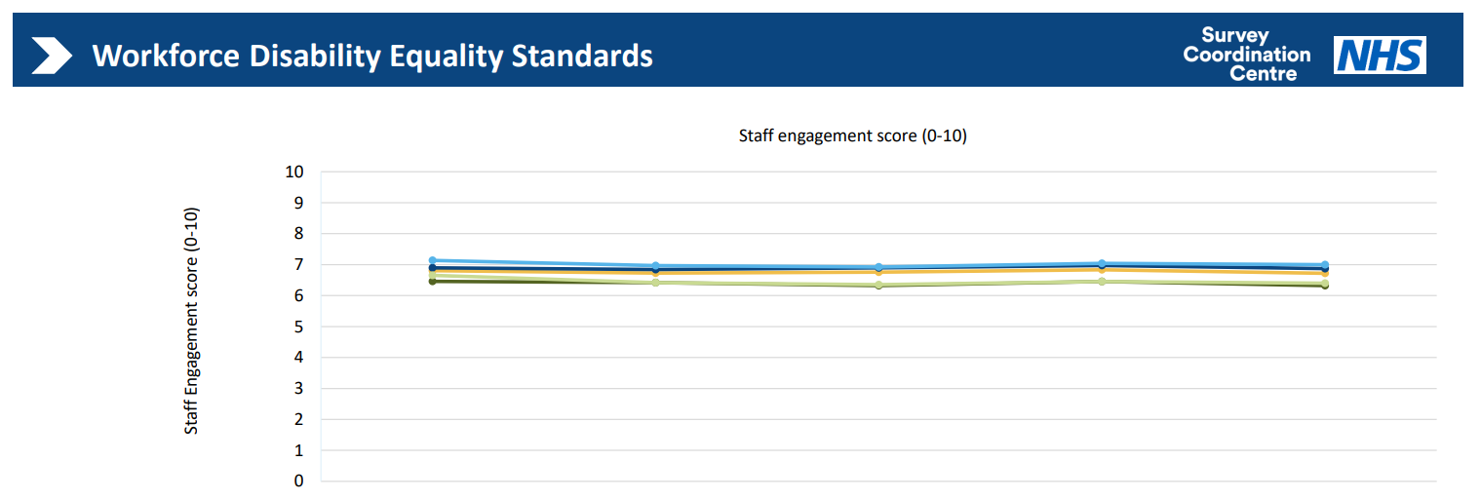

Table 9: Workforce Disability Equality Data for Metric 9a from 2020 to 2024.
Staff group | 2020 | 2021 | 2022 | 2023 | 2024
Organisation average | 6.81 | 6.73 | 6.76 | 6.83 | 6.72
Staff with a LTC or illness DGFT | 6.46 | 6.42 | 6.32 | 6.46 | 6.32
Staff without a LTC or illness DGFT | 6.90 | 6.84 | 6.90 | 6.97 | 6.87
Staff with a LTC or illness average | 6.65 | 6.42 | 6.35 | 6.46 | 6.40
Staff without a LTC or illness average | 7.14 | 6.97 | 6.92 | 7.04 | 7.00
Staff with a LTC or illness responses | 432 | 699 | 641 | 726 | 781
Staff without a LTC or Illness responses | 1785 | 2378 | 2094 | 1932 | 2100

Metric 9b – How the organisation facilitates the voices of staff with disabilities
Over the past 12 months, we have made significant strides in increasing the visibility of our Disability & Long-term Conditions Staff Network. The Network has been dedicated to raising awareness about disabilities and long-term conditions, highlighting available support, and encouraging staff to share their experiences. By doing so, we aim to implement meaningful actions that enhance their working lives and help us achieve our strategic goal of being a brilliant place to work and thrive.
We have continued with our ‘This is Who I Am’ initiative, collaborating with the Electronic Staff Record (ESR) team to encourage staff with disabilities and long-term conditions to share or update their equality status. As a result, we have seen progress, with the disclosure rate now at 6.4% and a reduction in our nondisclosure rate to 25%. Our ongoing aim is to deepen our understanding of staff demographics, ensuring we can provide the necessary information, support, and services.
In 2024, we were reassessed by the Employers Network for Equality and Inclusion (enei) for the Disability Confident scheme, and we are pleased to have maintained our Disability Confident Leader status. Additionally, we retained our gold status with enei for the Talent Inclusion & Diversity Evaluation (TIDE) Mark for 2024.
We also partnered with Dudley Council in 2024 to launch the ICAN programme, which offers paid work placements funded by the Commonwealth Games Legacy Fund. The programme saw 30 participants, 43% of whom had disabilities. Through this initiative, we have targeted young people leaving care and individuals with disabilities. The pilot was highly successful, and we have secured additional funding to support further placements.

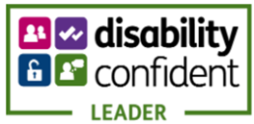

Conclusion
The 2025 Workforce Disability Equality Standard (WDES) data reflect our ongoing commitment to improving the experiences of staff with disabilities and long-term conditions across The Dudley Group NHS Foundation Trust. While we have made meaningful progress in several areas, including disability declaration rates, board-level representation, and access to reasonable adjustments, significant challenges remain.
Staff with long-term conditions continue to report disproportionately high levels of bullying, harassment, and abuse, particularly from patients, the public, and colleagues. Although managerial behaviours have improved and reporting rates have increased, these experiences highlight persistent cultural issues that must be addressed. Trust in organisational processes and psychological safety must be strengthened to ensure all staff feel safe and supported.
Encouragingly, perceptions of equal opportunity for career progression have improved slightly, and presenteeism has declined. However, only one in three staff members with long-term conditions feel valued by the organisation, and engagement scores remain lower than those of their non-disabled peers. These findings point to a need for more profound cultural change and more visible recognition of the contributions of disabled staff.
The increase in board-level disability representation is a positive step, signalling our commitment to inclusive leadership. Initiatives such as the “This is Who I Am” campaign and the success of the ICAN programme demonstrate the power of targeted, inclusive action.
Looking ahead, our focus must remain on embedding equity into every aspect of the employee experience from recruitment and development to wellbeing and leadership. By listening to our staff, acting on their feedback, and holding ourselves accountable, we will continue to build a workplace where everyone can thrive, contribute meaningfully, and feel proud to belong.

Action Planning
As part of our ongoing commitment to advancing disability equality, The Dudley Group NHS Foundation Trust has developed a focused action plan aligned with the Workforce Disability Equality Standard (WDES). This plan addresses the disparities identified in our 2025 data and supports our broader Equality, Diversity, and Inclusion (EDI) Workforce Journey (2023–2025).
Our approach is holistic, evidence-based, and rooted in lived experience. It aims to create a workplace where disabled staff and those with long-term conditions feel safe, supported, and empowered to thrive. Below is a summary of our short, medium and long terms actions, our detailed action plan can be viewed here: EDI Journey Actions

Short-Term Goals (0–6 months) - Actions to build awareness and lay the foundation:

Disability Representation & Recruitment Equity
  - Continue to promote the “This is Who I Am” campaign and support updating disability status on ESR.
  - Continue to train all recruiting managers on inclusive recruitment.
  - Continue to apply the Disability Confident scheme for interviews.
  - Encourage leaders to talk openly about wellbeing.
Capability Process
  - Continue to focus on early support and coaching, not formal processes.
Harassment & Discrimination
  - Reinforce “Zero Tolerance” in patient areas.
  - Research real-time reporting tools.
  - Train managers on inclusion and conflict resolution.
Career Progression & Staff Experience
  - Promote leadership programmes with staff with disabilities.
  - Celebrate Disability History Month.
  - Share staff stories and lived experiences.
Presenteeism & Reasonable Adjustments
  - Continue to train managers on compassionate sickness management.
  - Support and train managers on how to provide effective adjustments.

Medium-Term Goals (6–18 months) - Embed practices and expand support
Disability Representation & Recruitment Equity
  - Train managers to talk supportively about disability.
  - Ensure diverse panels for senior roles.
  - Monitor recruitment data and address unfair outcomes.
  - Set targets for disability representation at senior levels.
Harassment & Discrimination
  - Increase visibility of Wellbeing Champions and Speak Up Guardians.
  - Track and monitor inclusion goals from managers’ appraisals.
Career Progression
  - Increase and promote inclusive mentoring and sponsorship programme.
  - Review promotion processes for fairness.
Presenteeism & Reasonable Adjustments
  - Promote flexible working and phased returns.
  - Build a culture where it’s okay to take time off when unwell.
Staff Experience & Staff Voice
  - Involve disabled staff in designing engagement activities.
  - Run regular staff forums to hear staff concerns.

Long Term Goals (18+ months) - Drive cultural change and long-lasting impact
Disability Representation & Recruitment Equity
  - Normalise self-disclosure through the appraisal process with leadership support.
  - Fully embed inclusive recruitment practices across the organisation.
  - Review Board leadership pipelines to ensure accessibility and inclusion.
Capability Process
  - Make coaching-first support the standard approach.
Harassment & Discrimination
  - Build long-term partnerships with communities to promote respect.
Career Progression
  - Ensure internal opportunities are inclusive and accessible.
Presenteeism & Reasonable Adjustments
  - Create a lasting culture that prioritises health and well-being.
  - Roll out the centralise adjustments process to encompass all adjustments.
Staff Experience
  - Make recognition and inclusion part of everyday culture.

These actions are designed to drive meaningful change and ensure that all staff, regardless of disability or health condition, can thrive in a safe, inclusive, and supportive environment. As part of our commitment to continuous improvement, our progress will be regularly reviewed and transparently reported.

Appendix 1 – Workforce Disability Equality Standard Metrics summary 2020-2025
Workforce Disability Equality Standard Metrics |  |  |  | Reporting Year
 |  |  |  | 2020 | 2021 | 2022 | 2023 | 2024 | 2025
1 | Workforce Representation. Percentage of Disabled staff* |  | Overall |  | 3.6% | 4.0% | 5.4% | 6.1% | 6.4%
2 | Relative likelihood of non-disabled staff applicants being appointed from shortlisting across all posts compared to Disabled staff. |  |  | 2.15 | 1.09 | 0.87 | 1.34 | 1.16 | 1.14
3 | Relative likelihood of Disabled staff entering the formal capability process (performance management rather than ill health) compared to non-disabled staff.** |  |  |  | 1.75 | 6.34 | 0 | 0 | 10.63
4a | Percentage of staff experiencing harassment, bullying or abuse in the last 12 months *** | From Managers | Staff with a long lasting health condition or illness | 21.7% | 21.1% | 14.5% | 17.2% | 15.9% | 14.1%
4a |  | From Managers | Staff without a long lasting condition or illness | 15.8% | 13.0% | 8.7% | 8.8% | 8.6% | 8.2%
4a |  | From Other Colleagues | Staff with a long lasting health condition or illness | 28.0% | 29.4% | 23.3% | 25.3% | 25.0% | 26.0%
4a |  | From Other Colleagues | Staff without a long lasting condition or illness | 19.4% | 18.4% | 14.3% | 15.0% | 15.1% | 15.0%
4a |  | From Patients / Public | Staff with a long lasting health condition or illness | 37.9% | 32.3% | 29.7% | 33.0% | 29.4% | 29.9%
4a |  | From Patients / Public | Staff without a long lasting condition or illness | 30.3% | 24.4% | 24.7% | 22.6% | 22.8% | 20.3%
4b | Percentage of disabled staff compared to non-disabled staff saying that the last time they experienced harassment, bullying or abuse at work, they or a colleague reported it *** |  | Staff with a long lasting health condition or illness |  | 52.9% | 50.0% | 44.7% | 45.0% | 50.5%
4b |  |  | Staff without a long lasting condition or illness |  | 49.6% | 48.8% | 45.9% | 49.3% | 53.3%
5 | Percentage of staff believing that trust provides equal opportunities for career progression or promotion *** |  | Staff with a long lasting health condition or illness | 46.1% | 54.8% | 51.9% | 55.3% | 55.5% | 56.1%
5 |  |  | Staff without a long lasting condition or illness | 56.1% | 59.6% | 60.3% | 61.1% | 61.6% | 60.5%
6 | Percentage of staff saying that they have felt pressure from their manager to come to work, despite not feeling well enough to perform their duties *** |  | Staff with a long lasting health condition or illness | 35.8% | 33.1% | 33.1% | 28.3% | 32.0% | 28.5%
6 |  |  | Staff without a long lasting condition or illness | 24.7% | 28.7% | 26.0% | 20.4% | 19.4% | 20.0%
7 | Percentage of staff saying that they are satisfied with the extent to which their organisation values their work *** |  | Staff with a long lasting health condition or illness | 30.0% | 35.2% | 31.5% | 29.3% | 36.2% | 33.2%
7 |  |  | Staff without a long lasting condition or illness | 39.6% | 44.2% | 39.1% | 42.6% | 45.5% | 43.2%
8 | Percentage of Disabled staff saying that their employer has made adequate adjustment(s) to enable them to carry out their work *** |  | Staff with a long lasting health condition or illness |  |  |  | 66.7% | 72.4% | 72.4%
9a | Staff engagement score (a composite of nine questions) *** | ` | Staff with a long lasting health condition or illness | 6.3 | 6.5 | 6.4 | 6.3 | 6.5 | 6.3
9a | Staff engagement score (a composite of nine questions) *** |  | Staff without a long lasting condition or illness | 6.8 | 6.9 | 6.8 | 6.9 | 7.0 | 6.9
9b | Percentage of trusts that facilitate the voices of Disabled staff to  be heard within the organisation. |  |  |  | Yes | Yes | Yes | Yes | Yes
10 | Percentage of Disabled staff on Boards **** |  | Overall |  |  | 6% | 11% | 5% | 9.5%
Note: staff survey metrics are 1 year behind submission year; 2025 data shown in this table is 2024 staff survey metrics.
This table is an accessible version of the chart on page 8.

