

Workforce Race Equality Standard Annual Report 2025

Definitions
- BME - Black and Minority Ethnic: As a Trust, we are moving away from using the term Black and Minority Ethnic (BME) or Black, Asian, Minority Ethnic (BAME). Instead, with full support from our EmbRACE Staff Network, we will use the term ‘ethnically diverse’ or refer directly to ethnicity or nationality. The data sets in this report compare the experience of Black and Minority Ethnic (BME) staff to White staff; however, our narrative will always avoid these acronyms where possible.
- NHS – National Health Service
- WRES - Workforce Race Equality Standard
- CPD – Continuous Professional Development

Introduction
The Workforce Race Equality Standard (WRES), introduced in 2016, aims to improve the workplace and career experiences of staff from ethnically diverse backgrounds across the NHS. It comprises nine specific metrics that enable NHS organisations to compare the experiences of ethnically diverse staff with those of white staff, helping to identify disparities and drive meaningful change.
This report presents The Dudley Group NHS Foundation Trust’s performance against the WRES metrics for 2025. It highlights key trends, areas of progress, and ongoing challenges, and informs our strategic actions to advance racial equity across the organisation.
Data from our Electronic Staff Record (ESR) and the NHS Annual Staff Survey are used to compile the data sets, meaning that the language used to describe staff groups differ.
The WRES is mandated through the NHS Standard Contract and overseen by the Equality and Diversity Council. Metrics 5 to 8 are derived from the NHS Staff Survey. In 2024, 49% of our workforce participated in the survey, with 24.8% of responses from ethnically diverse staff.
Our workforce comprises approximately 6,000 staff. As of March 2025, 29% of our colleagues identify as belonging to an ethnic group other than white, a 1.5 percentage point increase from the previous year. The proportion of staff who have not disclosed their ethnicity has decreased to 7%, reflecting improved data completeness and trust in our reporting processes.

Executive Summary
At The Dudley Group, we are committed to fostering an inclusive culture where diversity is valued, championed, and embedded at every level. We believe a diverse and engaged workforce is essential to delivering high-quality, compassionate care and driving innovation across our services.
The 2025 Workforce Race Equality Standard (WRES) results reflect progress and persistent challenges. While representation of staff from ethnically diverse backgrounds has increased, disparities remain in recruitment, disciplinary processes, access to development, and senior leadership representation.

Key Highlights:
Improved measures in 2025
- Workforce Representation: Staff from ethnically diverse backgrounds now comprise 29% of our workforce, with undeclared ethnicity reducing from 9% to 7%.
- Disciplinary: Staff from ethnically diverse backgrounds are 1.51 times more likely to enter formal disciplinary processes than white colleagues.
- Internal Bullying: Reports declined for both groups, with a 2.7% drop among staff from ethnically diverse backgrounds.
- Discrimination: Reports of discrimination from managers or colleagues slightly declined but remain significantly higher for staff from ethnically diverse background (18.3% vs. 5.7%).

Declined measures in 2025
- Recruitment: Applicants who are white remain 1.55 times more likely to be appointed from shortlisting than applicants from ethnically diverse backgrounds (19% vs.12%).
- Development Access: Staff from a white background are 1.28 times more likely to access non-mandatory training and CPD.
- Harassment from the Public: Reports increased among staff from ethnically diverse backgrounds (27%) and decreased among staff from a white background (21.67%).
- Career Progression: Perceptions of equal opportunity remain unchanged at 51.8% for staff from ethnically diverse backgrounds, with a 10.3% gap compared to staff from a white background.
- Board Representation: Ethnic diversity at Board level fell to 9.5%, well below the 29% workforce benchmark.
These findings underscore the importance of sustained, targeted action. Our refreshed WRES action plan focuses on inclusive leadership, equitable recruitment and development, and a zero-tolerance approach to discrimination and harassment.
We remain steadfast in our commitment to creating a workplace where everyone feels valued, supported, and empowered to thrive. This report is a key step toward a fairer, more inclusive future for all.

It is important to note that a short while before the NHS Staff Survey 2023 was due to be published, a potential problem was discovered with the data for some of the questions. Statistical techniques have been used to compensate for the problem results, and the data for question 14 have been modified from those published previously. This means the data comparisons for 2023 are different to the previous published report. For more information, please see Survey Coordination Centres guidance: Survey documents related to conducting the survey | NHS Staff Survey

Annual Submission Measures
The Workforce Race Equality Standard is a set of nine specific measures which enable NHS organisations to compare the workplace and career experiences of ethnically diverse staff (Black and Minority Ethic - BME) and White staff.
The Measures provide a high-level view; we have therefore completed a more detailed analysis to inform our conclusions and action plans.
Workforce Race Equality Standard Metrics:
1. Workforce Representation
2. Recruitment
3. Disciplinary
4. Training and Continuing Professional Development (CPD)
5. Harassment, Bullying and Abuse from Patients / Public
6. Harassment, Bullying and Abuse from Staff
7. Career Progression
8. Discrimination
9. Board Representation

Workforce Race Equality Standard Overview
Over the past 5 years, we have undertaken a detailed analysis of our Workforce Race Equality Standard metrics. The chart below summarises our performance and provides a trend analysis from 2020 to 2025 on all nine metrics. Appendix 1 provides this breakdown in an accessible version.
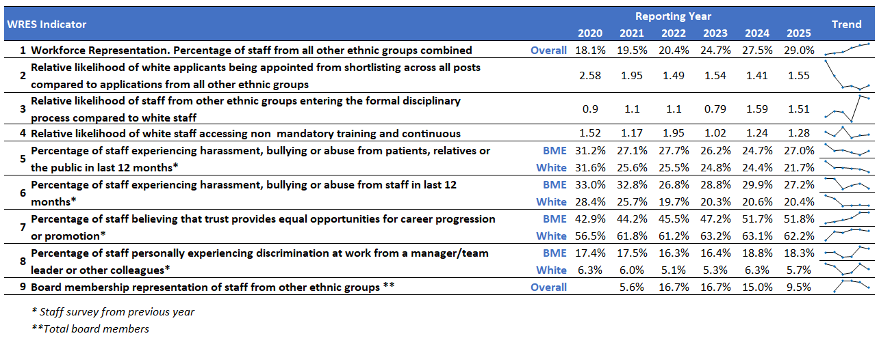
Note: Staff survey metrics are 1 year behind the submission year; the 2025 data shown in this table are 2024 staff survey metrics.

Metric 1 – Overall Representation
According to data from the NHS Electronic Staff Record (ESR), 29% of the Trust's workforce identified as being from an ethnically diverse background as of March 2025, reflecting a 1.5 percentage point increase since 2024.
Over the past five years, The Dudley Group has seen a positive trend in workforce ethnic diversity, with a steady increase in representation and a corresponding reduction in the ‘not stated’ or ‘unknown’ category. More staff are comfortable disclosing their ethnicity, indicating growing trust in the organisation's inclusion efforts.
The chart below illustrates this progression.
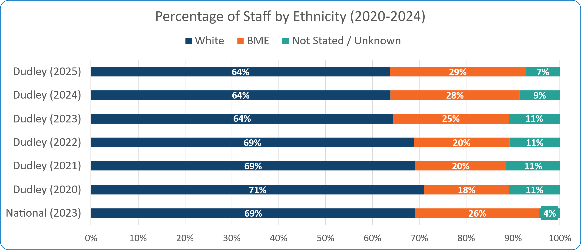
Staff from ethnically diverse backgrounds are shown here as BME (Black and Minority Ethnic)
To support a more targeted analysis, representation data for Metric 1 is disaggregated by clinical and non-clinical roles. This approach enables a clearer understanding of disparities across staff groups and informs more focused action planning.
Clinical roles involve direct patient care and require medical qualifications, while non-clinical roles support healthcare delivery through administrative, operational, and strategic functions without direct patient interaction.
The tables below present ethnic representation across non-clinical and clinical staff by pay band. Notably, patterns of representation in non-clinical roles differ significantly from those in clinical areas, offering valuable insight to guide tailored interventions.

Metric 1 – Non-Clinical Banding Comparison 2024-2025
The data highlights some disparity in the ethnic diversity of non-clinical staff across AfC pay bands. Staff from an ethnically diverse background are notably higher in the lower pay bands, particularly at Bands 1 (Apprentices), 5, and 6, but decline sharply at senior levels, with VSM roles occupied entirely by staff from a white background.
While 'Not Stated/Unknown' responses are minimal, the clear trend suggests a progression gap that limits staff from ethnically diverse backgrounds from advancing into higher-banded and leadership roles. This underlines the need for targeted action to improve equity in career development and leadership pathways, ensure that promotion processes are inclusive, and effectively support and retain diverse talent at all levels.

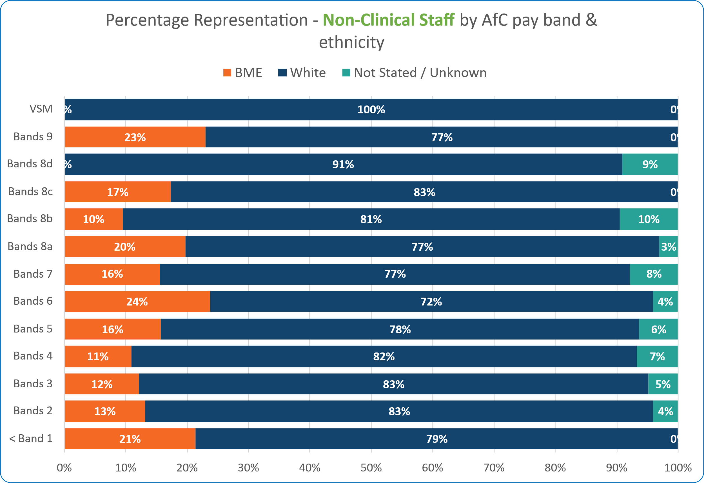
Staff from ethnically diverse backgrounds shown here as BME (Black and Minority Ethnic)
There is a major gap in senior leadership representation, underscoring the need for focused succession planning and accountability at the top.

Metric 1 – Clinical Banding Comparison 2024 -2025
The data show that while ethnically diverse staff are strongly represented among clinical staff across Bands 5 to 8a, with staff from ethnically diverse backgrounds making up as much as 44% at Band 5, this diversity is not reflected at the most senior levels. Bands 8c, 8d, 9, and VSM roles are still predominantly held by staff from a white background, with VSM and Band 8d comprising 100% staff who are white.
This indicates a significant progression gap, where, despite a diverse clinical workforce at operational levels, staff from ethnically diverse backgrounds are not advancing proportionately into leadership positions. To address this, there is a clear need to strengthen inclusive career development, succession planning, and leadership support for clinical staff who are ethnically diverse , ensuring that progression opportunities are equitable and fully accessible.
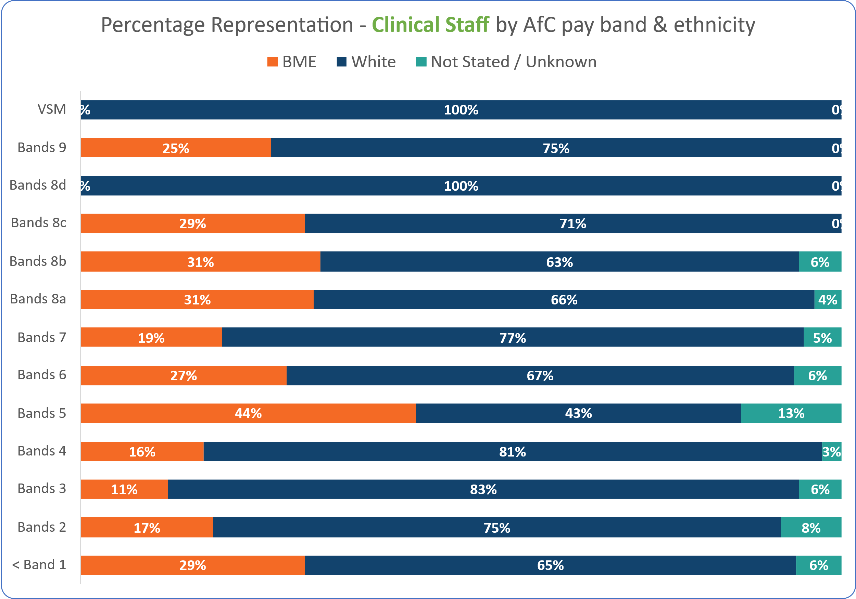
Staff from ethnically diverse backgrounds shown here as BME (Black and Minority Ethnic)
There is a major gap in senior leadership representation, underscoring the need for focused succession planning and accountability at the top.

Metric 2 – Relative likelihood of white applicants being appointed from shortlisting across all posts compared to ethnically diverse applicants
A relative likelihood score of 1 indicates parity between groups. In 2025, the relative likelihood of applicants from ethnically diverse backgrounds being appointed from shortlisting was 1.55, an increase from 1.41 in 2024, indicating a widening disparity. Appointment rates were 12% for ethnically diverse applicants compared to 19% for white applicants. In percentage terms, white applicants are 55% more likely to be appointed than staff from ethnically diverse backgrounds.
Values | White | BME | Unknown | Grand Total
Number of Shortlisted Applicants | 2278 | 2401 | 113 | 4792
Number Appointed from Shortlisting | 433 | 294 | 19 | 746
Relative Likelihood of appointment from shortlisting | 19% | 12% | 17% | 16%
Relative likelihood of white applicants being appointed from shortlisting across all posts compared to BME applicants | 1.55
Staff from ethnically diverse backgrounds shown here as BME (Black and Minority Ethnic)
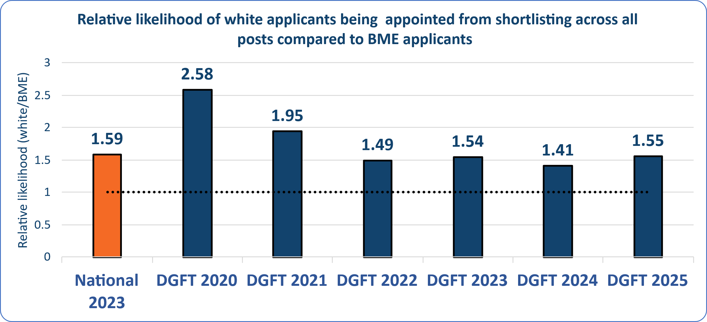
The data demonstrates disparity in recruitment outcomes, highlighting a need to strengthen inclusive hiring practices and reduce bias.

Metric 3 - The relative likelihood of ethnically diverse staff entering the formal disciplinary process compared to white staff

A relative likelihood score above 1.00 indicates that staff from ethnically diverse backgrounds are more likely than white staff to enter the formal disciplinary process. In 2025, this figure stands at 1.55 a slight improvement from 1.59 in the previous year. While the difference is modest, it reflects that 0.67% of staff from ethnically diverse backgrounds entered the formal disciplinary process compared to 0.45% of white staff.
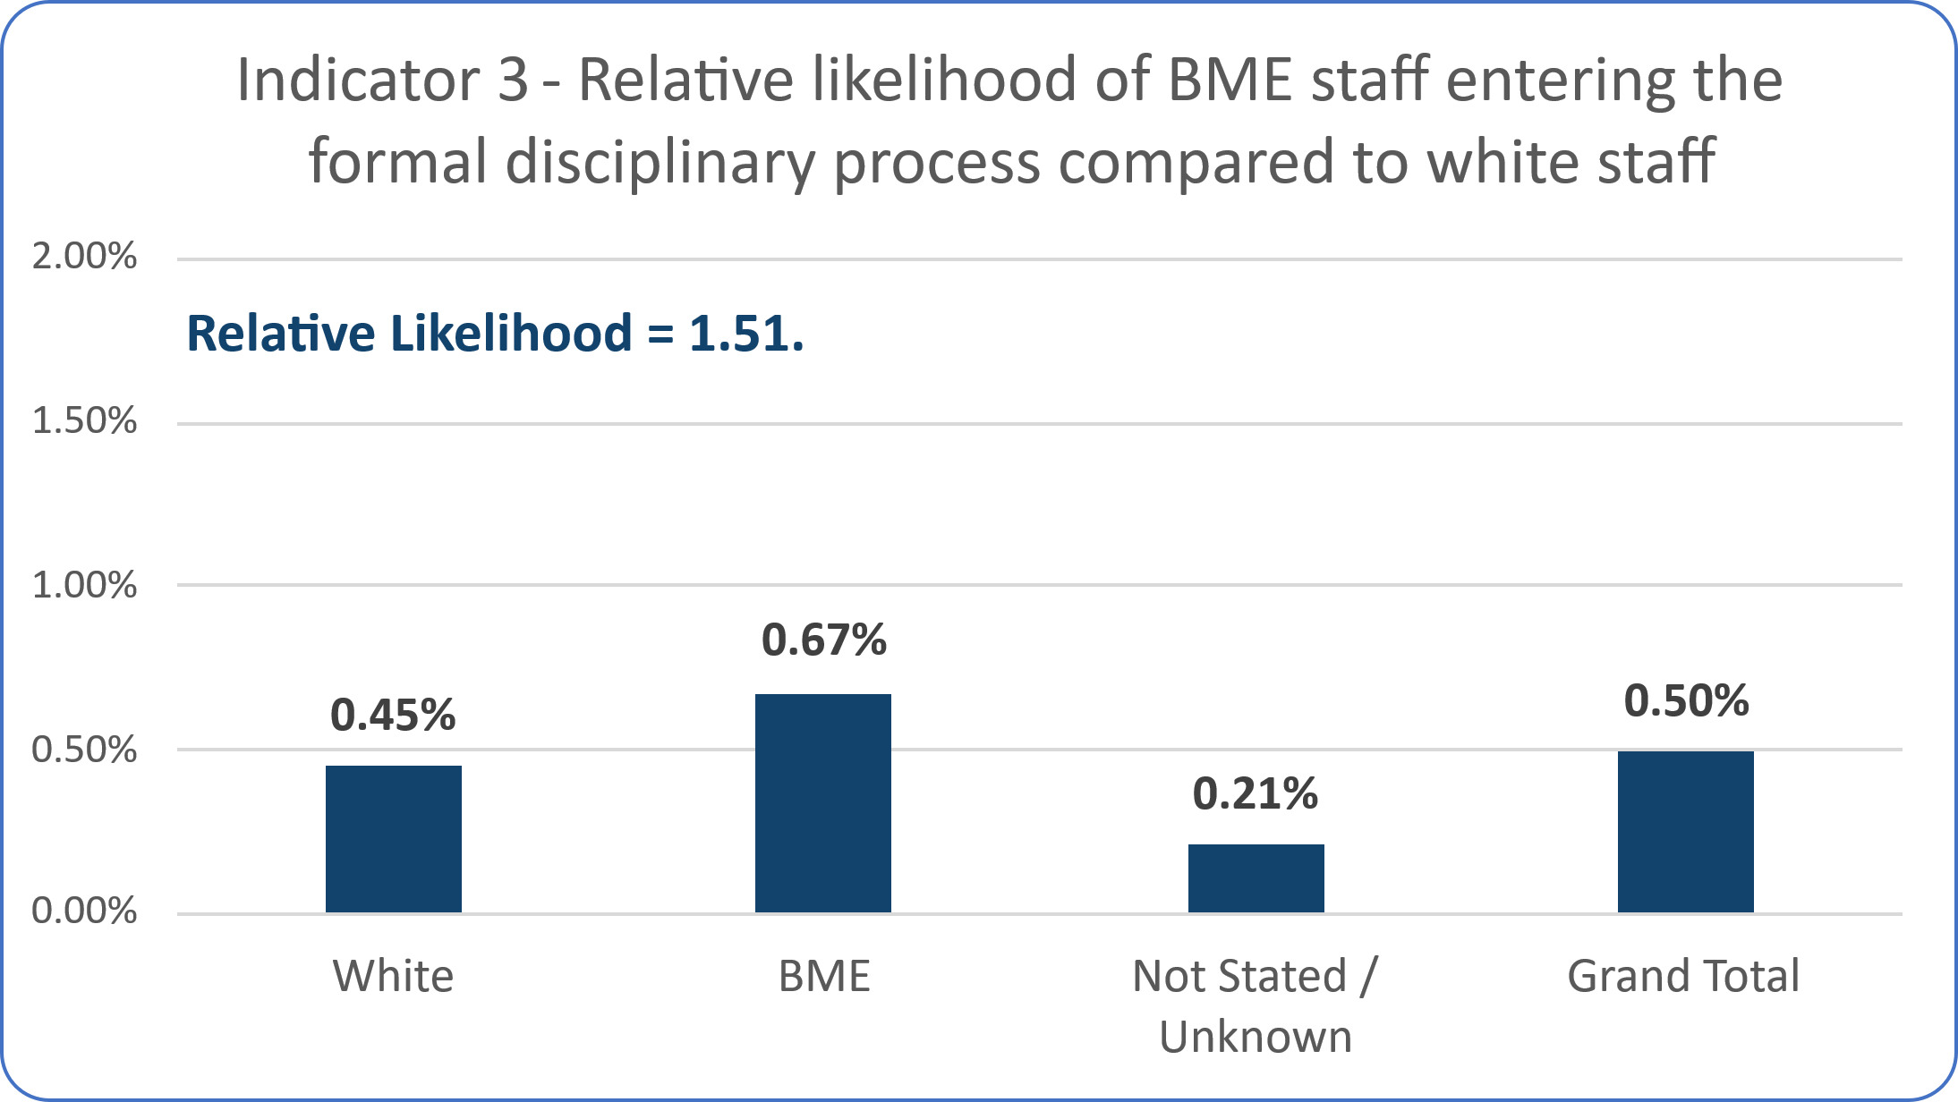
Staff from ethnically diverse backgrounds shown here as BME (Black and Minority Ethnic)
Staff from ethnically diverse backgrounds are more likely to face formal disciplinary action, indicating potential bias or inconsistency in how policies are applied. To address this ongoing disparity, training for managers on bias in the disciplinary process has been developed alongside adopting a ‘Just Culture’ model of practice into our policies and procedures.

Metric 4 - The relative likelihood of white staff accessing non–mandatory training and continuing professional development (CPD) compared to ethnically diverse staff
The relative likelihood of staff from a white background accessing non-mandatory training and continuous professional development (CPD) compared to staff from ethnically diverse backgrounds is 1.28 an increase from 1.24 in 2023/24. A score above 1.00 indicates that white staff are more likely to access these development opportunities.
This metric is based on the total number of course attendances among substantive staff, meaning individuals attending multiple sessions are counted more than once. When using a distinct headcount of individual participants instead, the relative likelihood increases slightly to 1.29. Current guidance does not clearly specify whether to report on attendance count or distinct attendees. Historically, the Trust has reported based on the number of attendees; however, both approaches yield similar outcomes.
An example of this could be an individual attending two out of three training sessions on allyship. The attendance count would include them twice, whereas the distinct count would include them once.

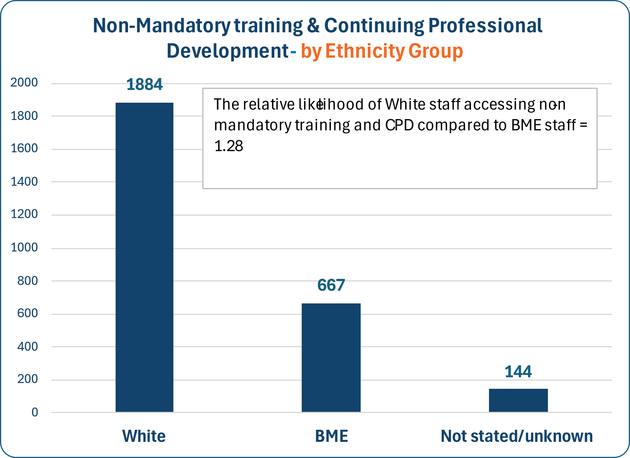
Staff from ethnically diverse backgrounds shown here as BME (Black and Minority Ethnic)
The data suggests there are barriers to development opportunities for staff from ethnically diverse backgrounds, which may impact long-term career progression.

Metric 5 - The percentage of staff experiencing harassment, bullying or abuse from patients,
relatives or the public
The proportion of staff reporting harassment, bullying, or abuse from patients, relatives, or the public in the past 12 months has increased among staff from ethnically diverse backgrounds, rising to 24.68% in 2024, a 2.3 percentage point increase from the previous year. In contrast, the rate for staff from white backgrounds has decreased to 21.67%, representing a 2.7 percentage point improvement.
Staff from ethnically diverse backgrounds accounted for 24.8% of all completed staff surveys in 2024.
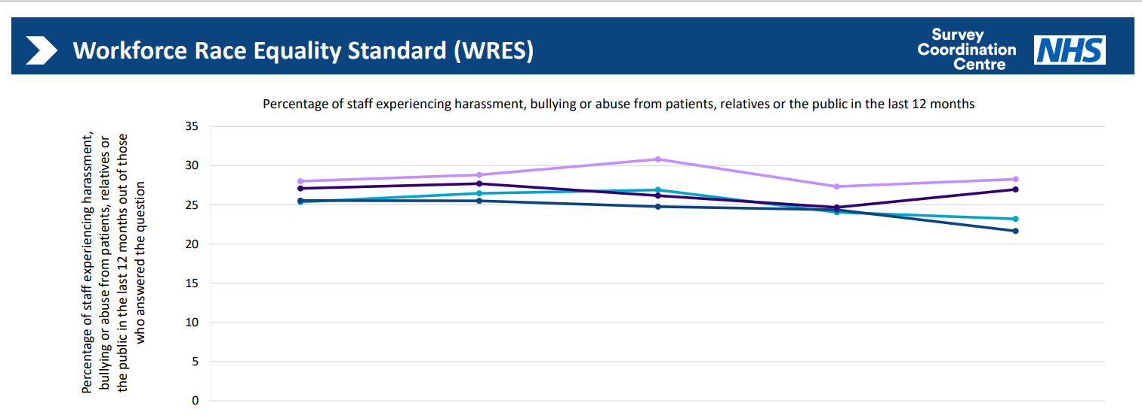
Table 1: Workforce Race Equality Data for Metric 5 from 2020 to 2024.
Staff group | 2020 | 2021 | 2022 | 2023 | 2024
White staff DGFT | 25.56% | 25.52% | 24.78% | 24.37% | 21.67%
All other ethnic groups DGFT | 27.09% | 27.71% | 26.17% | 24.68% | 26.97%
White staff average | 25.36% | 26.47% | 26.91% | 24.05% | 23.21%
All other ethnic group's average | 28.01% | 28.84% | 30.82% | 27.34% | 28.27%
White staff responses | 1796 | 2449 | 2147 | 1912 | 2169
All other ethnic group responses | 299 | 480 | 577 | 575 | 712

Staff from ethnically diverse backgrounds are experiencing rising levels of abuse from the public, indicating a need for stronger protections and public-facing campaigns.

Metric 6 - The percentage of staff who experienced harassment, bullying or abuse from other staff
The percentage of staff from ethnically diverse backgrounds reporting harassment, bullying, or abuse from colleagues in the past 12 months has decreased to 27.22% in 2024 a reduction of 2.7 percentage points compared to the previous year. For staff from white backgrounds, the rate stands at 20.35%, reflecting a smaller decrease of percentage points since 2023
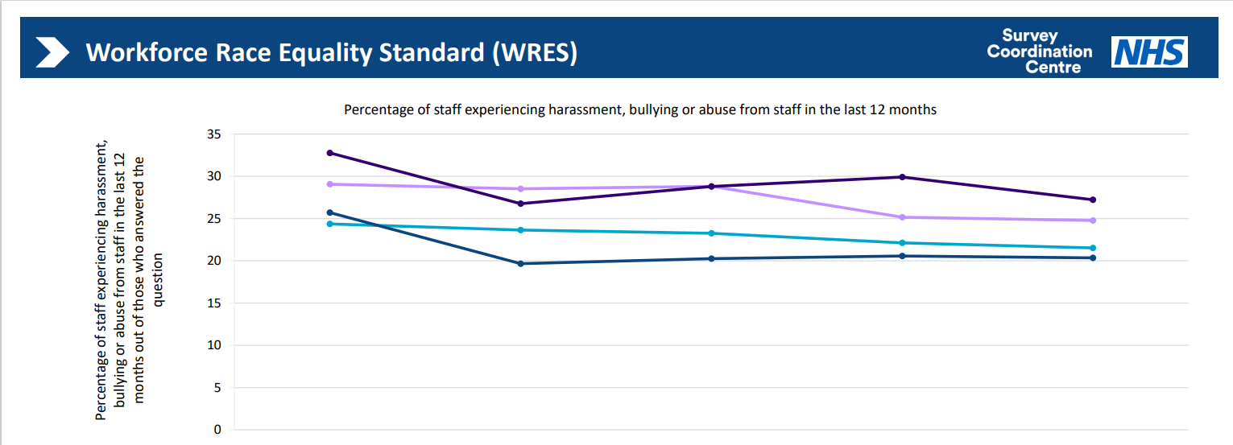
Table 2: Workforce Race Equality Data for Metric 6 from 2020 to 2024.
Staff group | 2020 | 2021 | 2022 | 2023 | 2024
White staff DGFT | 25.71% | 19.67% | 20.26% | 20.57% | 20.35%
All other ethnic groups DGFT | 32.78% | 26.76% | 28.79% | 29.92% | 27.22%
White staff average | 24.37% | 23.65% | 23.25% | 22.12% | 21.53%
All other ethnic groups average | 29.07% | 28.53% | 28.81% | 25.16% | 24.89%
White staff responses | 1797 | 2451 | 2152 | 1904 | 2162
All other ethnic group responses | 299 | 482 | 580 | 574 | 709

Positive progress is being made in reducing internal bullying, though continued focus is needed to sustain improvement.

Metric 7 - The percentage of staff who believed that the trust provided equal opportunities for career progression or promotion
The percentage of staff from ethnically diverse backgrounds who believe the Trust provides equal opportunities for career progression or promotion remains unchanged from 2023, at 51.8%. A disparity persists between staff from ethnically diverse backgrounds and staff from white backgrounds, with a gap of 10.3 percentage points (51.8% vs. 62.1%). However, survey responses from staff from ethnically diverse backgrounds have shown a notable improvement over the past five years, indicating a gradual positive shift in overall experience.
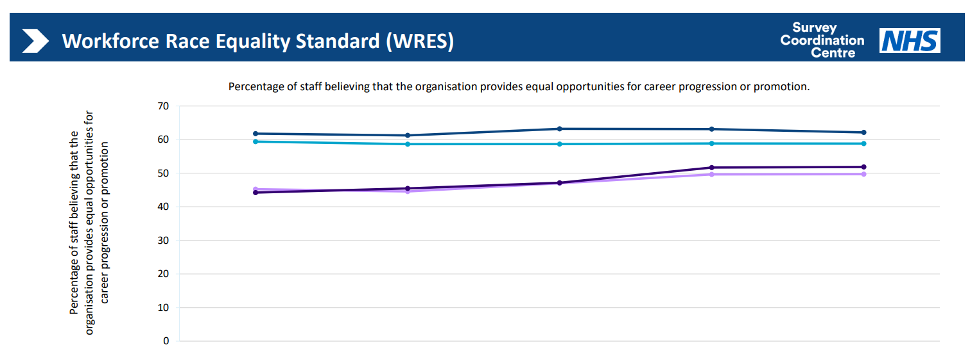
Table 3: Workforce Race Equality Data for Metric 7 from 2020 to 2024.
Staff group | 2020 | 2021 | 2022 | 2023 | 2024
White staff DGFT | 61.77% | 61.24% | 63.19% | 63.13% | 62.15%
All other ethnic groups DGFT | 44.22% | 45.47% | 47.15% | 51.69% | 51.84%
White staff average | 59.39% | 58.64% | 58.65% | 58.84% | 58.82%
All other ethnic groups average | 45.24% | 44.56% | 47.00% | 49.64% | 49.70%
White staff responses | 1839 | 2518 | 2141 | 2034 | 2156
All other ethnic group responses | 303 | 497 | 579 | 652 | 706

Many staff from ethnically diverse backgrounds still feel disadvantaged in career progression, pointing to a need for more visible and equitable advancement pathways.

Metric 8 - The percentage of staff who personally experienced discrimination at work from a manager, team leader or other colleagues
The percentage of staff reporting discrimination from a manager, team leader, or other colleagues has decreased slightly across all groups. Among staff from ethnically diverse backgrounds, the rate stands at 18.3% for 2024 a 0.5 percentage point reduction while for staff from white backgrounds, it is 5.7% in 2024, reflecting a 0.6 percentage point decrease. The disparity between the two groups remains consistent at 12.6 percentage points.
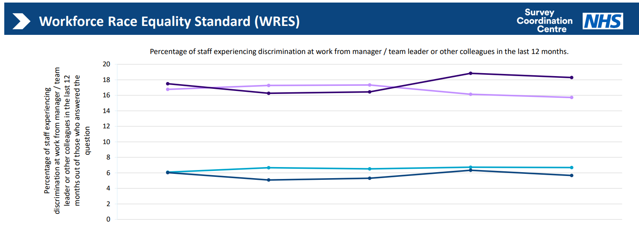

Table 4: Workforce Race Equality Data for Metric from 2020 to 2024.
Staff group | 2020 | 2021 | 2022 | 2023 | 2024
White staff DGFT | 6.03% | 5.08% | 5.31% | 6.34% | 5.67%
All other ethnic groups DGFT | 17.49% | 16.27% | 16.44% | 18.84% | 18.30%
White staff average | 6.09% | 6.67% | 6.52% | 6.73% | 6.69%
All other ethnic groups average | 16.77% | 17.28% | 17.33% | 16.14% | 15.72%
White staff responses | 1856 | 2537 | 2147 | 2036 | 2152
All other ethnic group responses | 303 | 498 | 584 | 653 | 705

Discrimination remains a significant issue, particularly within teams, and requires targeted cultural and leadership interventions.

Conclusion
The 2025 Workforce Race Equality Standard (WRES) data highlights encouraging progress and persistent challenges in achieving racial equity across The Dudley Group NHS Foundation Trust.
We are proud to report a continued increase in the representation of staff from ethnically diverse backgrounds, now at 29% of our workforce. This reflects our ongoing commitment to building a more inclusive organisation. However, the data also reveals areas where disparities remain, particularly in recruitment outcomes, disciplinary processes, access to development opportunities, and representation at senior leadership levels.
Applicants from ethnically diverse backgrounds continue to face lower appointment rates from shortlisting, and staff from ethnically diverse backgrounds are more likely to enter formal disciplinary processes. Access to non-mandatory training and CPD remains unequal, and perceptions of fairness in career progression show a persistent gap. Reports of harassment and discrimination, especially from patients and the public, underscore the need for stronger protections and support mechanisms.
Despite these challenges, we are making progress. Internal reports of bullying and harassment have declined, and perceptions of equal opportunity among staff from ethnically diverse backgrounds have improved over the past five years. These gains result from deliberate, sustained efforts and they reinforce the importance of continuing this work.
Our Equality, Diversity, and Inclusion (EDI) Workforce Journey, embedded within the Dudley People Plan and the Shaping #OurFuture Strategy, provides a clear roadmap for action. We are committed to using this data to inform targeted interventions, strengthen inclusive leadership, and ensure that every workforce member feels respected, supported, and empowered to succeed.
By listening to our staff, acting on their feedback, and holding ourselves accountable, we will continue to build a workplace where equity is not just a goal but a lived reality for all.

Action Planning
As part of our ongoing commitment to advancing racial equality, The Dudley Group NHS Foundation Trust has developed a focused action plan aligned with the Workforce Race Equality Standard (WRES). This plan addresses the disparities identified in our 2025 data and supports our broader Equality, Diversity, and Inclusion (EDI) Workforce Journey (2023–2025).
The plan focuses on removing systemic barriers and creating equitable opportunities for all staff, particularly those from ethnically diverse backgrounds. It is structured around the nine WRES metrics and prioritises inclusive leadership, fair recruitment, equitable development, and a zero-tolerance approach to discrimination and harassment.
Our approach is holistic, evidence-based, and rooted in lived experience. It aims to create a workplace where disabled staff and those with long-term conditions feel safe, supported, and empowered to thrive. Below is a summary of our short, medium and long-term actions. Our detailed action plan can be viewed here: EDI Journey Actions
Short-Term Actions (0–6 months) – Actions to build awareness and lay the foundation:
Workforce Representation, Recruitment & Promotion Equity
- Continue to train all recruiting managers on inclusive recruitment.
- Promote cultural awareness through events and campaigns that reflect workforce diversity.
Training and Development
- Ensure all managers complete the Manager's Essentials training, covering bias awareness training on fairness and cultural competence.
Disciplinary and Grievance Processes
- Continue tracking disciplinary outcomes by ethnicity to identify disparities.
- Encourage early resolution through mediation and restorative practices.
Harassment, Bullying, and Abuse
- Reinforce the Zero Tolerance Campaign to address abuse from the public.
- Train managers on inclusion and conflict resolution.
- Research real-time reporting tools
Leadership and Accountability
- Share regular updates on progress, challenges, and next steps to build transparency.
- Increase and promote inclusive mentoring and sponsorship programme.
Medium-Term Goals (6–18 months) - Embed practices and expand support Race Representation & Recruitment Equity
Workforce Representation, Recruitment and Promotion
- Review succession planning and talent identification for inclusivity.
- Audit promotion and talent processes for potential bias.
- Ensure diverse panels for senior roles.
- Set targets for ethnicity representation at senior levels.
- Strengthen the EmbRACE Staff Network and other staff networks.
Disciplinary and Grievance Processes
- Promote Just Culture practices such as early resolution and mediation.
- Introduce independent case review panels to assess disciplinary proportionality.
Harassment, Bullying, and Abuse
- Explore real-time reporting tools for abuse and structured follow-up.
- Increase visibility of Wellbeing Champions and Speak Up Guardians.
- Track and monitor inclusion goals from managers’ appraisals.
Leadership and Accountability
- Highlight success stories of diverse role models and inclusive teams.
Long Term Goals (18+ months) - Drive cultural change and long-lasting impact
Workforce Representation & Recruitment Equity
- Promote positive action through NHS development programmes.
- Develop systems to track CPD and promotion activity by protected characteristics.
- Fully embed inclusive recruitment practices across the organisation.
- Review Board leadership pipelines to ensure accessibility and inclusion.
Training and Development
- Expand inclusive mentoring and sponsorship schemes to support career growth.
Disciplinary and Grievance Processes
- Escalate concerns about disciplinary disparities to senior leadership.
Harassment, Bullying, and Abuse
- Engage with community groups and patient representatives to promote respectful interactions.
Leadership and Accountability
- Embed inclusion goals into appraisals and hold managers accountable for team culture.
These actions are designed to drive meaningful change and ensure that all staff, regardless of disability or health condition, can thrive in a safe, inclusive, and supportive environment. As part of our commitment to continuous improvement, our progress will be regularly reviewed and transparently reported.

Appendix 1 – Workforce Race Equality Standard Metrics summary 2020-2025
 |  |  | Reporting Year
 |  |  | 2020 | 2021 | 2022 | 2023 | 2024 | 2025
1 | Workforce Representation. Percentage of staff from all other ethnic groups combined | Overall | 18.1% | 19.5% | 20.4% | 24.7% | 27.5% | 29%
2 | Relative likelihood of white applicants being appointed from shortlisting across all posts compared to applications from all other ethnic groups |  | 2.58 | 1.95 | 1.49 | 1.54 | 1.41 | 1.55
3 | Relative likelihood of staff from other ethnic groups entering the formal disciplinary process compared to white staff |  | 0.9 | 1.1 | 1.1 | 0.79 | 1.59 | 1.51
4 | Relative likelihood of white staff accessing non-mandatory training and continuous professional development (CPD) compared to BME staff |  | 1.52 | 1.17 | 1.95 | 1.02 | 1.24 | 1.28
5 | Percentage of staff experiencing harassment, bullying or abuse from patients, relatives or the public in last 12 months | BME | 31.2% | 27.1% | 27.7% | 26.2% | 24.7% | 27.0%
5 |  | White | 31.6% | 25.6% | 25.5% | 24.8% | 24.4% | 21.7%
6 | Percentage of staff experiencing harassment, bullying or abuse from staff in the last 12 months | BME | 33.0% | 32.8% | 26.8% | 28.8% | 29.9% | 27.2%
6 |  | White | 28.4% | 25.7% | 19.7% | 20.3% | 20.6% | 20.4%
7 | Percentage of staff believing that trust provides equal opportunities for career progression or promotion | BME | 42.9% | 44.2% | 45.5% | 47.2% | 51.7% | 51.8%
7 |  | White | 56.5% | 61.8% | 61.2% | 63.2% | 63.1% | 62.2%
8 | Percentage of staff personally experiencing discrimination at work from a manager/team leader or other colleagues | BME | 17.4% | 17.5% | 16.3% | 16.4% | 18.8% | 18.3%
8 |  | White | 6.3% | 6.0% | 5.1% | 5.3% | 6.3% | 5.7%
9 | Board membership representation of staff from other ethnic groups | Overall |  | 5.6% | 16.7% | 16.7% | 15.0% | 9.5%
Note: staff survey metrics are 1 year behind submission year; 2025 data shown in this table is 2024 staff survey metrics. This table is an accessible version of the chart on page 7.

