


Paper for submission to the Public Board of Directors on January 15th 2026
Report title: | Midwifery Workforce paper- Biannual.
Sponsoring executive / Presenter: | Martina Morris - Chief Nursing Officer DGFT, Group Deputy CNO DGFT & SWBH and Maternity Safety Champion
Report author: | Claire MacDiarmid – Interim Group Director of Midwifery  Katie Philpott - Head of Midwifery

- Summary of key issues
Assure
This bi-annual paper provides assurance to Trust Board that Midwifery workforce planning, staffing levels, and training compliance continue to meet the requirements of the Maternity Incentive Scheme (Year 7) Safety Action 5 and the Ockenden recommendations. Birth activity remains stable, and the Birthrate Plus acuity tool demonstrates robust real-time monitoring of staffing against demand.
While periods of increased acuity, sickness absence, and annual leave have resulted in reduced daytime fill rates, particularly within inpatient and community services, safety-critical standards have been maintained throughout the reporting period. There have been no occasions where one-to-one care in established labour was not achieved, and the band 7 shift coordinator has always remained supernumerary.
Recruitment activity is largely complete, with newly qualified midwives commencing between September and November 2025 and expected to improve fill rates following completion of supernumerary periods. Mandatory and maternity-specific training compliance remains above the required thresholds, providing assurance that the maternity workforce is safe, competent, and effectively governed.
Advice & Alert - nil

2. Alignment to our Vision
Patients: Deliver right care, in the right place, at the right time | x
People: Be a brilliant place to work and thrive
Place: Build innovative partnerships to improve the health of our communities

3. Report journey
Quality Committee

4. Recommendation(s)
The Public Board of Directors is asked to:
- Accept this bi-annual report as assurance of adequate Midwifery staffing establishment as per the requirements of MIS year 7

5. Impact reflected in our Board Assurance Framework (BAF)
BAF Risk 1.0 | x | Failure to deliver the right care, in the right place every time
BAF Risk 2.0 |  | Failure to ensure Dudley is a brilliant place to work and thrive
BAF Risk 3.0 |  | Failure to build innovative partnerships to improve the health of our communities
BAF Risk 4.0 |  | Failure to remain financially sustainable in 2025/26 and beyond
BAF Risk 5.0 |  | Failure to achieve operational performance requirements & deliver strategic objectives
BAF Risk 6.0 |  | Failure to take sustained action on infrastructures that enables strategic objectives
Is Quality Impact Assessment required if so, add date: Staffing QIA November 2025
Is Equality Impact Assessment required if so, add date: N/A




Midwifery Workforce
Supporting compliance with MIS year 7 Safety action 5
Report to Trust Board on the 15th January 2025
1. EXECUTIVE SUMMARY
This report provides assurance to Trust Board regarding the safety and effectiveness of the maternity workforce, in line with the Ockenden recommendations and the Maternity Incentive Scheme (Year 7). It presents the current position for midwives and maternity support workers and demonstrates ongoing monitoring of safe staffing levels.
A full Birthrate plus recalculation was undertaken during summer of 2025, and concluded that the requirement for Midwifery, and qualified midwifery support workers remained broadly stable compared to the 2022 calculation. Whilst acuity in the patients had increased, the ability to delegate some of the postnatal workload to Midwifery support worker, mitigated the requirement for an increase in the number of midwives required.
Birth activity remains stable, with 4,063 births in 2024/25. Staffing is monitored using the Birthrate Plus acuity tool, with good compliance. While periods of increased acuity and staff absence led to some short-staffed shifts, particularly in July and September, mitigations were implemented and safety-critical standards were maintained. There were no occasions where one-to-one care in labour was not achieved, and the band 7 coordinator remained supernumerary throughout the reporting period.
The maternity workforce is close to funded establishment, with remaining vacancies largely covered by recruitment in progress. Daytime inpatient and community fill rates remained below baseline; however, newly qualified midwives commenced between September and November and will complete their supernumerary period by December, which is expected to further improve staffing levels.
Mandatory and maternity-specific training compliance remains high across all staff groups, meeting the requirements of the Maternity Incentive Scheme. Overall, this report demonstrates that effective systems are in place to review the maternity workforce and provide assurance of safe staffing and care.
2. BACKGROUND INFORMATION
The aim of this report is to provide assurance to Trust Board that there is an effective system of midwifery workforce planning, and monitoring of safe staffing levels. This is a requirement of the Maternity Incentive Scheme. The report provides an accurate account of the current workforce status.
Table 1
Number of births at Dudley Group by month April 23- November 2025
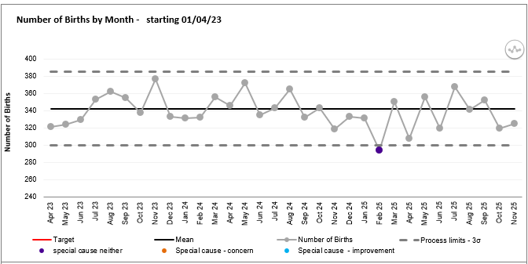
Table 1.1
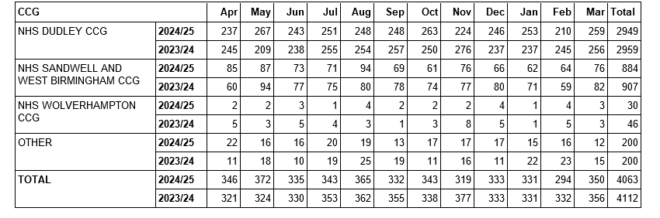

Table 1.1 highlights the number of births at the Trust by month. There were 4063 babies born at the Trust during the 2024/25 financial year. This number remains similar to previous years as shown below:
Table 1.2
Year | Number of births | % of non-Dudley Births
2019/20 | 4144 | 29%
2020/21 | 4055 | 30%
2021/22 | 4156 | 29%
2022/23 | 4158 | 29%
2023/24 | 4112 | 28%
2024/25 | 4063 | 27%

Birthrate plus acuity tool
Table 2 provides the staffing position on the high-risk Delivery suite over the last 6 months using scoring from the Birthrate acuity tool, which is completed in real time by the shift leader on the Delivery suite and the Maternity ward, every 4 hours. Compliance with completion of the tool over the period 1/05/25 to 30/11/25 is demonstrated below:
Compliance in completing the Birthrate plus acuity tool.
 | May | June | July | August | September | October | November
Compliance % | 91.94% | 93.33% | 89.78% | 86.56% | 85.00% | 83.87% | 83.33%

The green bar demonstrates the number of times the Maternity unit has had the correct number of staff for the number of patients and the complexity of their health needs. The amber bar evidences the percentage of shifts that are short staffed by up to 2 midwives, with the red bar evidencing the percentage of shifts that were over 2 midwives short.
The table demonstrates that red shifts equate to between 5% and 16% of entries with a mean average of 9% and green shifts vary between 58% and 70% with a mean average of 67%.
Table 2
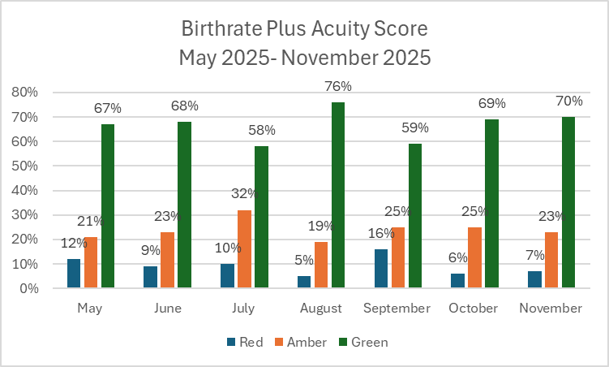
Both July and September were noted to have significantly increased Acuity, the birth rate for those months was higher than average. In July the department was at maximum annual leave of 17% with additional long-term sickness. In September, the short-term sickness increased predominantly with respiratory illness and Gastrointestinal. Mitigations
Red Flags
A midwifery red flag event is a warning sign that there may be concerns with midwifery staffing. If a midwifery red flag event occurs, the midwife in charge of the service should be notified. The midwife in charge should determine whether midwifery staffing is the cause, and the action that is required. The classification of a midwifery red flag is as follows:
- Delayed or cancelled time-critical activity.
- Missed or delayed care (for example, delay of 60 minutes or more in washing and suturing (due to lack of midwifery staffing).
- Missed medication during an admission to hospital or midwifery-led unit (for example, diabetes medication).
- Delay of more than 30 minutes in providing pain relief.
- Delay of 30 minutes or more between presentation and triage.
- Full clinical examination not carried out when presenting in labour.
- Delay of 2 hours or more between admission for induction and beginning of process.
- Delayed recognition of and action on abnormal vital signs (for example, sepsis or urine output).
- Any occasion when 1 midwife is not able to provide continuous one-to-one care and support to a woman during established labour.
- Other midwifery red flags may be agreed locally.
Table 3: Red flags
Safe midwifery staffing for maternity settings
Month (2025/26) | Total number of red flags | 1:1 care in labour not met | Coordinator not supernumerary
May | 14 | 0 | 0
June | 8 | 0 | 0
July | 1 | 0 | 0
August | 7 | 0 | 0
September | 12 | 0 | 0
October | 0 | 0 | 0
November | 1 | 0 | 0

*Missed or delayed care relates to delays in undertaking artificial rupture of membranes, during the induction of labour process. No incidents occurred as a result of the delay and no harm was caused.
There have been 0 occasions between 1st May 2025 and 30th November 2025 where 1:1 care in labour has not been achieved.
There have been 0 occasions between 1st May 2025 and 30th November 2025 where the band 7 shift leader has not been worked in a supernumerary capacity.
This data is gathered via the Datix system and via on call manager handover information. Birthrate plus acuity is also scrutinised for any gaps in this provision.
Midwifery Recruitment
Table 4
 | Funded Establishment | In Post end of November | Revised Birthrate plus recommended staffing figures
Total Midwives Band 5-8 | 172.98 WTE | 167.22 WTE | 173.79 WTE
Qualified band 3 MSW | 5.99 | 5.99 | 5.99 WTE
Band 3 MSW- commenced competency assessment due to complete December | 7.63WTE | 7.63 | 7.63 WTE
Total | 178.97 | 173.21  180.84 (by December) | 187.41
Breakdown by area
Community
 | Budget | In Post | Variance | Recruited to but not started | At Advert/ VAR
MSW | 5.46 | 4.21 | -1.25 | 0 | 0.8
Midwives + RN GTT | 30.63 | 25.34 | 5.29 (of which 1.8 is B7) | 0.6 | 1.0 (Band 7)

Outpatients
 | Budget | In Post | Variance | Recruited to but not started | At Advert/ VAR
MSW | 3.66 | 5.35 | +1.69 | 0 | 0
Midwives | 11.14 | 10.86 | 0.28 | 0 | 0

Maternity Unit
 | Budget | In Post | Variance | Recruited to but not started | At Advert/ VAR
MSW | 32.19 | 30.37 | -1.82 (kept for seconded staff) | 0 | 0
Midwives | 109.87 | 108.23 | 1.64 | 0 | 2

Current vacancy Midwifery workforce: 7.21 WTE RM however 4.4 WTE recruited are awaiting start date or at advert. 1.81 WTE total vacancy.
Current vacancy in Maternity support workers: 1.38 WTE
Birthrate plus staffing inclusive of 22% uplift which is recruited into fully.
Midwife to birth ratio for November 2025 is 1:28
This calculation takes into consideration the number of births for the month vs number of available midwives available to undertake direct clinical care (as per BR Plus calculations). Note this does not take into consideration the impact of deprivation, ethnicity or additional care needs. The recommended figure should be between 1:26 and 1:34.

Table 5: Fill rates for maternity inpatients
Fill rates for maternity inpatients. | May 2025 | June  2025 | July  2025 | August  2025 | Sept  2025 | Oct  2025 | Nov  2025
Day | 78.5% | 78.1% | 78.5% | 77% | 79% | 78.7% | 80.5%
Night | 98% | 97.6% | 94.9% | 95.8% | 90.7% | 91.9% | 97.4
Overall | 86.5% | 85.5% | 84.9% | 84.2% | 83.6% | 83.4% | 86.8%

From May to November 2025, maternity inpatient fill rates remained consistently below the planned baseline overall, driven primarily by lower daytime fill rates, which stayed in the mid-70% range throughout the period. Night-time staffing remained consistently high, but this did not offset daytime shortfalls, resulting in overall fill rates remaining in the mid-80% range with only modest improvement by November. Recruitment has been completed, and newly qualified Registered Midwives have commenced in post between September and November, they will all have completed their supernumerary period by the end of December. This will then in turn increase the fill rates for Maternity Inpatients.
Table 6: Fill rates for Community Midwifery:
 | May 2025 | June | July | August | Sept | Oct | Nov
Fill rates for community Midwifery | 84.2% | 80.2% | 83.7% | 82.3% | 94% | 80.2% | 88.4%

From May to November 2025, Community Midwifery fill rates remained below the agreed baseline in most months, with performance generally in the low-80% range. Although there was a marked improvement in September and partial recovery in November, this was not sustained, indicating an ongoing workforce capacity gap rather than isolated short-term variance. Recruitment within the Community team is ongoing and will be completed by January with planned start dates between February and April. Maternity leave in the community team accounts for 9.7% with return dates from May to October 2026.
Turnover by staff group
Table 7- Maternity unit.
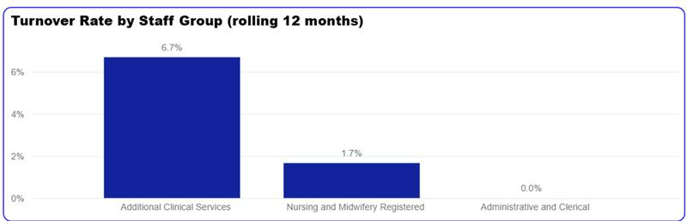

Unavailability
Table 8 Absence FTE- October 2025
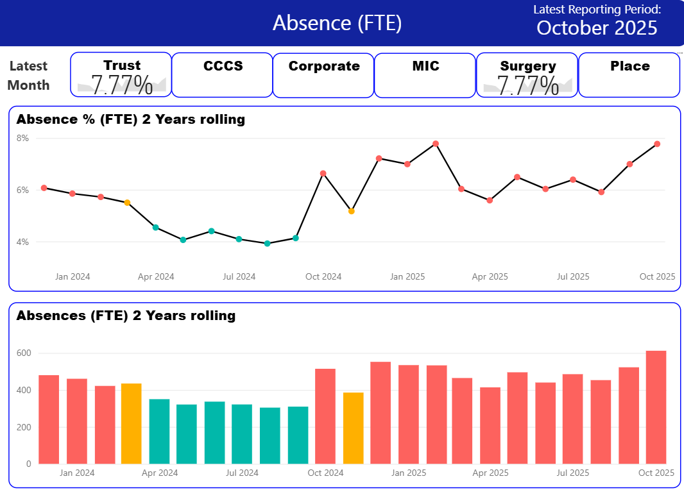
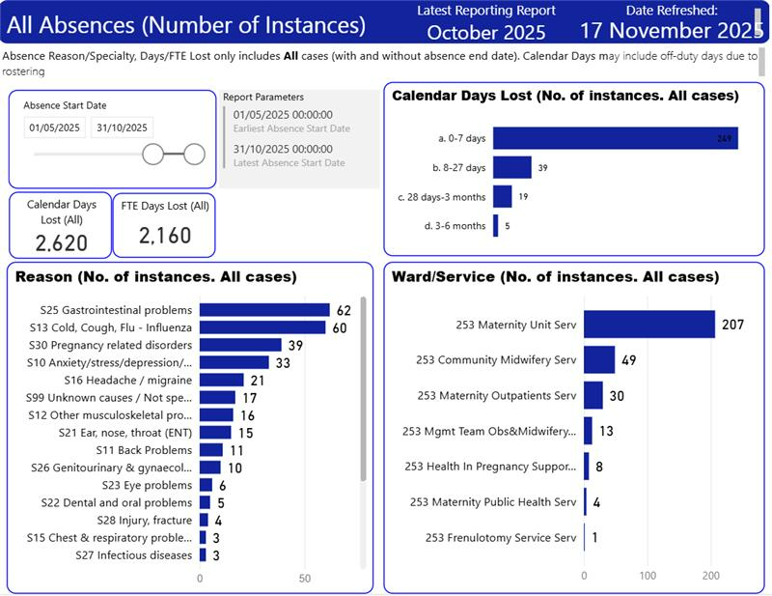

*Midwives only
Line managers have been working with HR to support staff following sickness absence to return to work in a supportive way in an effort to reduce the elevated sickness absence figure. The trend for sickness absence has changed from stress/ anxiety to gastrointestinal problems and cold and flu. The ward managers have taken responsibility for sickness management and staff are being appropriately managed through the sickness absence policy stages. Return to work processes have been strengthened to ensure meaningful support can be put in place. Staff have also been encouraged to access their Flu vaccines and reminded about enhanced IPC processes.
Maternity specific training
Table 9
 | Midwives 30/11/25 | MSW 30/11/25
PROMPT | 97% | 97%
In Situ Sim | 97% | n/a
Fetal monitoring | 97% | n/a
Neonatal resuscitation | 98% | 99%
Adult resuscitation | 97% | 99%

 | Consultant obstetricians | ST1-7
PROMPT | 100% | 90%
In Situ Sim | 100% | 90%
Fetal monitoring | 100% | 95%
Neonatal resuscitation | 100% | 100%
Adult resuscitation | 100% | 95%

 | Anaesthetic consultants | Anaesthetic registrar (that cover obstetrics)
PROMPT | 90% | 100%
In Situ Sim | 90% | 100%

Role appropriate neonatal resuscitation training
 | Neonatal consultants | Resident neonatal doctors | Neonatal nurses (all bands) | ANNP
Neonatal Resuscitation | 100% | 91% | 96% | 100%

These sessions are facilitated on Delivery Suite by the Resus Team/SPMWPD and the NLS (Newborn Life Support) Instructors.
*MSW Neonatal resus. training is adapted from the full NLS to be relevant and appropriate to their job role.
Table 9 demonstrates current position with maternity specific mandatory training, which forms the core competency framework V2, as part of compliance with the Maternity incentive scheme year 7. The service is currently compliant. A robust plan maintains in place to ensure compliance remains above 90%. The scheme requires 90% attendance of relevant staff groups by the end of the 12-month period in the topics:
1. Fetal monitoring training
2. Multi-professional maternity Emergencies training /PROMPT
3. Neonatal Life Support Training
*PROMPT is PRactical Obstetric Multi-Professional Training
Trust specific mandatory training- Midwifery
Table 10
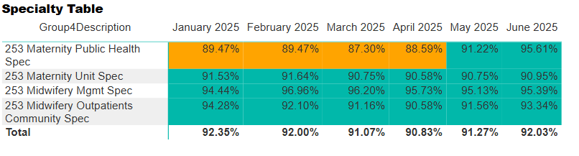
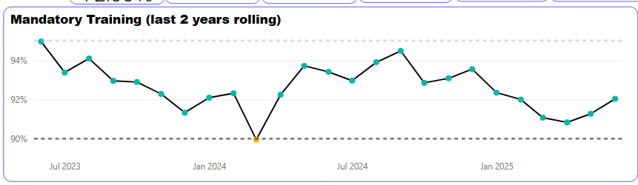

Midwives P1 -93.7%
Obstetrics P1 -87.6%

Midwives P2 -95.1%
Obstetrics P2 -86.4%

Midwives P3 -82.5%
Obstetrics P3 -80.3%

Safeguarding Level 2 Adults
Midwifery– 90% Obstetrics – 68%
Safeguarding Level 3 Adults
Midwifery –90% Obstetrics – 100%
Safeguarding Level 3 Children
Midwifery –88% Cons 17/18 -94% Resident 14/24 -58%

3.0 RISKS AND MITIGATIONS
The requirements for evidence for Ockenden, Maternity incentive scheme year 7, and the perinatal quality surveillance model for assurance are very specific, and significant in its amount. Quality Committee/Trust Board is required to receive and minute detailed information particularly in relation to Maternity workforce current position and plans to mitigate risks.
The principal risk relates to periods of workforce pressure arising from increased clinical acuity, sickness absence, annual leave, and vacancies, which can result in reduced fill rates, particularly during daytime hours and within Community Midwifery services. These pressures have the potential to impact service resilience; however, no safety-critical standards have been breached, and one-to-one care in established labour has been consistently maintained. The impact of reduced bank rates has been noted to have a negative impact on the fill rates for day shifts.
These risks are mitigated through robust, real-time monitoring using the Birthrate Plus acuity tool and a clearly defined escalation process. Specialist Midwives, Ward Managers and Deputy Matrons provide additional clinical support during periods of increased demand, alongside redeployment and use of temporary staffing where required. Recruitment is ongoing, with newly appointed midwives now in post and further starters planned, which will strengthen staffing capacity. Workforce risks are further mitigated through active sickness absence management, review of red flag events, and close oversight of training compliance to ensure staff remain competent and services continue to operate safely.
4. RECOMMENDATION(S)
The Board of Directors are asked to accept this paper as assurance that Maternity Workforce is being thoroughly reviewed twice per year as per requirements of the Maternity incentive scheme, Safety action 5, and safety is being demonstrated through the data contained within this paper.

