

Paper for submission to the Quality Committee on 24th June 2025

Report title: | Bi-Annual Midwifery Workforce paper
Sponsoring executive: | Martina Morris - Chief Nurse and Board Level Maternity Safety Champion
Report author: | Claire Macdiarmid - Director of Midwifery and Maternity Safety Champion

- Summary of key issues using Assure, Advise and Alert

This report outlines the current position with Maternity department staffing. This is in line with the recommendations published in the Ockenden report (2020 and 2022). The report covers the period 1st November 2024 to 30th April 2025.

There have been 0 instances where the shift leader has not been supernumerary, or when a woman has not been provided with 1:1 care in labour. This is a requirement of the Maternity incentive scheme year 7.

Incident of ‘red’ acuity calculated via the Birthrate plus acuity tool remains low with a mean average of 4.8%. Green shifts remain high with an average of 75%. Shift fill rates are contained within the report with a decline in fill rates for community midwifery, lined to current vacancy.

The Maternity unit has funded establishment in line with Birthrate plus requirements. There is however a vacancy in the Midwifery workforce of 12.68 WTE and Midwifery support workers of 9.6 WTE. All posts have been recruited to; the majority will commence employment September/October 2025. Most of this RM vacancy sits within the Community Midwifery department.

The Midwife to birth ratio for April is 1:29, this is within acceptable levels.

Maternity specific multidisciplinary training compliance remains above 90%. Some elements of other Trust mandatory training are currently below 90% however there are rectification plans in place. MIS requirements state that we must be at 90% compliance or above by the end of the reporting period.

2. Alignment to our Vision
Deliver right care every time | x
Be a brilliant place to work and thrive | x
Drive sustainability (financial and environmental)
Build innovative partnerships in Dudley and beyond
Improve health and wellbeing | x

3. Report journey:
Quality Committee.
Public Board.
Maternity safety Champions
LMNS Perinatal Quality Surveillance

4. Recommendation(s)
The Quality Committee is asked to:
- Accept assurance within this biannual report of current position with Midwifery workforce as per MIS year 7 requirements, and any required mitigation.

5. Impact
Board Assurance Framework Risk 1.1 | x | Deliver high quality, safe person-centred care, and treatment
Board Assurance Framework Risk 1.2 |  | Achieve outstanding CQC rating.
Board Assurance Framework Risk 2.0 |  | Effectively manage workforce demand and capacity
Board Assurance Framework Risk 3.0 |  | Ensure Dudley is a brilliant place to work
Board Assurance Framework Risk 4.0 |  | Remain financially sustainable in 2023/24 and beyond
Board Assurance Framework Risk 5.0 |  | Achieve carbon reduction ambitions in line with NHS England Net Zero targets
Board Assurance Framework Risk 6.0 |  | Deliver on its ambition to building innovative partnerships in Dudley and beyond
Board Assurance Framework Risk 7.0 |  | Achieve operational performance requirements
Board Assurance Framework Risk 8.0 |  | Establish, invest, and sustain the infrastructures, applications, and end-user devices for digital innovation
Is Quality Impact Assessment required if so, add date:
Is Equality Impact Assessment required if so, add date: N/A


Midwifery Workforce
Supporting compliance with MIS year 7 Safety action 5
Report to Quality Committee on the 24th June 205

1 EXECUTIVE SUMMARY
This report outlines the current position with Midwifery and Midwifery support worker workforce. This is in line with the recommendations published in the Ockenden report (2020 and 2022).
This report demonstrates Dudley Group are funded to the required Birthrate plus recommended establishment, and currently have a vacancy of 12.68 WTE, which has actively been recruited into. New starters will commence over the next 6 months.
2. BACKGROUND INFORMATION
The aim of this report is to provide assurance to the Quality Committee and Trust Board that there is an effective system of midwifery workforce planning, and monitoring of safe staffing levels. This is a requirement of the Maternity Incentive Scheme Year 7- safety action 5. The report provides an accurate account of the current workforce status.
Table 1
Number of births at Dudley Group by month November 2024- May 2025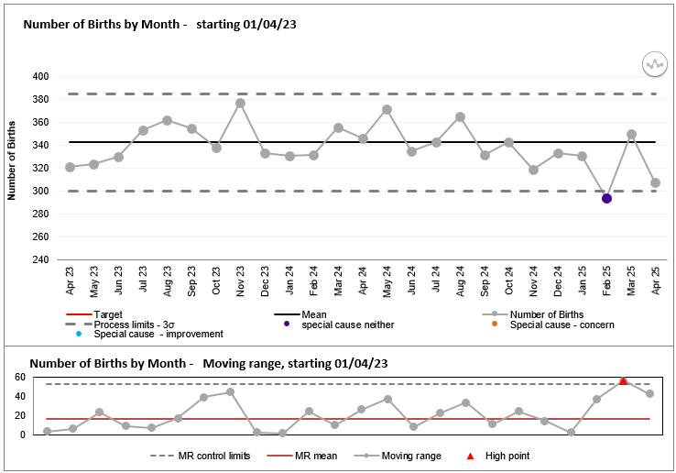

Table 1.1
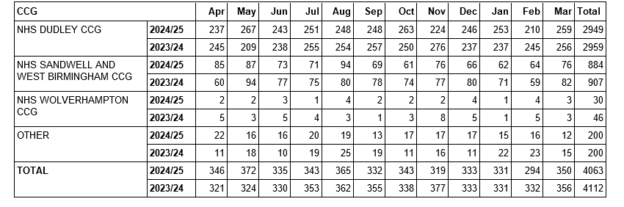

Table 1 highlights the number of births at the Trust by month. There were 4063 babies born at the Trust during the 2024/25 financial year. This number remains similar to previous years as shown below:
Table 1.3
Year | Number of births | % of non-Dudley Births
2019/20 | 4144 | 29%
2020/21 | 4055 | 30%
2021/22 | 4156 | 29%
2022/23 | 4158 | 29%
2023/24 | 4112 | 28%
2024/25 | 4063 | 27%

Birthrate plus acuity tool
Table 2 provides the staffing position on the high-risk Delivery suite over the last 6 months using scoring from the Birthrate acuity tool, which is completed in real time by the shift leader on the Delivery suite and the Maternity ward, every 4 hours. Compliance with completion of the tool over the period 1/11/4 to 30/4/25 is demonstrated below:
Compliance in completing the Birthrate plus acuity tool.
 | November | December | January | February | March | April
Compliance % | 79.44% | 73.66% | 74.73% | 80.36% | 69.89% | 73.33%

The green bar demonstrates the number of times the Maternity unit has had the correct number of staff for the number of patients and the complexity of their health needs. The amber bar evidences the percentage of shifts that are short staffed by up to 2 midwives, with the red bar evidencing the percentage of shifts that were over 2 midwives short.
The table demonstrates that red shifts equate to between 3 and 9% of entries with a mean average of 4.8% and green shifts vary between 67% and 82% with a mean average of 75%.
Table 2

Red Flags
A midwifery red flag event is a warning sign that there may be concerns with midwifery staffing. If a midwifery red flag event occurs, the midwife in charge of the service should be notified. The midwife in charge should determine whether midwifery staffing is the cause, and the action that is required. The classification of a midwifery red flag is as follows:
- Delayed or cancelled time-critical activity.
- Missed or delayed care (for example, delay of 60 minutes or more in washing and suturing (due to lack of midwifery staffing).
- Missed medication during an admission to hospital or midwifery-led unit (for example, diabetes medication).
- Delay of more than 30 minutes in providing pain relief.
- Delay of 30 minutes or more between presentation and triage.
- Full clinical examination not carried out when presenting in labour.
- Delay of 2 hours or more between admission for induction and beginning of process.
- Delayed recognition of and action on abnormal vital signs (for example, sepsis or urine output).
- Any occasion when 1 midwife is not able to provide continuous one-to-one care and support to a woman during established labour.
- Other midwifery red flags may be agreed locally.

Table 3: Red flags
Safe midwifery staffing for maternity settings
Month (2024/25) | Total number of red flags | 1:1 care in labour not met | Coordinator not supernumerary
November | 3 (Missed or delayed care) | 0 | 0
December | 7 (Missed or delayed care) | 0 | 0
January 2025 | 7 (6 x Missed or delayed care, 1 x delayed pain relief) | 0 | 0
February | 2 (Missed or delayed care) | 0 | 0
March | 7 (2 x delayed time critical activity, 5 x missed or delayed care) | 0 | 0
April | 7 (missed or delayed care) | 0 | 0

*Missed or delayed care relates to delays in undertaking artificial rupture of membranes, during the induction of labour process. No incidents occurred as a result of the delay and no harm was caused).
There have been 0 occasions between 1st November 2024 and 30th April 2025 where 1:1 care in labour has not been achieved.
There have been 0 occasions between 1st November 2024 and 30th April 2025 where the band 7 shift leader has not been worked in a supernumerary capacity. This data is gathered via the Datix system and via on call manager handover information. Birthrate plus acuity is also scrutinised for any gaps in this provision.
Midwifery Recruitment
Table 4
 | Funded Establishment | In Post May 2024 | Birthrate plus recommended staffing figures | Shortfall in funded establishment
Total Midwives Band 5-8 | 172.98 WTE | 160.30 WTE | 172.98 | 0
Qualified band 3 MSW | 5.99 | 5.99 | 5.99 | 0
Total | 178.97 | 166.29 | 178.97 | -
Current vacancy Midwifery workforce: 12.68WTE RM
Current vacancy in Maternity support workers: 9.6 WTE (3.6 WTE recruited to and awaiting start date)
Birthrate plus staffing inclusive of 22% uplift which is recruited into fully.
Recruitment has taken place to fill all vacancy for registered midwives. There has been delays in the recruitment processes due to trust process, however Midwifery support worker vacancy will be recruited to as soon as is possible to do so.
Midwife to birth ratio for April 2025 is 1: 29
This calculation takes into consideration the number of births for the month vs number of available midwives available to undertake direct clinical care (as per BR Plus calculations). Note this does not take into consideration the impact of deprivation, ethnicity or additional care needs. The figure should be between 1:26 and 1:34.
Please note a revised Birthrate plus calculation for the workforce at Dudley Group is due for publication later this month and will be reported to the relevant groups and committees for consideration.

Table 5: Fill rates for maternity inpatients
Fill rates for maternity inpatients. | November 2024 | December 2025 | January 2025 | February 2025 | March 2025 | April 2025
Day | 94% | 92% | 94% | 90% | 90% | 92%
Night | 96% | 96% | 98% | 97% | 94% | 96%

Table 6: Fill rates for Community Midwifery:

 | May 24 | June 24 | July 24 | August 24 | Sept 24 | Oct 24
Fill rates for community Midwifery | 96% | 97% | 90% | 85% | 97% | 89%

 | November 2024 | December 2024 | January 2025 | February 2025 | March 2025 | April 2025
Fill rates for community Midwifery | 91% | 87% | 87% | 79% | 89% | 81%

Table 5 and 6 evidence a fully green position relating to fill rates of Midwifery shifts in inpatient areas. Community midwifery has declined, and this is predominantly due to a Midwifery vacancy. The vacancy has been out to advert multiple times and a rectification plan is in place to ensure band 5 midwives are fast tracked out to their community posts.
Turnover by staff group
Table 7- Maternity unit.
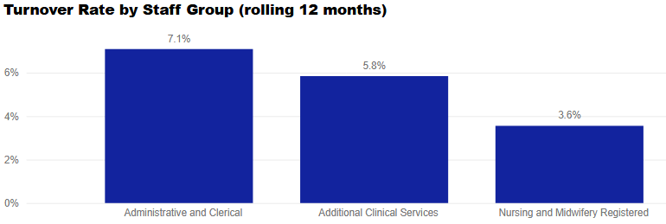

Unavailability
Table 8 Absence FTE- May 2025
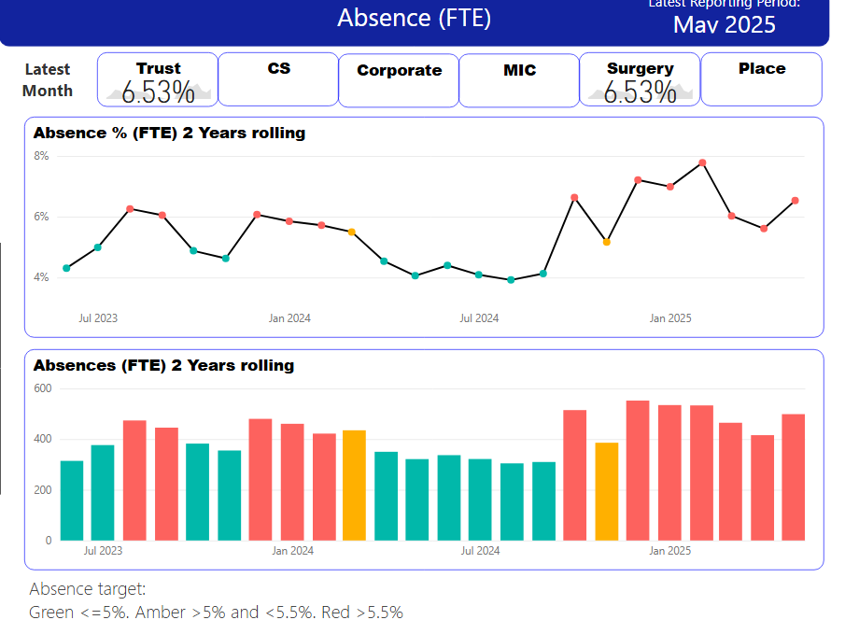
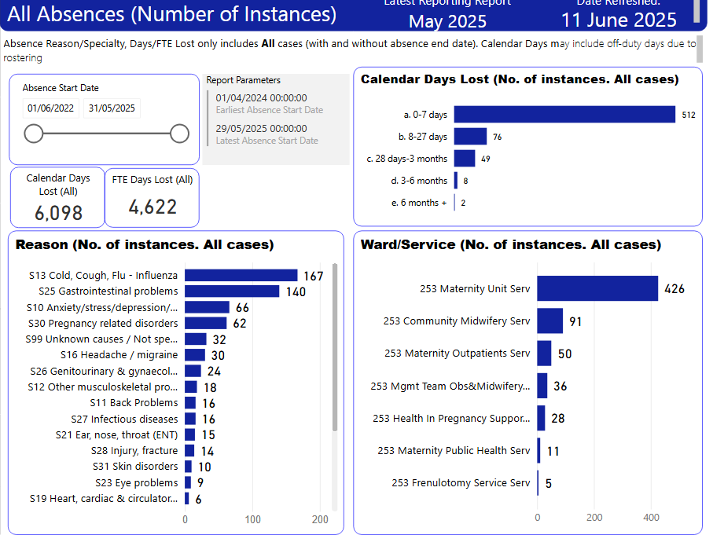

*Midwives only
Line managers have been working with HR to support staff following sickness absence to return to work in a supportive way in an effort to reduce the elevated sickness absence figure.

Maternity specific training
Table 9

 | MIDWIVES  COMPLIANCE % | OBSTETRIC  COMPLIANCE %
PROMPT | 100%  MSW 100%  Anaes 94% | 98%
CTG/FM | 98% | 97%
Saving Babies Lives | 99% | 100%

.
 | Midwifery compliance % | Obstetric compliance %
Adult Resuscitation | 88% | 87%
Neonatal Resuscitation | 82% | 76%

*Reminders are sent out electronically to all staff to remind them of the importance of booking in a timely manner, so they do not reduce compliance by going out of date. This will be monitored closely to ensure compliance is not affected and staff who do not book onto sessions will be reported to Line Managers/Management.
These sessions are facilitated on Delivery Suite by the Resus Team/SPMWPD and the NLS (Newborn Life Support) Instructors.
*MSW Neonatal resus. training is adapted from the full NLS to be relevant and appropriate to their job role.
Table 9 demonstrates current position with maternity specific mandatory training, which forms the core competency framework V2, as part of compliance with the Maternity incentive scheme year 7. The service is currently compliant. A robust plan maintains in place to ensure compliance remains above 90%. The scheme requires 90% attendance of relevant staff groups by the end of the 12-month period in the topics:
1. Fetal monitoring training
2. Multi-professional maternity Emergencies training /PROMPT
3. Neonatal Life Support Training
*PROMPT is PRactical Obstetric Multi-Professional Training
Trust specific mandatory training- Midwifery
Table 10
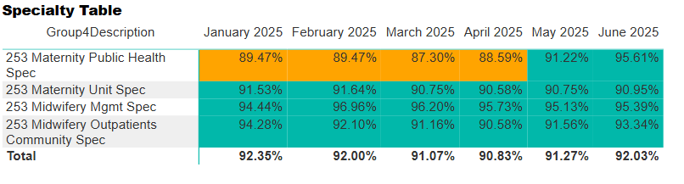
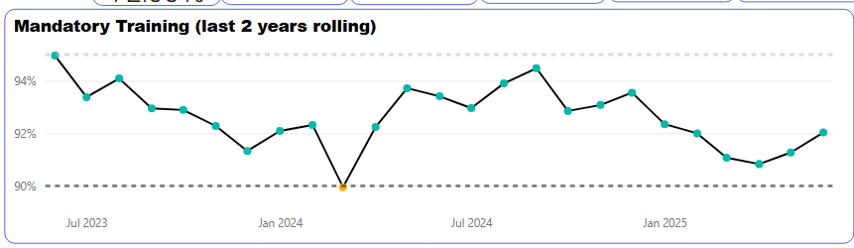

Mandatory training rates have remained above 90% across all topics.
*Maternity public health is a much smaller group of staff therefore small changes have a big impact on the rates.

3.0 RISKS AND MITIGATIONS
The requirements for evidence for Ockenden, Maternity incentive scheme year 7, and the perinatal quality surveillance model for assurance are very specific, and significant in its amount. The Committee is required to receive and minute detailed information particularly in relation to Maternity workforce current position and plans to mitigate risks.
The current risks are as follows:
- The Midlands Regional Maternity heat map has demonstrated a concern around the Midwifery leadership structure that we have committed to resolve. This has resulted in the title change and reviewed job description of the substantive Head of Midwifery to become the Director of Midwifery, and a process to create a new Head of Midwifery role. This process is due to conclude in July 2025.
- The Maternity service currently have a vacancy within the Midwifery and Midwifery support worker workforce, which has been recruited to and new starters are due to commence over the coming months, with the majority joining in September/October 2025. Funded midwifery workforce aligns with the calculations recommended by birthrate plus in 2022.

4. RECOMMENDATION(S)
The Quality Committee team are asked to accept this paper as assurance that Maternity Workforce is being thoroughly reviewed twice per year as per requirements of the Maternity incentive scheme, Safety action 5, and safety is being demonstrated through the data contained within this paper.

Name of Author: Claire Macdiarmid
Title of Author Director of Midwifery
Date 17th June 2025

