Paper ref:



Sandwell & West Birmingham NHS Trust
The Dudley Group NHS Foundation Trust

Report Title: | Nursing Safer Staffing Review - Emergency Department and Community Nursing – The Dudley Group NHSFT.
Sponsoring Executive: | Martina Morris – Chief Nurse and Director of IPC
Report Author: | Philippa Brazier – Associate Deputy Chief Nurse – Workforce and Professional Development
Meeting name: | Executive team | Date: | 18th November 25

Suggested discussion points
This report outlines the approach taken by the Trust to undertake the safer staffing review during September 2025, for emergency department and District Nursing teams in line with national guidance and provides the outcome and recommendations for individual clinical areas from an establishment and skill mix perspective.
Safer Nursing Care Tools (SNCT) /Community Nursing safer staffing tool (CNSST) – summary of the review:
• Overall, the safer staffing establishments within District Nurse (DN) teams are in a positive position to maintain the provision and delivery of safe, effective, high-quality care.
• No serious concerns pertaining to quality and safety have been identified by Community Nursing Service leads.
• Community teams do not currently have the 22% headroom as part of their funded establishment apart from the out of hours team, which has a different staffing model compared to the other community teams.

• Significant work has been completed with DN Recruitment and Retention. In September 2025, there were 18.62WTE vacancies, demonstrating a positive reduction from 55.70WTE reported prior to that time.
• Geographical boundaries were reviewed in September, and agreed changes aim to improve patient experience, reduce travel time, and align caseloads with safer staffing tool recommendations. Teams will now operate based on postcodes rather than PCNs. For example, Halesowen team will gain 120 patients from SLW, aligning staffing with caseload needs. Stourbridge will lose these patients but gain 50 from Kingswinford. These changes will ensure caseloads are effectively managed with the current workforce establishment. Implementation is planned for December 2025.
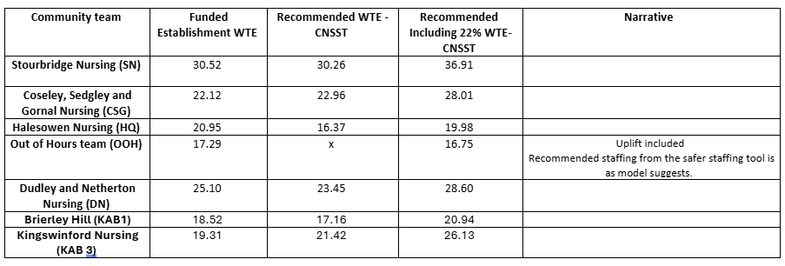
The overall outcome of the safer staffing review is as follows:
- No staffing uplifts or reductions are recommended.
- Community team to realign staffing to postcodes rather than the PCNs as explained above.
- Undertake ED staffing review again in January 2026 due to the poor data collection and compliance with safer staffing review process.

Alignment to our Vision
Patients: | x
People: | x
Place/population:

Previous consideration/ journey
Senior Leaders Group.

Recommendation(s)
The Executive team is asked to:
a) | Receive this report for assurance and evidence of the Trust’s compliance with reviewing safer  staffing (nursing) in line with national requirements.
b) | Agree the recommendations outlined in this report.

Escalation
Nil.

Impact reflected in our Board Assurance Framework (BAF)
BAF Risk 1.0 | x
BAF Risk 2.0
BAF Risk 3.0
BAF Risk 4.0 | x
BAF Risk 5.0 | x
BAF Risk 6.0
Is Quality Impact Assessment required if so, add date: N/A
Is Equality Impact Assessment required if so, add date: N/A


Safer Staffing Review - Emergency Department and Community Nursing Teams
Executive committee
18th November 2025
- EXECUTIVE SUMMARY
The purpose of this report is to inform the Executive team, Quality Committee, People Committee and subsequently Trust Board, of the outcomes of the September 2025 assessment of safe staffing levels using the Safer Nursing Care Tool for Emergency Department and Community Nursing safer staffing tool (SNCTs/CNSST - Shelford Group 2023) and professional judgement. The Developing Workforce Safeguards, published by NHS improvement in 2018 builds on various publications by the National Quality Board (2018) and Lord Carter of Coles review (February 2016) providing guidance and recommendations in relation to the reporting of safe staffing to Trust Boards.
The Developing Workforce Safeguards (NHSI 2018) reinforces the requirement for Trusts to adopt a triangulated approach for the use of evidence-based tools, professional judgement, and patient outcomes to provide assurance of safer, sustainable, and effective staffing. Compliance with the principles outlined in the document is to be assessed annually.
In relation to workforce planning, the guidance recommends that establishment setting must be undertaken bi-annually and this process should consider the following:

- Patient acuity and dependency using the latest validated Shelford Safer Nursing Care Tool
- Activity levels
- Professional Judgement
- Seasonal variation in demand
- Service developments/changes and commissioning.
- Staff supply and experience including e-rostering data
- The use of temporary staffing above the set establishment
- Patient and staff outcome measures

Additionally, comprehensive quality impact assessments must be completed when new roles are introduced, there is workforce redesign or a change in skill mix is considered.
This report fulfils expectations of the Nursing Quality Board’s requirements for Trusts in relation to safer nurse staffing and fulfils several of the requirements outlined in the NHS Improvement Developing Workforce Safeguards guidance which sets out how to support providers to deliver hight quality care through safe and effective staffing. This review also meets standards outlined in the RCN Nursing Workforce Standards (May 2021). Organisations are expected to be compliant with the recommendations in these reports and are subject to review on this as part of the CQC inspection programme under both ‘safe’ and ‘well led’ domains.
At The Dudley Group NHS Foundation Trust, the level of cover (headroom/relief) built into ward establishments is 22% (429 hours) per Whole Time Equivalent (WTE) staff member. This includes:
- 17.5% Annual leave and Bank Holiday
- 3.5% Short term sickness
- 1% Mandatory Training time

Community teams do not have the 22% headroom as part of their funded establishment apart from the out of hours team that has a different staffing model compared to the other community teams. This means there is zero relief for annual leave, sickness and study leave.

Authorised funded establishments should also afford staff in leadership roles the time to assume supervisory status which is evidenced to improve staff engagement and improve patient outcomes. The SNCT /CNSST includes an allowance for ward leaders to undertake their leadership roles in a supervisory capacity for 40% of their time. As a Trust we have committed to supporting our Lead Nurses to have 80% of their time in a supervisory capacity. This was flexed during times of operational extremis and decreased to 60% and has had a negative impact on their supervisory roles.

2. PROCESSES
The safer staffing review has been undertaken using the latest validated Safer Nursing Care Tools (SNCTs) and Community Nursing safer staffing tool (CNSST’S) This is a NICE-endorsed evidence-based tool currently used in the NHS. The overall data collection output when using the tool can be viewed at Appendix 1 & 2
The SNCT/CNSST has been developed to help NHS to measure patient acuity and/or dependency to inform evidence-based decision making on staffing and workforce. Each tool has their own decision matrix (Appendix 2) to support the measurements. The tool, when aligned to Nurse Sensitive Indicators (NSIs), offers nurse leaders a reliable method against which to deliver evidence-based workforce plans to support existing service or the development of new services.
Acuity and dependency measurements should take place twice yearly as a minimum with data collection timeframes locally agreed. An average of the combined data sets is used to support nurse establishment setting/resetting. Ultimately this evidence base should support workforce plans for nursing that should accurately predict and enable resources to be identified to support nursing establishments that meet patient and service needs.
During data collection periods it is strongly recommended that external validation of acuity and dependency measurements is undertaken weekly in partnership with the designated senior nurses. This validation must be undertaken by a senior professional who has been appropriately trained. The Trust identified key senior professionals who were allocated areas to quality assure and validate data collection.
Quality control is seen as fundamental to ensure a robust approach to the data collection. This process ensures accuracy and consistency of scoring whilst providing greater assurance to the Trust board in relation to the tool’s recommendations.
Patient Flow The tool considers patient flow, such as admissions, discharges transfers/escorts. There for the addition of resources for these elements may result in double counting and lead to inaccurate recommendations.
Enhanced therapeutic observations (present in previous versions of the tool) of the additional staffing requirement to support patient needs for safety reasons and/or reducing risk of harm, was not included and needed to be collected separately. The new version of the tool, used in the review has new levels of acuity to meet this progressing need.
Nurse Sensitive Indicators are quality outcomes linked to nursing care. They inform nurses of good and poor patient outcomes enabling sharing of good practice and review of potential reasons for poor quality. Nurse sensitive indicators when aligned to acuity and dependency data and supported with professional judgement will enable agreement of nursing establishment appropriate to meet the needs of each ward/department. These indicators or outcomes can vary between speciality and therefore should be locally agreed for each clinical area.
The main NSIs reviewed as part of this review are unplanned omissions in providing patient medication and patient observation’s (Early Warning Scores EWS) not assessed or recorded as outlined in the plan of care. It is recommended that a delay of 30 minutes in providing pain relief is also reviewed, however this data is challenging to obtain due to the lack of preset family groupings of the medications on the system.
It is widely accepted that these NSIs can be linked to nurse staffing challenges, including leadership, establishment levels, skill-mix and training and development of staff.
Emergency Department:
During the designated two-week period in September, the Emergency Department (ED) undertook acuity data collection. However, the data presented to the Chief Nurse revealed inconsistencies in the collection process, resulting in unreliable outputs. Consequently, the data was deemed insufficient to support a meaningful narrative around safer staffing levels across both adult and paediatric areas.
Considering this, a decision has been made to repeat the safer staffing review in January 2026, in alignment with the wider acute ward assessments. This timing is considered more appropriate given several significant developments currently underway within ED, including:
- The commissioning of the Resuscitation Unit in November.
- The planned co-location of the Paediatric Assessment Unit (PAU), contingent on the availability of beds/trolleys in the Ambulatory Area (AA).
- A recent change in departmental Matron, who will be reviewing the staffing establishment as part of this process.
Additionally, the Medical Division is progressing a substantial service improvement initiative under the “Learn, Adapt and Transform” programme. The anticipated outcomes aim to enhance patient flow through ED and across ward areas, with more streamlined processes to ensure patients are placed in the right ward or area at the right time.
It is important to acknowledge the unpredictable nature of ED demand, where patient volume and acuity can fluctuate significantly. A staffing template that is financially robust must also provide sufficient flexibility to accommodate surges in activity and maintain patient safety. Evidence from the Royal College of Nursing’s Better Care guidance indicates that reducing staff to meet financial targets can compromise timely care and lead to poorer outcomes.
Regulatory bodies, including the Care Quality Commission (CQC), are increasingly attentive to staffing ratios and guidance from the Royal College of Emergency Medicine (RCEM) and RCN. These standards have recently been applied in inspections at our sister hospital, Midland Met. Any review of ED staffing must therefore consider benchmarking, regulatory, and accreditation requirements.
Furthermore, the frequent need for patient transfers for imaging and escort duties places additional demand on staffing, particularly given the location of the medical bed base on the second floor.
Next Steps:
- The safer staffing review will proceed in January 2026.
- Staff will receive training and guidance to ensure accurate and consistent acuity data collection during the review period.

3. NURSE SENSITIVE INDICATORS
Nurse sensitive indicators (NSIs) refer to quality outcomes that can be linked to nurse staffing issues, including leadership, establishment levels, skill-mix and training and development of staff. This information can be further used to support ward staffing requirements identified through acuity and dependency measurement. Medication errors, slips, trips & falls and pressure ulcers are all NSIs which have been identified as key indicators of quality of care with specific sensitivity to nursing intervention and lack of.
These are regularly scrutinised across the divisions and within the clinical areas, with a significant amount of work being undertaken to support their reduction.
Incident type by cluster and overall percentage reported: 100 incidents: 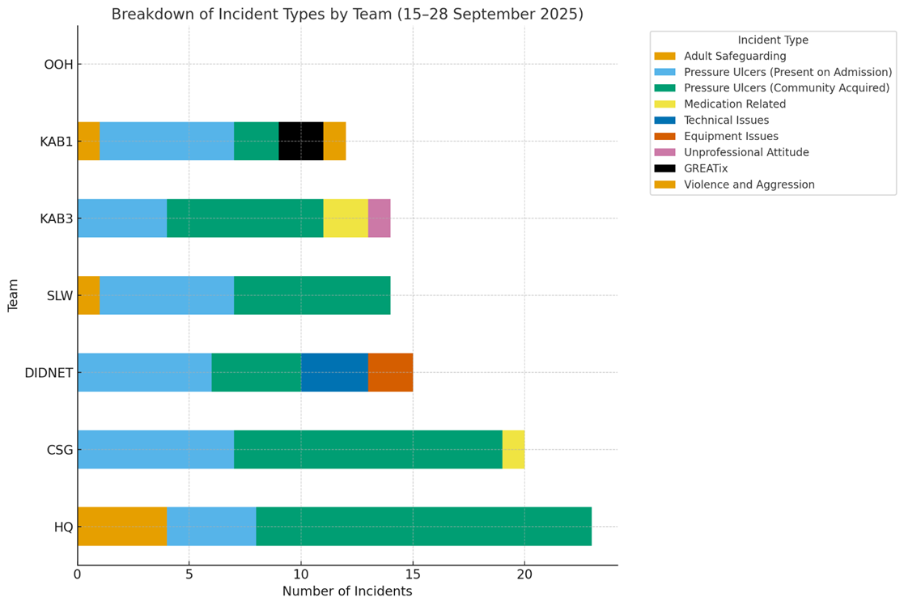
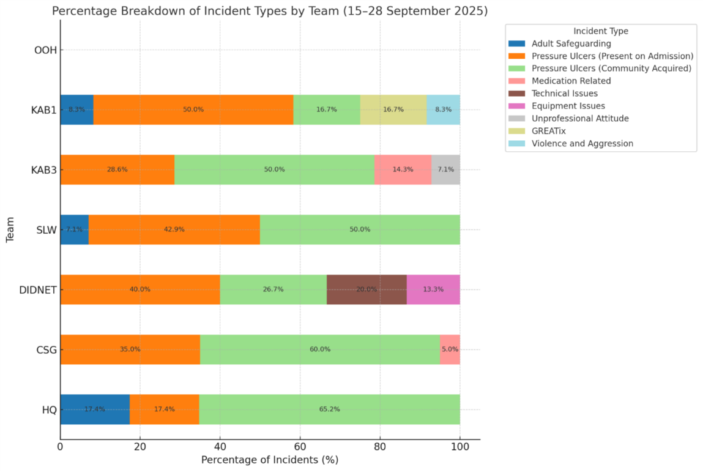

Overarching incident themes:
Rejected incidents were all related to duplicate submissions under skin damage subcategories, 5 of these were previously reported by the acute trust prior to the patients being discharged.
Community acquired skin damage incident reports feature as the highest reported category with present on admission skin damage being the runner up. Skin damage incidents were the highest reported categories across all clusters excluding Out of Hours, who did not submit any reports across the reviewed timeframe.
Skin damage both community acquired and present on admission continue to feature above 2/3 of the total incidents reported. This is reflective of the usual pattern reported.
There were 7 safeguarding incidents reported across the timeframe featuring in 5 out of 7 of the clusters (all featuring at least one incident). OOH and CSG did not report any safeguarding incidents during this time frame.
2 clusters reported medication related incidents (3): 2 for the same patient/cluster with learning and 1 relating to patient refusal in another cluster.
Out of Hours did not submit any reports across the review timeframe, however this is not unusual for this team, they have minimal incidents to report. OOH do not routinely perform skin checks; this would account for one theme major difference between the day service and them.
In terms of positive reporting, KAB1 featured 2 GREATix submissions within the timeframe.

4. PROFESSIONAL JUDGEMENT

Professional judgement can be described as the use of accumulated knowledge and experience, as well as critical reasoning to make an informed professional decision – often to help solve a problem, or in relation to a patient; or policies and procedure affecting patients. Staffing decisions based solely on professional judgement are considered subjective and may not be transparent.
However, professional judgement remains an essential element of safer staffing decisions. For this reason, the Trust uses a triangulated approach, with safer staffing data, clinical quality indicators and professional judgement.
As part of the safer staffing reviews professional judgement must include consideration of the following:

- Professionally do you agree with the proposed staffing establishment? If no, why?
- Is the staffing establishment similar to other DN team with the same caseload?
- Is the team operating with high number of vacancies, high staff turnover, sickness absence and/or using a high level of temporary staffing?
- Are the current staff being rostered properly? What is your RN/CSW ratio per shift.
- Number of current double up visits?
- Does the geographical area add to workload e.g. because of distance between visits/borders? Consider Mileage/Out of area patients with a Dudley GP/Connectivity issues/Safety of areas – requiring joint working to maintain safety
- Does the amount of work vary between times of day and day of the week?
- Does the team have a high patient referral/turnover/throughput?
Another key item which has been factored into the review is the time commitments required when undertaking our safeguarding processes. Anecdotally each referral takes 45-60 minutes with additional work following for case conferences, preparation of reports and ensuring the additional safety requirements of the patients are met.
Professional Judgement has been a key guiding influence with this and the knowledge of seasonal variation within the patient cohorts, the impact of flow and capacity challenges during the data collection month and the additional measures undertaken to support patient care, and experience.

Current DN Staffing Establishment:
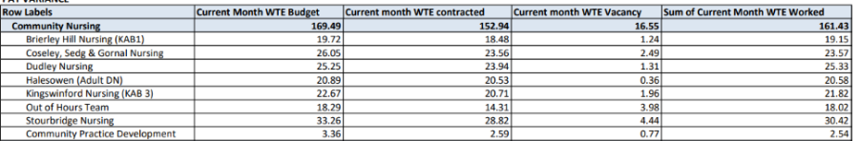
Significant work has been completed with DN Recruitment and Retention. In September 2025, there were 18.62WTE vacancies, demonstrating a positive reduction from 55.70WTE reported prior to that time.
There is a predominantly junior workforce within some teams (21 graduates within the last 12 month).
Community Long term sickness
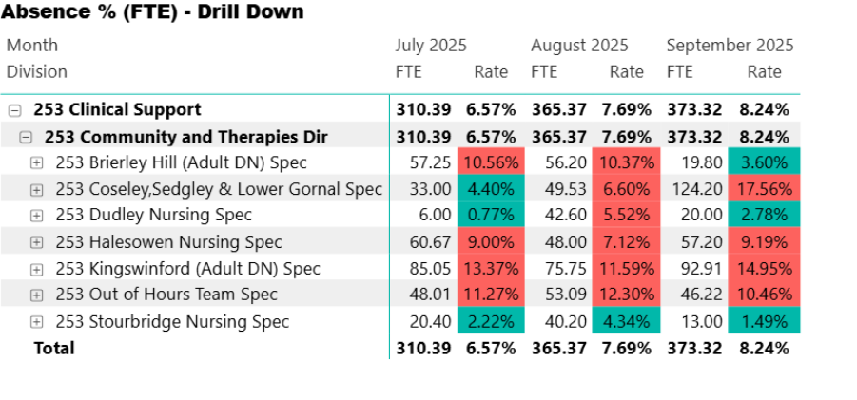
Ongoing Long Term Sickness challenges within some teams mainly OOH. Delayed wellbeing reviews to support staff to RTW due to SHAW staffing challenges to meet with staff in a timely manner and action referral.
Bank Spend week 1 to 28
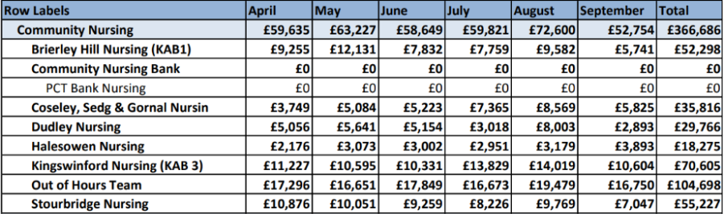
- TRAINING
The initial all individuals involved in the data collection and data assurance within community had to undertake training re knowledgeable and competent to assess acuity and use the CNSST. Following completion of training, individuals who were undertaking the reviews or quality assuring the reviews completed an assessment to verify competence. This training is required two yearly or if staff require a refresher, this then gives data integrity can be assured by ensuring staff have relevant training and are competent.
- WHAT DOES THE DATA TELL US
Overall, the community nursing safer staffing establishments are in a positive position to ensure the provision of safe, effective, high-quality care. Quality assurance/validation
Community team | Total Category 1 | Total Category 2 | Total Category 3 | Total Category 4 | Funded Establishment WTE | Recommended WTE -CNSST | Recommended Including 22% WTE- CNSST | Narrative
Stourbridge Nursing (SLW) | 224 | 490 | 40 | 40 | 30.52 | 30.26 | 36.91
Coseley, Sedgley and Gornal Nursing (CSG) | 988 | 345 | 268 | 36 | 22.12 | 22.96 | 28.01
Halesowen Nursing (HQ) | 582 | 80 | 415 | 62 | 20.95 | 16.37 | 19.98
Out of Hours team (OOH) | 532 | 62 | 387 | 7 | 17.29 | x | 16.75 | Uplift included  Recommended staffing from the safer staffing tool is as model suggests.
Dudley and Netherton Nursing (DN) | 888 | 318 | 320 | 108 | 25.10 | 23.45 | 28.60
Brierley Hill (KAB1) | 673 | 253 | 273 | 23 | 18.52 | 17.16 | 20.94
Kingswinford Nursing (KAB 3) | 854 | 387 | 213 | 14 | 19.31 | 21.42 | 26.13

Area | RECOMMENDATIONS & NEXT STEPS | Chief Nurse  Outcome of Professional discussion with Divisional CNs
General finding of the District Nurse teams | - ECOMMUNITY: all teams now solely allocating using ECommunity, paperless process since 30.9.25. We are working towards all teams successfully allocating twice weekly. ECommunity administrator supporting with local action plan, SOP and troubleshooting support for staff. BCP in place.  Next steps to update treatment codes in several steps as advised by Allocate. Work with caseload analysis tool and skills within ERoster to be completed also to support full functionality of system.  - Focus upon Quality-Senior Leaders continue to have visibility at sites, supporting clinically and in absence of DN team leaders.  - 4 DN team leaders with prescribing qualification being supporting by ACPs to maintain and develop competencies, SPDNs who qualify also now have this course.  - Progress with training for the delegation of insulin to remaining Band 3 staff.16 staff are applicable to complete and participate. 11 are completed and signed off and are doing the task. Challenges to completion for the remaining 5 are lack of suitable patients on the team caseload, lack of senior support to complete, further support needed to gain confidence. The position has improved significantly within the last 2 months thanks to the hard work of the teams.  - All staffing rosters reviewed, day teams moving to 1 in 3 weekends for all staff to support caseload demand, and reduce Bank spend.  - Peer review of acuity of patients on DN caseloads.  - Review and identify triage model for DN service, to support future SPA plan task and finish group established. Robust triage will support efficient management of duplicate referrals, with the aim to centralise triage. Current timeframe for this will be February 2026. | Agreed with no change within the community teams and happy with the actions recommended to review the boundaries within the teams work allocation.
KAB3 | - They are currently scoping a change in location for the KAB 3 team as this will reduce travel time and improve attendance at handover as travel time to and from the current site to patients' location is around 15-25 minutes. This will support with reducing the cost of travel and attending to unplanned call outs within a more suitable time frame and will increase capacity within the team allowing more clinical time to see planned patients. We are scoping a room at one of the larger GP surgeries within the boundary and this will support with team working and GP collaboration.
HQ | - They are working towards finalising the Geographical SOP which has enabled us to complete a caseload review. Some teams are gaining/losing caseload, which will support the safer staffing tool recommendations and improve patient experience, reduce travel time and will be post code focused rather than PCN. For example, HQ funded staffing is currently 20.95 and recommended is 16.37, from the Geographical review HQ will be gaining approximately 120 patients from SLW which will in turn require the need for the currently funded staffing and SLW are losing this caseload however gaining approximately 50 from KAB 3 who's current funded staffing is below the recommended and will enable them to have more capacity for the caseload they will have as a result of the changes.

CNSST quality review-
Both District nurse service leads undertook the same approach to quality review the CNSST complexity scoring. They were present at the DN team's handover to identify any changes that may have occurred during the visit. They held a professional discussion with the staff allocated to score that day, then challenged when needed in relation to score and this was documented on the forms submitted for validation. They did find that the scoring became more accurate in the 2nd week due to staff becoming more familiar with the matrix. With regards to out of hours team the service leads, and the lead Nurse met and went through some planned and unplanned caseload and the complexity of the patients. They were unable to sit in handover due to the time this is done but were still able to have that professional challenge.
11. RISKS
The use of professional judgements remains subjective, however has been extremely important with the understanding as to the differences in recommendations between the tools and the actual of the current establishments. The interpretation of the data available is also subjective however it is felt that the scrutiny and wider understanding of the information by the Chief Nurse, Deputy Chief Nurse and Associate Deputy Chief Nurse has been able to support the Divisional Chief Nurses interpretation.
12. NEXT STEPS
The proposed next steps are as follows:
- Executive Team, Quality Committee and People Committee to discuss, consider and provide view on the outcome and recommendations of the review.
- Further training sessions to be made available for ED staff before the next data collection is undertaken in January 2026 and support with the staff during the data collection.
- Completed safer staffing review for acute ward areas in January 2026.
- Complete safer staffing for Theatres, Neonates, Critical care and Community, the potential outpatient's department and same day emergency care at the same time in March 2026.

Community matrix- Appendix 1

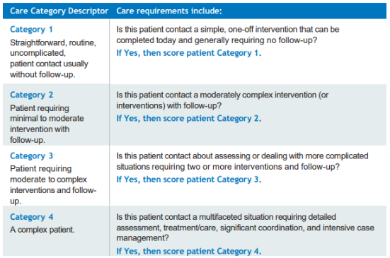
Safer Nursing Care Tool Decision Matrix Emergency department- Appendix 2
