Paper ref:



Sandwell & West Birmingham NHS Trust
The Dudley Group NHS Foundation Trust

Report Title: | Nursing Safer Staffing Biannual Review - Inpatient areas, Acute Medical Unit and Emergency Department.
Sponsoring Executive: | Martina Morris – Chief Nurse DGFT and Deputy Group CNO  Mel Roberts – Group CNO
Report Author: | Philippa Brazier – Associate Deputy Chief Nurse – Workforce and Professional Development
Meeting name: | People committee |  | 28th April 2026

Suggested discussion points
This report outlines the approach taken by the Trust to undertake safer staffing reviews, in line with national guidance (National Quality Board), and provides the outcome and recommendations for individual clinical areas from an establishment, skill mix, acuity coupled with professional judgement perspective.
During this period, a specific acuity review report has also been completed which supplements this latest safer staffing review and provides evidence of rising complex patient management and its impact on staffing and quality. Please see a separate paper for more details.
Summary of outcome:
- Overall, the safer staffing establishments remained generally in a positive position to provide and deliver safe, effective, high-quality care.
- No significant quality and safety concerns were identified by Divisional Chief Nurses associated with their current establishments, although patient acuity has increasingly been very challenging in some areas requiring additional temporary staff to maintain patient safety and quality. The main negative impact has been on patient experience especially with corridor care due to lack of privacy and dignity, affecting patients being able to sleep due to lighting and noise.
- It remains evident from the quantitative data collected as part of the review, that we must always apply professional judgement and triangulate it with nurse sensitive indicators alongside the data to agree safe staffing establishment. This approach has been a key guiding principle and the knowledge of seasonal variation within the patient cohorts, the impact of flow and capacity challenges during the data collection month and the additional measures undertaken to support patient flow, safety and experience.
- The significant change from the last 3 staffing reviews in the increase in 1b category of patients, who require increase of nursing care as they are dependent on nursing care teams to meet most or all their care needs and a decrease of acuity 0, that are patients who may only require minimum care.
- The following table provides a summary of the clinical areas that have requested changes and if these were supported, subject to the Divisions identifying their required workforce reduction elsewhere or identifying funding to enact the change/submission of a business case and completion of a Quality Impact Assessment (QIA).

Establishment change requests following Divisional reviews:
Ward | Request changes
AMU2 | Request for an additional RN for nights to support SAM guidance compliance.
C1A | Request to increase current establishment by 2.73 WTE CSW to support enhanced observations on nights.
ED | Request for staff increase to achieve 1:1 care ratio in resus and to staff 6 cubicles.
C6 | Request for an additional CSW on nights.
B4 | Request for an additional RN - day and night.
B2 Hip | Request for an additional CSW for nights, which should eliminate the requirement for an additional bank CSW for 1:1 care.
B3 | Request for an additional CSW for nights.
B5 | Request for an additional RN on nights. However, before any changes are agreed, this area needs to be re-reviewed from a safer staffing review perspective.
Surgical SDEC | May require changes however requires a robust review in the first instance, which is in progress.
C2 | Request for an additional CSW - day and night.

- Detailed review was conducted by the Divisional Chief Nurses, together with HR and Finance business partners and clinical leaders from each area.
- The majority of clinical area staffing establishments have not been identified as requiring amendments.
- In terms of Medicine, full realisation of the Learn, Adapt and Transform (LAT) project remains a priority, with ensuring that Surge area is closed, Discharge Lounge is reinstated and identified clinical areas closed as per the plan. AMUA closure is already being progressed with plans being developed for closure of AMU 3 (A4). This will result is staff being moved to other clinical areas, which will significantly help with vacancy management across the Trust and could support with the proposed establishment changes as outlined below.
- Equality and Quality Impact Assessments (E/QIAs) will be completed by the Divisions to outline any risks and mitigations associated with any staffing related decisions.
Site Chief Nurse recommendations for establishment changes:
Following the Divisional review, each Divisional Chief Nurse has met with the site Chief Nurse and Associate Deputy Chief Nurse – Workforce and Professional Development to discuss their recommendations and provide constructive challenge, using data triangulation, professional judgement, quality indicators and wider intelligence.
The site Chief Nurse recommendations are as follows:
- Agreement on no staffing establishment changes in most clinical areas as articulated in Table 5 of this report.
- From the clinical areas listed in the above table, no changes are supported for C6, B3, C2 and B5 at the present time.
- Medicine - AMU2 and C1a should develop a business case if no funding is available within the current financial envelope or other opportunities for staff moves identified, to increase their staffing as articulated in the above table. In addition, consideration should be given to support an increase in cubicle use within resus to 6 and 1:1 care provision, subject to business case approval.
- Surgery - B2 Hip and B4 should develop a business case if no funding is available within the current financial envelope or other opportunities for staff moves identified, to increase their staffing as articulated in the above table.
- E/QIA must be completed as part of the process.
In addition, an uplift on C3 as agreed by the Executive team as part of the last review for Band 2 Clinical Support Worker (CSW) should be enacted. This has been delayed due to funding approval and enhanced vacancy controls. Bank has been utilised to mitigate the gap in the meantime.

Further to the Group Chief Nursing Officer review and discussion at Execs, this addendum reflects the view of the Group chief nurse and outcome of the discussion at the executive committee on the 24th March 2026 regarding the safer staffing 6 monthly review and subsequent report.
Group CNO Recommendations:
- Group Chief Nurse and DOF to meet with all 4 areas following discussions with the divisional Chief Nurses for surgery and to explain decision making
- Plan to increase ED resus to 6 beds from October as part of winter planning. ED to undertake demand and capacity exercise in relation to resus ensuring only patients that are within resus receiving resus support are included in this work. Share learning from Sandwell ED re flexing beds in times of high demand.
- Triangulate with finance at Group level – CW highlighted that some areas were not staffing to baseline, and budgets had been set at Month 10 run rate so would include any bank usage and there has been a vacancy freeze in place.
- Aim to reassess staffing levels in three months following the LAT work and closure of beds alongside the community shift to assess impact.
- Addendum to go to Execs from the Group Chief Nurse with recommendations.
- Equity work to be encompassed into SS paper every 6 months.
- Share ETOC work from Sandwell across DGHFT to support 1-1 observational needs.
- Access requirements for 1:1 observations over a 3 year period to gain a reflection of need and demand of DG patient group.
- Implement triumvirate meeting of DOF, COO and Group CNO 6 monthly to review staffing paper prior to submission to Executive meeting
- Ensure future staffing reports include the Group Chief Nurse recommendations

Alignment to our Vision
Patients: | x
People: | x
Place/population: | x

Previous consideration/ journey
Divisional meeting (Divisional Chief Nurse, HR and Finance business partners) and then site Chief Nurse meeting with Divisional Chief Nurses.

Recommendation(s)
The Executive team is asked to:
Receive this report for assurance and evidence of the Trust’s compliance with reviewing safer
staffing (nursing) in line with national requirements.
Debate and provide view on the recommendations outlined in this report.

Escalation
N/A. Report to be presented at People Committee.

Impact reflected in our Board Assurance Framework (BAF)
BAF Risk 1.0 | x | Failure to deliver the right care, in the right place every time
BAF Risk 2.0 | x | Failure to ensure Dudley is a brilliant place to work and thrive
BAF Risk 3.0 |  | Failure to build innovative partnerships to improve the health of our communities
BAF Risk 4.0 | x | Failure to remain financially sustainable in 2025/26 and beyond
BAF Risk 5.0 |  | Failure to achieve operational performance requirements & deliver strategic objectives
BAF Risk 6.0 |  | Failure to take sustained action on infrastructures that enables strategic objectives
Is Quality Impact Assessment required if so, add date: TBC
Is Equality Impact Assessment required if so, add date: TBC

Safer Staffing Bi-annual Review Report – March 2026.
1 EXECUTIVE SUMMARY
To deliver safe quality patient care it is essential wards have optimal Nurse staffing levels. It has been acknowledged that one of the contributory factors linking failures in care and patient safety were inadequate staffing levels (Francis 2013). In July 2016, the National Quality Board published ‘Supporting NHS providers to deliver the right staff with the right skills, in the right place at the right time: Safe, sustainable and productive staffing’. This safe staffing improvement resource provided updated expectations for Nursing and Midwifery care staffing. The Developing Workforce Safeguards (DWS) published by NHS Improvement in October 2018 will assess Trusts compliance with a more triangulated approach to Nurse staffing planning in accordance with the National Quality Board guidance for all clinical staff. This document recommends a combination of evidence-based tools with professional judgement and nurse sensitive indicators to ensure the right staff, with the right skills are in the right place at the right time.
To demonstrate the Trust’s commitment to the above requirement a twice-yearly Adult Inpatient, Acute Assessment units and Paediatric inpatient skill mix review is completed.
The NHS Trust uses the ‘Safer Nursing Care Tool’ (SNCT). The SNCT is a simple-to-use, evidence based digital tool that calculates nurse staffing requirements based on the acuity and dependency (A&D) of the patients on a ward with data triangulated to nurse sensitive outcome indicators (NSI) and professional judgement from an experienced senior member of staff.
The SNCT has been rigorously validated using a substantial database over several years and is now widely used by NHS Trusts. The development of the SNCT has been supported and endorsed for use by NHS England and NHS Improvement. The SNCT now includes different staff multipliers for Acute Assessment Units, Acute Inpatient and Children and Young People’s Wards, and the ED-SNCT for Emergency Departments.
This tool enables the measurement of both acuity & dependency and can be applied to patients whose care can be delivered within acute adult, paediatric or acute assessment settings. A multiplier for calculating establishments will suggest Nursing Whole Time Equivalents (WTE) required to provide a safe and appropriate standard of care for each of the five levels of acuity and dependency identified by SNCT. Nurse Sensitive Indicators (NSIs) are quality indicators, which can be influenced by Nursing establishments and skill mix (appendix 2).
A&D data is collected twice a year to reflect seasonal periods (January and June) for one full month from:
- All Adult inpatient ward areas.
- Acute Assessment wards/units.
- Paediatric inpatient wards/one Paediatric Assessment Unit.
The SNCT June 2024 review incorporated the two new levels of care (1c, 1d) to capture patients requiring additional staffing resources to mitigate risk and maintain safety. The Tool also allows the basic scoring of ‘empty beds ’at level 0 providing a more accurate comparison to wards fully occupied.
In undertaking the skill mix review the A&D data is triangulated against Professional Judgement and Nurse Sensitive Indicators (NSI) and includes Falls, Pressure Ulcers, Medication Incidents, Complaints and Health Care Associated Infections (Appendix 7). Professional judgement considers ward layout, escort duties, shift patterns and other aspects (Appendix 4).
Emergency Department Safer Nursing Care Tool was adapted in December 25 for patients who remain in the Emergency Department for 12 hours or longer continue to be included within the Emergency Department Safer Nursing Care Tool (ED SNCT) acuity and dependency assessment for the duration of their stay in ED. The ED SNCT is location‑based rather than time‑based, and prolonged ED stays increase nursing workload and dependency, requiring professional judgement adjustment and triangulation alongside ED SNCT outputs.

Results

Occupancy, ACUITY, and dependency
The data in Table 1 below compares data from the previous establishment reviews undertaken biannually from June 2024 to Jan 2026 and shows the acuity split of patients across all inpatient areas including children and emergency department based on ‘levels of care’ (appendix 2). This summary shows an increase in the average of acuity of level 1b patients over the last four reviews.
The table also shows an increase of level 2 patients who need to be managed within a clearly identified designated bed space with resources, expertise and staffing levels.
Table 1 (average Acuity Scores collected by Level of care):

 | Jun 24 | Jan 25 | Jun-25 | Jan-26
Average acuity
Level 0 | 12.04 | 10.81 | 12.89 | 5.85
Level 1a | 6.02 | 6.45 | 6.09 | 4.54
Level 1b | 13.62 | 11.24 | 12.49 | 14.28
Level 1c | 2.07 | 2.58 | 3.12 | 1.90
Level 1d | 0.06 | 0.19 | 0.01 | 0.07
Level 2 | 0.79 | 0.89 | 0.87 | 1.14
Level 3 | 0.04 | 0.11 | 0.11 | 0.02
Empty beds | 1.53 | 1.3 | 2.10 | 1.40

Graph 1 below shows the change in acuity over time. From June 24-January 26

Recording of level 0 and 1a patients has continued to see a decline since June 2024. Previously an increase in level 2 activity was recorded over the January reviews period compared to June, potentially driven by seasonal acuity but this wasn’t the case in January 26 review.
The most significant change is the increase in 1b patients, reflecting a higher proportion of individuals who require increased nursing care and are dependent on nursing care teams to meet most or all their care needs. This accompanied by a reduction in level 0 patients who require minimum care.

Graph 1: Changes in acuity (last 4 SNCT reviews):

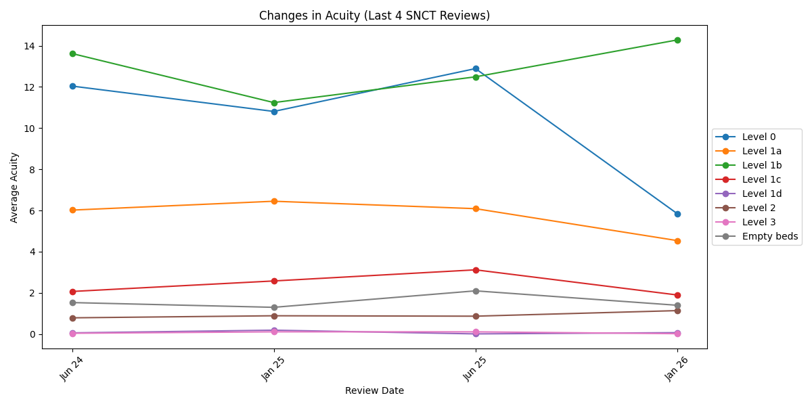

Nurse Sensitive Indicators (NSI) by ward comparison of JUNE 24 - Jan 26
Table 2 shows NSIs by ward comparing June 24 - January 26, providing a comparison across the staffing reviews
Nurse Sensitive Indicators are quality outcomes linked to nursing care. They inform nurses of good and poor patient outcomes enabling sharing of good practice and
review of potential reasons for poor quality. Nurse sensitive indicators when aligned to acuity and dependency data and supported with professional judgement will
enable agreement of nursing establishment appropriate to meet the needs of each ward/department.
It is widely accepted that these NSIs can be linked to nurse staffing challenges, including leadership, establishment levels, skill-mix and training and development of
staff.
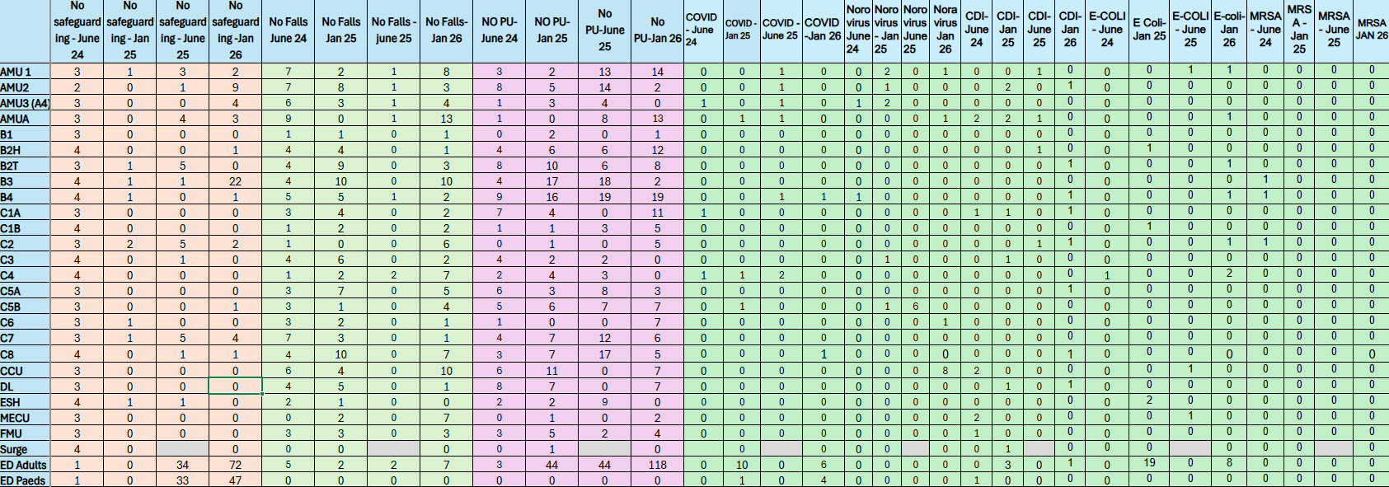

Establishments
Applying the SNCT multipliers (described in Table 1) to the acuity data collected, the differential between funded establishments and required establishments are calculated inclusive of 22% uplift (to provide direct comparison).
At The Dudley Group NHS Foundation Trust, the level of cover (relief) built into ward establishments is 22% (429 hours) per Whole Time Equivalent (WTE) staff member. Current practice at DGFT is that 15% of 22% relief can be recruited into and forms part of the wards/clinical area establishment but this is not in place consistently across all areas and standardisation requires Executive team agreement.
This includes:
- 17.5% Annual leave and Bank Holiday
- 3.5% Short term sickness
- 1% Mandatory Training time

It is recognised that the allocated 1% (15 hours) time for mandatory training is not sufficient. The undertaking of Priority 1 training, priority 2 and 3 training, appraisal support and preparation, professional registration reflections, Practice Supervisor and Assessor requirements and any additional champion/link roles require on average 143 hours for a Nurse, Midwife or Allied Health Professionals (AHP). Priority one training is being reviewed nationally and we were due to hear the new recommended training beginning of April, but we still haven’t heard for this to be updated in the trust. Other areas to be reviewed is the disparity with AHP staff protected time for CPD, that is not part of the Nurses allocated time.

Accuracy of Acuity
Inter-rater reliability audits of acuity data capture alongside professional confirm and challenge on submitted ward acuity has outlined that continuous training is required for all registered Nursing staff. This includes Matrons, Lead Nurses and shift Leads in all areas where staffing establishment reviews use the SNCT and will ensure staff understand the importance of accurate data entry and what the data is utilised for. This training at Dudley is required two yearly or if staff require a refresher, this then gives data integrity can be assured by ensuring staff have relevant training and are competent.
Skill Mix
The minimum skill mix recommended by the Royal College of Nursing (RCN) is a ratio of 65/35 Registered Nurses/Clinical Support Workers. The Trust agreed aspirational skill mix is 70/30 ratio; however, this is often not achieved with an average ratio of 60/40

In many areas where the acuity and intensity of patients have increased, and treatment and medication regimes are complex, further reduction in the overall skill-mix of registered to unregistered staff is not appropriate to maintain safe staffing levels and ensure adequate supervision. Focus is required to continue reviewing the overall registered to unregistered staff ratios to ensure any derogation is linked to planned model of care changes. This is reflected in January’s 2026 safer staffing review due to the implementation last year of the national changes of the non-registered workforce with the introduction of band 3 Higher care support workers in majority of our clinical areas and the impact this will have.

The ratio of Registered Nurses to Clinical Support Workers may be lower in some less acute areas such as areas where care needs are greater than nursing skill needs, or where other staff are involved in delivering care, for example, Assistant Practitioners and Allied Health Professionals (registered professionals) contribute significantly towards meeting patient needs

Table 3: demonstrates the different ratios of the Registered to non-registered skill mix, based on the acuity/speciality.

Jan 26 | RN/CSW% |  | Jan 26 | RN/CSW% |  | Jan 26 | RN/CSW%
AMU1 | 60/40 |  | B5 | 60/40 |  | C7 | 50/50
AMU2 | 55/45 |  | C1A | 50/50 |  | C8 | 55/45
AMU3 (A4) | 50/50 |  | C1B | 50/50 |  | CCU | 80/20
AMUA | 55/45 |  | C2 | 80/20 |  | DL | 50/50
B1 | 60/40 |  | C3 | 55/45 |  | SURGE | 50/50
B2H | 40/60 |  | C4 | 70/30 |  | MECU | 75/25
B2T | 50/50 |  | C5A | 60/40 |  | FMU | 30/70
B3 | 55/45 |  | C5B | 55/45 |  | ED | 60/40
B4 | 50/50 |  | C6 | 50/50 |  | ED paeds | 60/40

Jan 26 | Request suggested by ward leadership | Suggestions supported by divisions | Jan 26 | Request suggested by ward leadership | Suggestions supported by divisions | Jan 26 | Request suggested by ward leadership | Suggestions supported by divisions
AMU1 | Yes | No | B5 | Yes | No | C7 | No | No
AMU2 | Yes | Yes | C1A | Yes | Yes | C8 | Yes | No
AMU3 (A4) | Yes | No | C1B | Yes | No | CCU | Yes | No
AMUA | Yes | No | C2 | Yes | No | DL | Yes | Yes
B1 | No | No | C3 | No | No | surge | Yes | Yes
B2T | No | No | C4 | yes | No | MECU | Yes | No
B2H | Yes | Yes | C5A | No | No | FMU | No | No
B3 | yes | No | C5B | No | No | ED | Yes | Yes
B4 | Yes | Yes | C6 | No | No | ED paeds | yes | No

Table 4: Shows the overall position of the wards at the end of Jan 2026 safer Nursing care tool (SNCT).
Showing the average acuity levels and based on the SNCT tool the recommended budget and the last 2 previous budgets and the difference.

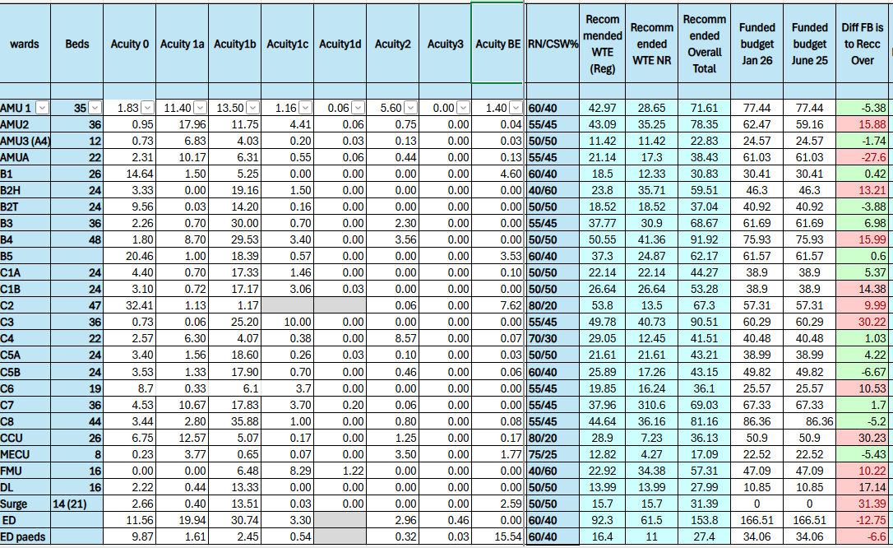

tRUST Care Hours per Patient Day (CHPPD)

Care Hours Per Patient Day
An additional part of the skill mix review has been to use data available on the NHS Model hospital to benchmark the Trust position with Care Hours Per Patient Day (CHPPD) (graph 4).
Graph 4 shows the position of the Trust CHPPD both nationally and when compared with peers for the review period of Jan 2025, the Trust value is 7.6 against a regional peer value of 8.6, Walsall Healthcare Trust (WHT) sat at 7.2.
Graph 4 shows the position of the Trust CHPPD both nationally and when compared with peers for the review period of Jan 2026, the Trust value is 8.4 against a regional peer value of 8.6.
Graph 3 – Care Hours per Patient Day – Total Nursing/Midwifery staff (Nov 25):
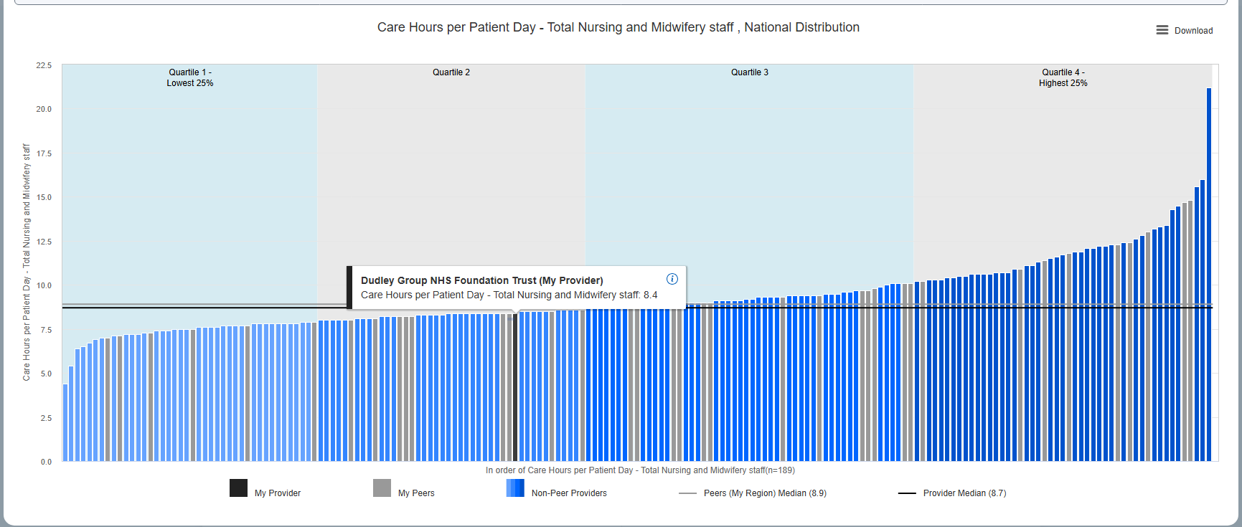
The summary position for the last three months to the data collection is shown in table below. A more detailed position for Jan 26 is in Appendix 5.
% Fill Rate | NOV 25 | DEC 25 | JAN 26
Registrant Day | 86 | 85 | 83
Registrant Night | 91 | 92 | 90
Non-Registered Day | 87 | 85 | 82
Non-Registered Night | 97 | 95 | 95

Analysis
It is essential that decisions to change staffing requirements are based on a thematic analysis over time rather than a single point measurement unless:
- One measurement has changed significantly and is supported by other triangulated data.
- Activity and/or acuity has been altered significantly (change of speciality/bed base change).
In this case other triangulated evidence is summarised in each individual departments’ summary.
The skill mix review was concluded by the site Chief Nursing Officer, Associate Deputy Chief Nurse – Workforce and Professional Development, Divisional Chief Nurses, Finance and HR business partners.
- PROFESSIONAL JUDGEMENT
Professional judgement can be described as the use of accumulated knowledge and experience, as well as critical reasoning to make an informed professional decision – often to help solve a problem, or in relation to a patient; or policies and procedure affecting patients. Staffing decisions based solely on professional judgement are considered subjective and may not be transparent.
However, professional judgement remains an essential element of safer staffing decisions. For this reason, the Trust uses a triangulated approach, with safer staffing data, clinical quality indicators and professional judgement. Details of the data sources, in addition to the below can be found in Appendix 4.
As part of the safer staffing reviews professional judgement must include consideration of the following:
- Ward layout/facilities: The configuration of wards and facilities affect the nursing time available to deliver care to patients, and this can be reflected in staffing establishments through professional judgement. For example, ward layouts, might make adequate surveillance of vulnerable patients more difficult. Some ward layouts are associated with significantly more walking between patients than others. Some wards have essential functions (dirty utility) out of the main ward environment.
- Escort duties: This is not captured by the Safer Nursing Care tool. Consideration needs to be given if this role is likely to affect the numbers of staff required, a local data collection and analysis exercise must be undertaken to determine a percentage to be added to the establishment to ensure staffing remains responsive to daily patient care need. This data has been captured using the Safecare (Allocate) system and the data has been made available for review.
- Shift pattern: The type of shifts (long day versus short day) in use may affect the overall establishment required to ensure shift-to-shift staffing levels. These should be monitored to understand the impact and effect on staff and patients.
- Multi-professional working: Consider the make-up of the care team for the ward. Would specific AHPs or support roles meet the needs of patient groups at periods of the day more appropriately? Conversely the absence of administrative support staff such as ward clerks may increase nurses' workload at times.
The following questions have been considered throughout this review:
- What is the care/treatment to be provided?
- What competencies are required to deliver that care/treatment?
- Which staff member (taking into consideration the wider multidisciplinary team) is competent and best placed to deliver that care/treatment?
- Can aspects of the care/treatment be safely delegated with appropriate education and training (if so, to whom)?
- What are all members of the team responsible for?
Another key item which has been factored into the review is the time commitments required when undertaking our safeguarding processes. Anecdotally each referral takes 45-60 minutes with additional work following for case conferences, preparation of reports and ensuring the additional safety requirements of the patients are met.
It is clear from the quantitative data that there is a disconnect between the tools recommended staffing establishments and the current funded staffing establishments. Throughout the reviews gaps have been scrutinised as best as possible and all the available data has been triangulated. However, it is recognised that some data has not been collected appropriately, and ongoing training will be provided prior to the next review. Professional Judgement has been a key guiding influence with this and the knowledge of seasonal variation within the patient cohorts, the impact of flow and capacity challenges during the data collection month and the additional measures undertaken to support patient flow, and experience.
Table 5: Findings from the safer staffing reviews
Divisional Chief Nurses at ward level undertook their confirm and challenge conversations with their Lead Nurses, Matrons, HR and Finance Business partners. All the available data was scrutinised and triangulated to understand what the ward and service need. As part of this, the professional judgement framework was used as a template for the conversations and guidance to ensure all items were given due consideration.
At these conversations, some ward areas approached their divisional review with requests for changes to their establishments. These requests have been scrutinised by the Divisional Chief Nurses, and the viability and other options have been reviewed.
Below are the collated detail ward level requests, Divisional Chief Nurse level asks and if supported by the Trust’s Chief Nurse.
Area | Ward/Department  Request/Amendments | Divisional Chief Nurse (DCN)  Outcome of Divisional Confirm and Challenge. | Chief Nurse  Outcome of Confirm and Challenge
AMU 1 | Lead nurse has AA and AMU one to manage (RCN guidance suggests each area should have a lead nurse) | Keep current establishment  Current bed base 34 – additional 4 extra beds  Sam Guidance outlines a 1:6 ratio with a nurse in charge of the 22 beds and in monitored there should be 1:4 with a supernumerary nurse in charge, hence with extra beds we should have 9/7  518 admissions a month / in monitored 168 patients were admitted. Discharges=176.  64 patients triggered for sepsis during census period, sepsis screening 92.3%, iv antibiotics 86%  Escorts are frequent to scanning and out of hospital  Sickness =13.9%  Retention 100%  Turnover 2 % for AMU as a whole  50 red flags entered and 13 staff redeployed to other areas to support during census period.  Frequently require 1:1 support which is coped with within establishment | No establishment changes have been agreed.
AMU2 | Based on SAM guidance 30 beds day 1:6 ratio with NIC, night 1:7 ratio with NIC  6 additional beds open | Suggest review of overnight band 5 to make the team SAM compliant this cannot be funded from divisional funds  Bank spend: is 26 thousand 10K band 5 15 k band 2 in Jan  Current bed base 36 – additional 6 additional beds  6/5 on LD, 5/5 at night  Sam guidance is 1:6 with a nurse in charge in addition.  Without additional beds AMU 2 is compliant with 5Rn and one NIC however at night they only have 1:4 and one NIC at night therefore a ratio of 1:7.5  14 red flags  22 patients with some news over 5 and 11 with a news over 7, 8 falls and 7 pressure ulcers  Security for 2 patients during census period, promethesus for 6 days then transfer to C3.  Sickness 7.43%  Retention =95.2%  Turnover =2%  3 datix for violence and aggression | Uplift is recommended for AMU for a band 5 overnight - however there is currently no recurrent funding available to fund this increase and the gap is mitigated by bank use.  A business case will need to be submitted for this additional post
AMU 3 | Request for separate lead Nurse | Hold current establishment due to proposed bed closure as part of the LAT work  Current bed base 12 beds  Lead nurse band 7 temporarily supporting from AMU assessment leaving a gap both on AA and A4 on other days.  1:6 ratio required under Sam guidance.  Frequently take patients with enhanced observation  12 triggers during census period to DPP  Sickness 6.22% | No establishment changes have been agreed
AMU A | Request for separate lead Nurse | Hold current establishment due to proposed bed closure as part of the LAT work.  Governed by SAM guidance ratio of 1:4 recommended, with a supernumerary nurse in charge  I patient transferred to MECU, 2 to critical care, 2 patients to CCU  Data showed empty beds but no empty beds during data collection  44 red flags during census period  13 staff redeployed to other areas to support during data collection.  13 falls and 13 PU during census period.  29 patients triggered DPP during census period | No establishment changes have been agreed especially with the temporary ward closure
B1 | Matron and Lead nurse agree to keep the funded establishment. | Keep current establishment  Current bed base 26 beds (12 elective surgery, 14 T&O elective surgery)  High admission and discharge area due to elective admissions.  High number of post-op observations.  1 red flag raised in January  Matron audit 92.7%  Eobs compliance 83.9%  DIEP flap patients require a 1to1 RN due to 15min observations during the first 12hrs. This budget is in the establishment.  Extensive list of training requirements due to the specialty patients they manage e.g. log rolling/mitomycin. | No establishment changes have been agreed
B2 T | Matron and Lead nurse agree to keep the funded establishment. | Keep current establishment  Current bed base 24 beds  11 red flags raised in January  Matron audit 98.3%  Eobs compliance 94.7%  Trauma/injury ward with majority patients requiring surgical intervention.  Complex traumatic injuries, requiring complex nursing interventions.  High dependency of ADL’s from patients.  Extensive list of training requirements due to the specialty patients they manage e.g. log rolling/complex wound care/traction. Log rolls can take up to 6 members of staff.  High use of IVABX due to infected joints. | No establishment changes have been agreed
B2 H | Matron and Lead nurse would like to request an additional CSW for the night shifts (5.4 Wte) which should then eliminate the requirement for an additional on bank for 1 to1’s. | A request is being made for an additional Clinical Support Worker (CSW) on the night shift (5.4 WTE). This will be reviewed as part of the B2T and B2H establishment review, including consideration of whether the post could operate flexibly across both wards.  Bank spend - £21,447 in January  Current bed base 24 beds  During data collection there were 3 complaints,2 falls and 7 pressure ulcers  21 red flags raised in January  Matron audit 100%  Eobs compliance 90.44%  Hip suite with majority patients requiring surgical intervention and high dependency of ADL’s from patients with acute confusion and dementia  Vulnerable patient group with co-morbidities and complex needs.  Extensive list of training requirements due to the specialty patients they manage e.g. log rolling/complex wound care/traction.  Use of best practice tariffs associated with the management of hip fractures. | Uplifts are recommended for B2 hip for Band 2 CSWs – LN - however there is currently no recurrent funding available to fund this increase and the gap is mitigated by Bank use. Division to review both B2T & B2H to see if there is scope within their establishment for an increase across both wards for a band 2 post
B3 | Matron and Lead nurse would like to request an additional on a night shift (5.4 Wte) | The current establishments should be maintained, with consideration given through a Trust‑wide approach to the potential introduction of a discharge facilitator role for B3, in response to complex discharge requirements and out‑of‑area patient  Bank spend during January £36, 282  Bed base 30 beds and 4 VASCU beds  During the data collection there was 1 complaint, 9 falls and  7 pressure ulcers  39 red flags raised in January  Matron audit 98.3%  Eobs compliance 68%  Vascular hub, diabetes and renal speciality. B3 accommodates patients from Dudley, Walsall and Wolverhampton.  Complex patients with co-morbidities and social requirements.  Patients undergo life changing surgeries i.e. limb removal, which leads to high risk of falls.  Elective patients are admitted directly to the ward.  There is a HOT clinic that accommodates 3 patients at a time with a rolling list. Patients require intense therapies, pain management and complex dressings.  VASCU level 1+ area, infusions (metaraminol), dopplers, regular monitoring, arterial lines.  High volume of 1to1 patients. | No establishment changes have been agreed. Discussions to be supported as part of a trust wide approach of a discharge facilitator to support the complex discharges on B3
B4 | Matron and Leads would like to request an additional RN Day and night (10.8 Wte) | Request an additional RN Day and night, especially due to the significant increase of pt acuity over the last 3 reviews and poor staff retention.  Also POCU currently accommodates 4 patients, but the ward frequently go up to 6 patients due to demand.  Bank spend during January £44,202  Current bed base 43 beds and 4 POCU  90 red flags raised in January that is significant high during this period  Matron audit 95%  Eobs compliance 68.32%  Colorectal and general surgical ward which takes direct step-downs from Critical Care. 4 bedded POCU.  Complex bowel patients requiring TPN, stoma care, drain management, bowel management, IV medication, NG feeding, PEG feeding, Ryles tubes, strict input and output, complex wound management, fistula management, complex medicines management.  B4 admit the brain injury patients requiring neuro observations and 1 to1 care and generally high volume of 1to1 patients.  Complex manual handling due to acuity of patients.  High sickness due to work related stress and high turnover of staff due to acuity on ward.  Poor staff survey results in bottom 5.  B4 staff frequently are called to support other patients across the Trust due to their competency in CVC, NG/NJ/PEG.  POCU currently accommodates 4 patients, but the ward frequently go up to 6 patients due to demand. | Uplift is recommended for B4 for a band 5 for LD/LN however there is currently no recurrent funding available to fund this increase and the gap is mitigated by bank use.  A business case will need to be submitted for this additional post
B5 | Ward will require 1 additional RN on a night which the division is currently looking to find funding for. D/W PB as ward area may need to be re-assessed due to having X2 assessment areas and clinics. | The current establishment should be maintained, as a repeat safer staffing data collection is currently being undertaken in response to recent changes to the ward. This will ensure a more accurate data set is available to inform any future review of staffing for B5.  Bank spend during January £28, 582  Curren bed base 10 male urology beds urology hot clinic, 11 female gynae/urology bed, GAU (X6 spaces), Surgical Assessment and short stay ward 12 beds  5 red flags raised in January  Matron audit 79.7%  Eobs compliance 66.82%  Urology, gynaecology, ENT, general surgery specialities on st1 and st2. Surgical assessment housed on station 3. Urology prostate biopsy clinics and HOT clinics also accommodated daily on the ward. GAU based on station 2.  High turnover of patients due to assessment areas.  B5 accommodates up to 6 additional patients overnight as a TES area on station one.  GAU capacity has increased and st2 has now outgrown this service.  Complex nursing skills are required for tracheostomy care, catheterisations and nephrostomy care and wound dressings. | No current establishment changes have been agreed for B5, recognising the need for a repeat safer staffing review
C1A | Request for additional CSW that will hopefully reduce bank spend | Request to additional CSW establishment  Bank spend: £22,627  Current bed base – 24 beds  One RN redeployed to surge  Endocrine speciality ward, has seen an increase in 1:1 and more complex neurology cases in recent weeks, in recent staffing review exec support was given from exec to improve CSW support overnight , this money had to be found from division funding now gone into budgets to allow 1 CSW additional on nights.  Complex patient still on ward 8 months later  Sickness 4.3%  16 red flags  Escorts daily to midland met for EEG etc  Additional patient in area every day | Uplift is recommended for C1a for a band 2 - however there is currently no recurrent funding available to fund this increase and the gap is mitigated by Bank use.  Business case will need to be submitted for this additional post
C1B | Team wish to be considered for an increase in a band 5 allocation to allow for more frequent dialysis on the ward (need to complete this with renal unit staffing review) | Keep current establishment and review next review period if additional CSW on c1 has mitigated any risk across area  Current bed base - 24 beds  One CSW was redeployed to surge  Renal speciality ward, and additional patient every day during census period  6 falls 5 PU, SG two a month  Escorts required regular to Deansley and renal unit that requires an escort  Team wish to be considered for an increase in a band 5 allocation to allow for more frequent dialysis on the ward (need to complete this with renal unit staffing review)  Sickness =2.24%  Retention 95%  Turnover 4.3%  16 red flags  Recently noted a high number of CSW additional requests in census period, ward frequently takes a lot of the general med take that does not fit with other specialities, including neuro patients and post prolonged ITU stay | No establishment changes have been agreed.
C2 | Ward would benefit from an additional CSW both day and night (10.8 Wte) | Keep present establishment, pending PAU move and closely monitor staffing.  Bank spend in January £44,044  During the data collection there was 4 complaints and12 red flags raised in January  Matron audit 76.9%  Eobs compliance 63.75%  PAU activity has increased by 16% since last winter.  Accommodate MRI list ½ day per week and have to provide an RN.  Only commissioned for 3 HDU beds but frequently use up to 6.  Day case beds never shut and are used for capacity overnight.  RCN guidance a minimum RN ratio of 1:3.  Poor staff survey results in bottom 5. | No current establishment changes have been agreed for C2, recognising there are some significant ward moves pending PAU, which may release opportunities, improve patient care and associated pathways.
C3 | No change to current establishment but to ensure the CSW is recruited based on the last review. | Keep current establishment but monitor closely additional requirements, recruit to additional night support  Additional CSW - 2.42 WTE in place on nights in line with previous staffing review vacancy frozen due to vacancy freeze  Complaints: 2 patient care and corridor care  Incidents =8 all falls no harm  Additional patient every day and night during census period  Additional duties requested =8 day shifts additional filled =1  Red flags 16 resolved 0  Sickness =3.94%  Retention 93.2%  Turnover 0 % | No establishment changes have been agreed.
C4 | Team feel the isolated area needs an additional staff | Keep current establishment  Current bed base – 16 bed, 6 isolation cubicles  Average at least one escort to Deansley daily that requires a CSW escort.  C4 is point of touch for SDEC out of hours for haem/onc calls, triaging on behalf of the eservice to UKONS guidance. | No establishment changes have been agreed.
C5a | No change to current establishment | Keep current establishment but monitor closely for acuity rise  Current bed base – 24 beds  Lead nurse worked 13 clinical shifts during census period  Sickness 8.06%  Turnover 2.1 %  One band 4 seconded to lounge  Support with NIV bleep pleural room used to house and additional patient every day and night during census period.  High number of hypoxic additional support required, some acuity usually managed on c5 b has overflowed to c5a this census period.  Insert 2-3 chest drains a week, regular post bronchoscopy recovery of patients  Bariatric patients are a normal part of work on C5 a workforce incident increased due to high number of mat leave and sickness. | No establishment changes have been agreed.
C5b | No establishment changes have been agreed. | Keep current establishment  Current bed base – 24 beds  12 bedded RSU in this area, having a 1:4 ratio NCEPOD guidance stipulates a 1: 2 ratios for acute NIV patients.  Lead nurse worked 11 clinical shifts during census period  2 clinical leads in the area and a PDN at band 7  3% sickness  One additional patient at times on c5 b | No establishment changes have been agreed.
C6 | No change to current establishment | Hold current establishment until decision made re FAU move longer term monitor additional requirement closely  Current bed base – 16 funded beds and open to 19 since the move to C6  The need to review the FAU trial in ED to establish if this is permanent move, this ends 31st March 2026, this may then impact if made permanent if a CSW is required on C6.  5 complaints received during this census period. 1 fall and  3 pressure ulcers  Additional duties requested = 29 16 filled.  Sickness 6.35%  Turnover 0  Retention 100%  No extra patient during census period | No establishment changes have been agreed.
C7 | No change to current establishment | Keep current establishment  Current bed base 36 beds  One additional patient each day and night in air room, frequently went to 2 additional on occasion during day  Two patients delayed going to critical care and MECU  1c patient was with Prometheus during the data collection  Tool picked up empty beds, but these are the holding beds throwing the algothrym  30 additional shifts requested during census period, 20 filled 10 unfilled.  18 further additional shifts were requested during this timeframe due to increased acuity of cohorted patients  C7 also redeployed staff to surge during census period  High number of complex nutrition, liver disease and alcohol withdrawal patients all with complex IV regimes. | No establishment changes have been agreed.
C8 | No – doesn't take into consideration bleep holder role | Keep current establishment but review posts after Ridge Hill have opened 6 weeks  Current bed base 44 beds  Ratios include:  HASU 1:3  ASU 1:6  Rehab 1:8  Currently meets SSNAP guidance however with ridge hill coming on board and requirement to support this with rotation from c8 this will challenge c8 staffing and likely to be a cost pressure in bank spend and we will need to monitor SSNAP targets closely.  Lead nurse already covers C8, discharge lounge and surge and now will have Ridge Hill also  Stroke bleep holders are off unit supporting front door pathways and new KPIS around CT booking and AI interpretation (taking 10-20 referrals a day)  Ward clerk and stroke coordinator support will also have to come from C8 to support ward area. At Ridge hill  47 red flags raised for census period  Frequently have complex neuro patients also | No establishment changes have been agreed.
CCU | No change to current establishment | Keep current staffing whilst service redesign is occurring led by Matron Perry  Bank spend for CCU is 7k on band 2 and 20K on band 5  Lack of a consistent staffing establishment 7 days a week, CCU support catheter lab three times a week also x 1 RN to bridge gaps in rota.  BACCN recommendations a supernumerary clinical coordinator each shift for units greater than 6.  Area has been up to ten beds since Jan 25.  RCN guidance suggests 1:4 ratio for telemetry (12 channels) currently this is held by the NIC of CCU. Guidance supports the role of a PDN in this area but historically the unit held a role like this shared with c5, but they deemed it not necessary and now have a clinical lead who supports on education.  CSW support on CCU is very minimal with overnight ration being 1:16  Sickness 5.39%  Turnover 0  Retention 92.6%  10 shifts red flagged during this census period poor reporting noted all resolved  Clinical lead works x1 clinical shift a week and 1x 9.5 hours on mandatory training.  Concern is only 15 out of 46 trained staff (32.6%) of staff are CCU trained this should be 75%  In July 2026 this will be 7 more staff trained  Sepsis screening 88.5% iv antibiotic administration 67% | No establishment changes have been agreed.
MECU | Team would like a supernumerary nurse in charge | Keep current establishment  Bank spend MECU is 9k 6 on band 5 3k on band 3  Current bed base of 8 beds  Level 1a facility, RCN guidance suggests 1:4 although agreed 1 : 3 due to layout of area and acute NIV patients who require 1:2 ratio NCEPOD  Sickness is 2.62%  Turnover is 0  Retention not noted.  Additional requests =11  During data collection period MECU had:  7 patients for 6/30 days  8 patients for 11/30  9 patients for 10/30  10 patients for 3/30 days  NIV hold bleep overnight for NIV  ICNARC data suggests requirement for a supervisory nurse when MECU acuity is increased. | No establishment changes have been agreed.
FMNU | No change to current establishment | No change to establishment  Current bed base 16 beds  During the data collection an additional patient every day apart from 5 days was on FMNU  1 complaint, Red flags 7  25 additional requests made during this time frame  Sickness 5.08%  Retention 100%  Turnover 0% | No establishment changes have been agreed.
DL | Lead and matron requests for this to return to intended purpose | Plan restore lounge to its intended facility but caution over staffing requirement now NHSE/GIRTH recommendations re eradication of corridor care:  Current bed base 16 beds  Ratio for lounge is 2/2 Monday to Sunday, staggered shift approach 8-8.30 Mon to Friday, 10-1800 Sat and sun  patients, from October 2025 requirement is now 3/2 and 2/2 every night 7/7 to meet the patient safety standards, ensure safe skill mix.  8 staff are redeployed from other areas in trust (not 8 WTE), corporate support gained for area on an ad hoc basis some for only 2 hours at time  High number of levels 1b patients with complex housing safeguarding and discharge arrangements outside of area of Dudley local authority  6.7% sickness in area | Support for the ward to be restored to intended facility of a discharge lounge
surge | Lead and Matron wish for this to be closed | Plan to close the ward  Highest peak of activity in Jan/Feb when unit full and taking between 6-15 additional patients seated for discharge.  During surge period:  No substantiative staff in this area at all | Support for the ward to be closed
ED | Lead and matron request for resus to be 1-1 nursing care | Request for 1-1 Nursing care for resus as per RCEM guidance and to be staffed for 6 beds  Bank spend during January is £41,248 RN and £7,149 for CSW’s  Acuity and alerts suggest we need at least 6 resus spaces and Dr Uppal and his critical care team agree that a 1:1 Nursing support must be in place to support high acuity patients and align us to neighbouring colleagues, currently we would be subject to regulatory scrutiny as we do not match RCEM guidance.  High number of mental health patient sin department 4-5 patients a day on some occasions up to 8 per day  Red flag poorly utilised during census period.  Current uplift does not cover mandatory training for Ed RCEM suggests 27% uplift  Average LOS was 235 minutes for non- admitted patients and 584 minutes for patients waiting admission  3318 admitted from Ed  1093 transferred to SDEC and 442 to surgical SDEC  1780 transferred to ward and enhanced care departments.  In January 26 21 patients transferred to critical care and 21 to MECU, acuity scores in resus indicate level 2/3 acuity.  Currently our 1:2 ratio is being held at vacancy freeze until april first this equates to 10 RN WTE and 5.46WTE HCSW.  Recruitment times now will also affect ability to even match this 1:2 ratio.  The assessment this round showed and increased level of acuity and demand and illustrated a gap in resource. Attendances exceeded 3103 this census period a significant rise from Feb 25 when this total was at 2843  Triage in front waiting room has 2 nurses allocated and CSW to front waiting room  One triage nurse allocated to ambulance triage  No scope to increase this when demand can mean 10 crews can arrive at the same time  Triage must happen in this department within 15 minutes and if one nurse not able to meet demand a second and sometimes third nurse is required to support.  Triage times ambulance 80.6%  Majors 61%  Minors 78%  Data demonstrates acuity is far higher than the HDA space available to treat patients.  Rat nurse has had to be removed from cohort to support resus move  Majors staffing: 5/5 for 22 cubicles  MWR has been assessed to take 32 people, data shows severe overcrowding in this are at up to 80 patients at times.  Current staffing to this area 1 x NIC  2 treatment nurses and x3 HCSW  Data showed that at any one time and additional 9 patients required treatment in this are not including these already in chairs.  In Jan 26 135 patients presented for red flag sepsis 61% triggered with a news of 7 suggesting and increased acuity presenting at front door  21 complaints in Jan 26 16 directly related to delays in care and treatment  Retention is currently 91.8% | Uplift is recommended for ED for a ratio of 1-1 for resus areas- however there is currently no recurrent funding available to fund this increase and the gap is mitigated by bank use.  A business case will need to be submitted for this additional post
ED paeds |  | Keep current establishment  Relief is set at 22% RCEM and RCN state this should be at 27% to ensure all mandated training is achieved  With new resus paeds resus is now geographically removed from dept if a child is brought into paeds resus nurse goes from paeds to assist.  ED paeds triage times are nationally monitored = 86.28%  January attendances in total 1842  180 children arrived by ambulance during this period in January.  Average length of stay in paeds Ed is 2.3 hours.  Delays to PAU during their peak activity is still noted. | No establishment changes have been agreed.

Establishment Review Data
It is accepted that being within 10% of the SNCT multiplier suggested WTE is within tolerance limits. The confirm and challenge meetings reviewed all wards and identified 15 wards to have a difference greater than 10% between present budgeted establishment. Then out of these 15 wards, 7 wards have a significant difference of the 10% variation between suggested budget and present budget.
Graph 4: Budget Variance Percentage by Ward
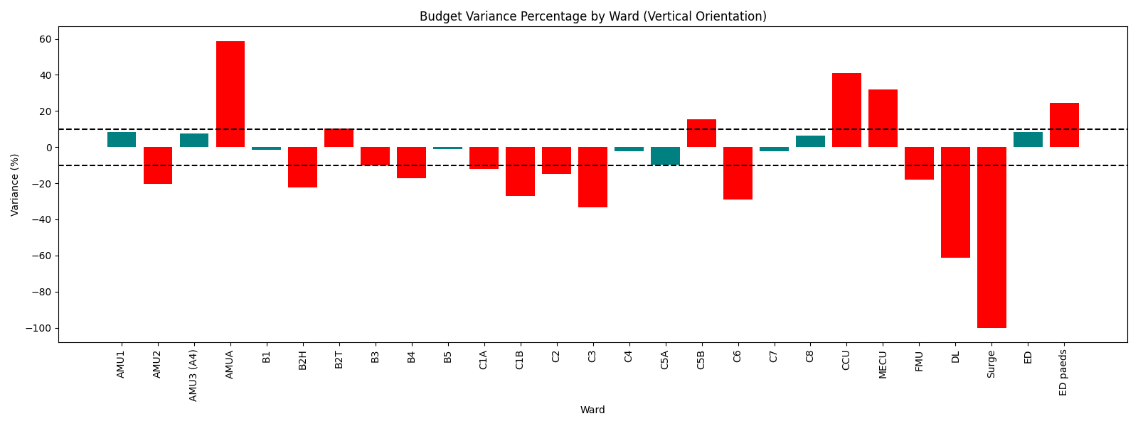
Graph 5: Budget Variance by Ward over the last 3 reviews

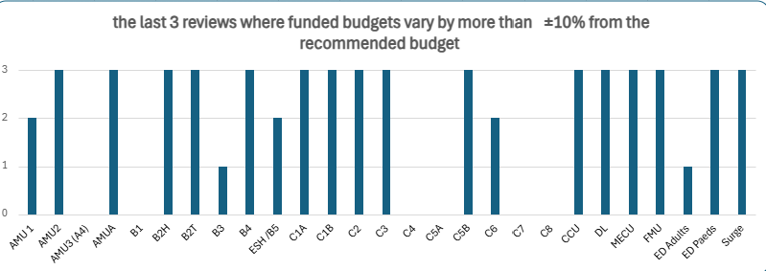

Chart 5 shows over the last 3 safer staffing reviews and departments that have been over their recommended budget for the last 3 reviews.

Safe Care Tool
Enhanced budgetary and temporary staffing controls were introduced in Jan 25 as part of financial recovery plans. It is questioned as to the impact this may have had on professional judgements as an increased number of areas have shown a difference of more than 10% between the SNCT tool and Professional Judgement.
The SafeCare system used on the inpatient areas records staffing utilisation as follows:
- Red – Short of nursing hours/overutilisation of staffing (above 110%)
- Amber – Short of nursing hours/overutilisation of staffing (105-110%)
- Grey – Correct level of staff based on entered patient acuity and dependency (90-105%)
- Green – Excess nursing hours/underutilisation of staffing (below 90%)
For January 2026, the workforce average utilisation for Adult Acute and Inpatient areas, excluding ED and Surge ward, demonstrated 10 wards (rated Red), reflecting a shortfall in nursing hours compared to required care hours, which was based on patient acuity and dependency as recorded in SafeCare tool.
5 wards were rated Amber and 4 wards were rated grey and finally 6 areas were rated a green, this is similar to the data represented in the SNCT tool.

Analysis of Nurse senstive indicators

Nurse Sensitive Indicators
Nurse sensitive indicators (NSI) refer to quality outcomes that can be linked to nurse staffing issues, including leadership, establishment levels, skill-mix and training and development of staff. This information can be further used to support ward staffing requirements identified through acuity and dependency measurement. Medication errors, slips, trips & falls and pressure ulcers are all NSIs which have been identified as key indicators of quality of care with specific sensitivity to nursing intervention and lack of.
These are regularly reviewed across the divisions and within the clinical areas, with a significant amount of work being undertaken to support their reduction.
Further analysis and breakdown of NSIs over the past 4 establishment reviews showed the following: -
Falls
Throughout January 26 there were 27 falls recorded across the areas through the DATIX system (to note the data extract at the end of January 26 and used by the Divisions would have been unvalidated data and all incidents would not have gone through the Trust internal validation frameworks e.g. Pressure ulcer scrutiny Group or Falls Group). Since the data collection in June 2025, we have reduced both falls and pressure ulcers that was recorded on Datix.
The hospital continues to see higher patient acuity and increasing demand for 1:1 nursing and/or cohorting of patients who are confused and at high risk of falls.

Graph 6 – Falls rates January 26

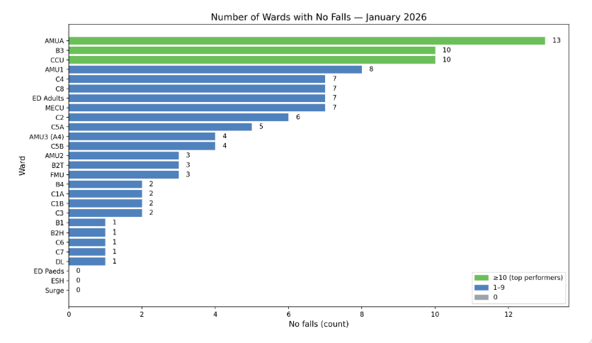
Graph 7 – Falls rates over the last 4 reviews

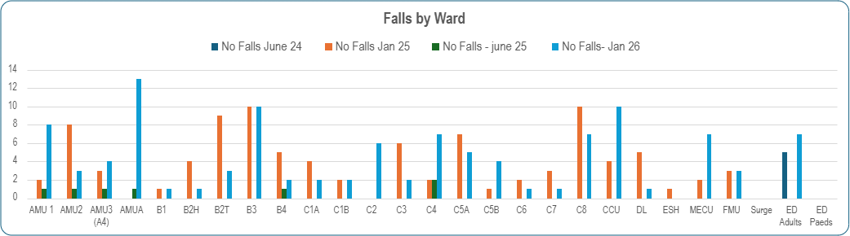

Graph 7 shows the falls data over the last 4 safer staffing reviews and areas that have seen a significant increase in falls in AMUA/AMU1/C2/CCU/MECU.

Pressure ulcers

Graph 8 January 2026 shows a total of 258 reported pressure ulcers via datix, demonstrating a significant increase over the last 4 reviews from 156 in June 24, 168 in Jan 25, 188 in June 25 and now 258 in Jan 26.

The trust overall increase of pressure ulcer incidents shows a significant increase in the trust front door services especially in the emergency department that may correlate with increase stay in the ED department. Other areas that have seen an increase may also relate to increase of patient's acuity levels over this period of the January review.
Graph 8 – Pressure ulcer Datix's report January 26

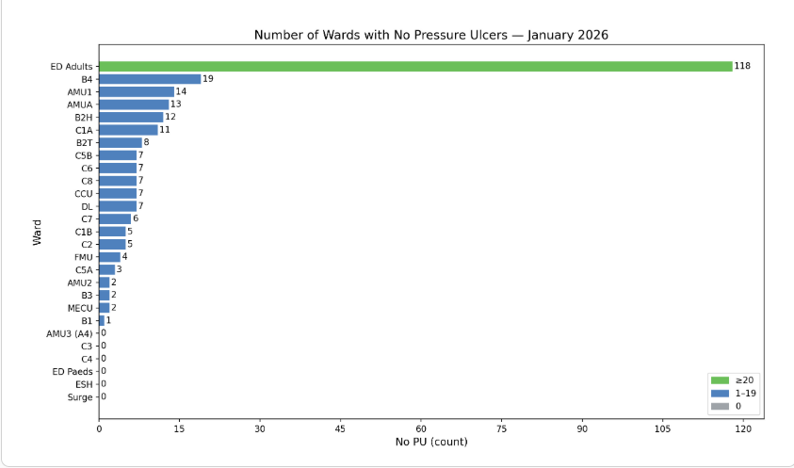

Graph 9- Pressure ulcers (PU) over the last 4 reviews

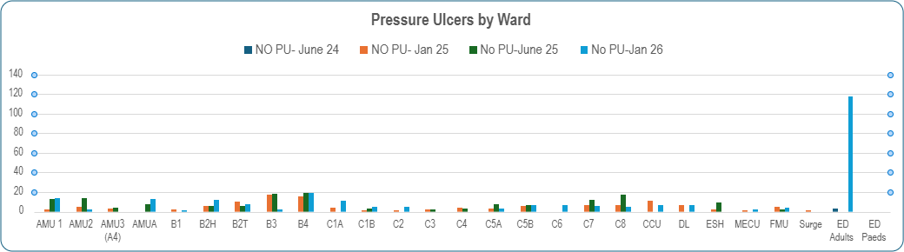

Health Care Acquired Infections (HCAIs)

HCAIs (related to Clostridioides difficile infections (C. diff)), COVID, Norovirus, CDI, E coli and MRSA)
This review hasn’t shown a significant increase of HCAI’s
One norovirus outbreak on C8 and one flu A outbreak on B4

Table 6: January 26 HCAI recorded

INFECTION PREVENTION CONTROL ESCALATIONS
Jan 26 |  |  | Jan 26 |  |  | Jan 26
AMU1 | 1 Norovirus  1 E-Coli |  | B5 | 1 CDI |  | C7 | 1 COVID  1 CDI
AMU2 | 1 CDI |  | C1A | 0 |  | C8 | 8 Norovirus
AMU3 (A4) | 0 |  | C1B | 1 CDI  1 E-Col |  | Surge | 0
AMUA | 1 Norovirus  1 E-Col |  | C2 | 0 |  | DL | 0
B1 | 0 |  | C3 | 2 E-Col |  | MECU | 0
B2H | 0 |  | C4 | 1 CDI |  | FMU | 0
B2T | 1 CDI  1 E-Col |  | C5A | 0 |  | ED | 6 COVID  1 CDI  8 E-Coli
B3 | 0 |  | C5B | 1 Norovirus |  | ED paeds | 4 COVID
B4 | 1 CDI  1 E-Col |  | C6 | 0 |  | CCU | 1 CDI

Safeguarding

Safeguarding the nature and complexity of the referrals is not to be underestimated and the workload this creates is substantial for both the teams undertaking the initial referrals and subsequently the teams who support with the inpatient care of these patients. Throughout the review period there were 171 safeguarding referrals compared to June 25 in which there was 33, that is a significant increase particular in the emergency department.

The number of referrals in January 26 for adults has increased in January, with increases in referrals due to domestic abuse, organisational abuse (by other care providers) and self-neglect. The number of children's safeguarding referrals is stable but there has been an increase in the number of referrals relating to CYP mental health. This is a common trend seen in January post-Christmas and school holidays.

Graph 10: safeguarding incidents over the last 4 reviews

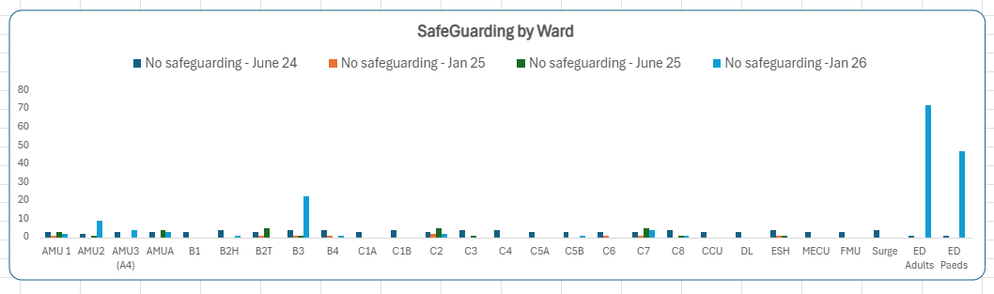

Formal Complaints

In addition to the above indicators, as a Trust we believe that the number of complaints which are received is also a strong indicator of nursing care and levels of staffing, throughout January there were 97 new complaints, which has increased from June 25 that was 34 complaints.

- Emergency department showed a significant increase from 5 in June 25 to 46 in January 26, this may be due to the waiting times in the department and corridor care
- Other areas had mainly stayed the same over the last reviews.

Table 7: January 26 complaints recorded on Datix

Jan 26 | complaints |  | Jan 26 | complaints |  | Jan 26 | complaints
AMU1 | 4 |  | B5 | 1 |  | C8 | 4
AMU2 | 3 |  | C1A | 2 |  | CCU | 2
AMU3 (A4) | 2 |  | C1B | 1 |  | DL | 1
AMUA | 3 |  | C2 | 1 |  | Surge | 0
B1 | 1 |  | C3 | 3 |  | MECU | 1
B2H | 3 |  | C4 | 1 |  | FMNU | 1
B2T | 2 |  | C5A | 0 |  | ED | 46
B3 | 1 |  | C5B | 2 |  | ED paeds | 1
B4 | 3 |  | C7 | 5

NICE RED FLAGS (Appendix 6 for full data set)
Nursing Red Flags are specified in Safer Staffing for Nursing in Adult Inpatient Wards in Acute Hospitals overview (NICE 2021). 2 key red flags have been examined through this review, patient vital signs not assessed or recorded as outlined in the care plan, and unplanned omissions is providing patient medications

Red flags January data collection:
- Total Red Flags Raised: 379
  - Surgical Division: 78
  - Medicine Division: 301
Highest Percentage Categories
- 53.3% – Between 70–90% of required registrants on shift
- 12.4% – Between 50-70% of required registrants on shift
- 9.23%– Unable to provide the required 1:1 care
- 8.9% – Unable to provide intentional rounds
- 7.91% – Physiological observations >30min of required time

Unplanned late/delayed or omitted patient medications
There were over 58 thousand late or missed medications throughout this data collection, compared to 73 thousand in June 2025 data collection. 7,174 were late (30 minutes or more after the directed time on the prescription) that is a decrease since June 25 that was 14,301 and 51,377 which were not performed. The reduction in missed or delayed medication may be a contributing part of the work undertaken for the quality and safety delivery plan for 2025/26 where time critical medication is being focussed on, which may have contributed to the improvement of late medication.

The data shows the missed or delayed medication was 20.2% during January 26 collection. (appendix 7shows for the wards data)

Graph 11: Shows the amount of delayed medication per ward

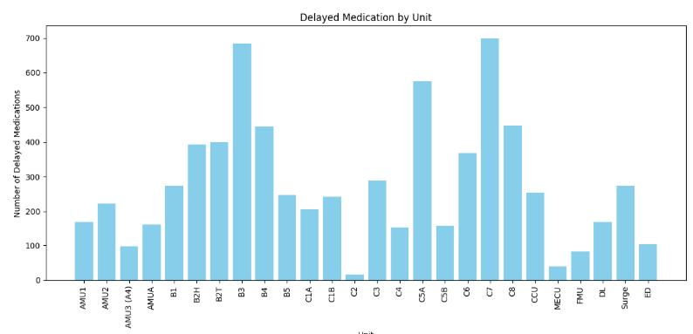

Vital signs compliance

The clinical risk dictates the frequency required for vital signs set out by national guidelines & changes with each score.
- High clinical risk, 30 min vital signs = 19.77% (17.10% in Dec)
- Medium clinical risk, 60 min vital signs = 34.64% (34.20% in Dec).
- Low clinical risk, 4 hourly vital signs = 63.73% (62.36% in Dec).
- ↓ 8 hourly vital signs = 66.47% (67.66% in Dec)
- ↑ 12 hourly vital signs = 84.81% (84.41% in Dec
- ↓ 24 hourly vital signs = 86.72% (87.91% in Dec)

Graph 12: Vital signs compliance
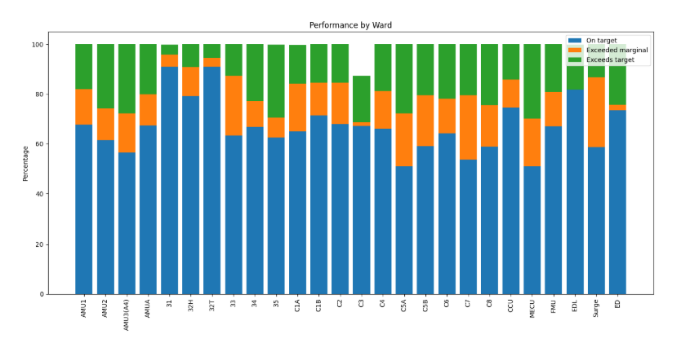
Graph 11 shows the percentage of observations from recorded on time, to exceeds marginal of 15 mins or exceeds over 15 mins

The trust overall position is below 70% for observation on time, with continuously improving picture as a result of focussed improvement work.

Table 8: January 26 – cardiac arrests and MET calls

Number of MET calls | Area | Number of MET calls | Area | Number of MET calls
AMU1 | 1x CA  17x MET | B4 | 1x CA  11x MET | C7 | 9x MET
AMU2 | 9 x MET | B5 | 16x MET | C8 | 6x MET
AMU3 (A4) | MET | C1A | 1x CA  11x MET | CCU | 3x MET
AMUA | 1x CA  6x MET | C1B | 1x CA  11x MET | MECU | 5x MET
B1 | 2x MET | C3 & FMNU | 9x MET | FMNU | see C3
B2 T | 5x MET | C4 | 14x MET | DL | 2x MET
B2 H | 5x MET | C5A | 23x MET | SURGE (A2) | 3xMET
B3 | 6x MET | C5B | 23x MET | ED | 3x MET
C2 paeds | 1x met | C6 | 2x MET | ED paeds | 7x MET
B6 | 5xMET | PCCU | 1x MET | SDEC | 1x CA  4x MET

Patients required to Cover 1-2-1 care
As part of the SNCT tool the trust includes patients with an acuity of 1c/1d requiring 1-1 care to part of the wards establishment that can make a significant impact of staffing levels.
Graph 2 shows the hours of 1:1 / Mental Health care by registered Nurse/unregistered staff
For Q3 2024/25 we requested 15,125 hours of registered staff and 23,402 non-registered staff a total of 38,567 hours which is a monthly average of 13,000 hours the majority of which were provided by bank staff. In comparison for Q3 2025/26 we requested 92 hours of registered staff and 7,866 non-registered staff a total of 7958 hours which is a monthly average of 2,652 hours the majority of which are is still provided by bank staff. The overall 30,609 hours reduction of hours requested is largely due to

- Monthly validation of the data as part of the workforce provider return to NHSE. Table 1 below shows the monthly ETOC staffing figures which are continuing to decrease.
- Pilot using change of location tab on allocate to record substantive staff as part of the ward establishment who are delivering ETOC with no additional staff
- Cleansing and reducing number of booking options on allocate
- Incorrect use of additional shift booking reason allocated as 1:1 by the requester but some of this was the rostering team
- Increased level of authorisation for additional shifts requested

Graph 13 – Hours of Enhanced therapeutic observation care (ETOC) over the last 6 months
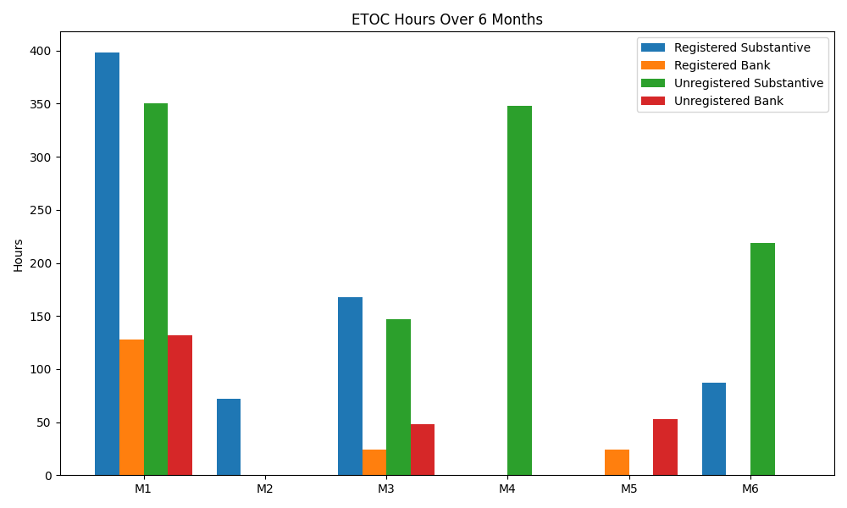
Next step
- Consideration of establishment changes by the Executive team as outlined in this report.
- Safer staffing reviews to be completed in the Community Nursing, SDEC areas, Theatres/Critical Care, and Neonatal unit in March 2026.
- New areas to undertake a staffing review planned in March will be renal unit and adult/children outpatient’s department.
- Progress action plan associated with the Developing Workforce Safeguards gap analysis completed in June 2025.
- Continue with progress to ensures wards utilise the safe care tool per shift to be able to review the patient's acuity and the actual staffing establishments per shifts
- Waiting for further information nationally for the next steps of reviewing band 5 graduates posts based on Nurses to benefit from boost to graduate pay and job progression - GOV.UK
Name of Author: Philippa Brazier
Title of Author: Associate Deputy Chief Nurse – Workforce and Professional Development
Date report prepared: March 2026

Appendix 1 – Trust compliance with safer Care Nursing tool red rules

 | SNCT Red Rule | Jan 26 Compliance | RAG |  | SNCT Red Rule | Jan 26 Compliance | RAG
AIP  AAU  CYP  ED | Nominate a senior registered nursing lead to quality control the data collection, process and outputs. This will include data collection timeframes, training records, external validation rotas, data analysis and dissemination of results. This should be a senior member of the corporate nursing team. | Philippa Brazier  Associate Deputy Chief Nurse |  | AIP  AAU  CYP  ED | Ensure a training and education process is in place, on how to implement the SNCT in practice encompassing and inter-rater reliability assessment and ongoing refresher training. Up to date and accessible training records must be maintained and held at trust level. | Numerous training sessions facilitated throughout the month leading up to the data collection month and throughout the data collection month.  Further dates have been planned and in place for the next review.  Training records are stored on a central Teams folder which is accessible the Division Chief nurses, their deputies and the corporate team.
AIP  AAU  CYP | Identify no more than 3 leads per ward to complete the scoring daily for the duration of the data collection period. | Clear instructions were given to the ward teams. The collated data sets support a maximum of 3 people in ward collected data each day |  | AIP  AAU  CYP  ED | The data collection should take place a minimum of twice per year to allow incorporation of variation within the year. The average combined data sets are used to support establishment setting/resetting. | Agreed across the Black Country Provider Collaborative that data collection will take place every June and January
ED | Identify a sufficient cohort if leads/shift leaders in the department to complete the scoring twice daily for the duration of the data collection period
AIP  AAU  CYP  ED | The three leads must include the Ward manager. If no Ward Manager is available a nominated member of staff should be agreed with the senior nurse for the Directorate/Division | Clear instructions were given to the ward teams, that the Lead Nurse and if not available the NIC should be one of the 3 people. |  | AIP  AAU | During data collection periods, every patient needs to have a level of care recorded daily for a minimum of 30 days using the decision matrix measuring the patient care required/received retrospectively for the previous 24 hours. | Data collected as directed at 15:00 each day.  ED data collected at the prescribed hours.
 |  |  |  | CYP | During data collection periods, every patient needs to have a level of care recorded daily for a minimum of 20 days using the decision matrix measuring the patient care required/received retrospectively for the previous 24 hours.
 |  |  |  | ED | Acuity and dependency data should be collected for each patient in the department at the set twice daily intervals.
AIP  AAU | Data collection should be undertaken over 30 consecutive days and be undertaken by appropriately trained and assessed staff. | AIP, AAU and CYP areas collected data for the entire month of June.  ED collected data for 14 days. |  | AIP  AAU  CYP  ED | Acuity and dependency data should be collected for each patient in each bed at the same agreed time, as part of a bed ward round. | As above for all areas/
CYP | Data should be collected for a minimum of 20 days
ED | Data should be recorded on every patient present in the department for a total of 12 days minimum.
AIP  AAU  CYP  ED | External validation is conduced weekly with the designated ward nurse as part of the daily ward round by a senior nurse outside of the ward’s budgetary responsibility | Rota plan created and disseminated for the QA areas. |  | AIP  AAU  CYP  ED | Nurse sensitive indicators/quality outcomes data for the same timeframe are to be collected retrospectively by a senior nurse or directly pulled from the electronic incident reporting system | Data collated from the central systems where possible.  Datix, Allocate safecare and Sunrise being the main ones. These were collated by the Corporate team and reviewed by the leading Deputy Chief Nurse.
AIP  AAU  CYP  ED | Ensure the senior nurses undertaking the external validation has been appropriately trained and assessed. | All asked to undertake the training and the AIP assessment. Cross referencing this |  | AIP  AAU  CYP  ED | Results should be provided to Ward Managers, Matrons, Heads of Departments Directors of nursing as soon as possible  These results should be reviewed within your biannual establishment setting process in line with the National Quality Board and Developing Workforce Safeguards guidance. | All results were available to the Lead Nurse, Matron, Deputy Divisional Chief Nurse, Divisional Chief Nurse, HR Business Partner, Finance Business Partner, Trust Deputy Chief Nurses and Trust Chief Nurse by March 26  Challenge conversations within the divisions was undertaken in March 25

Appendix 2 – safer nUrsing care tool decision matrix adult inpatient and dult acute assessment areas
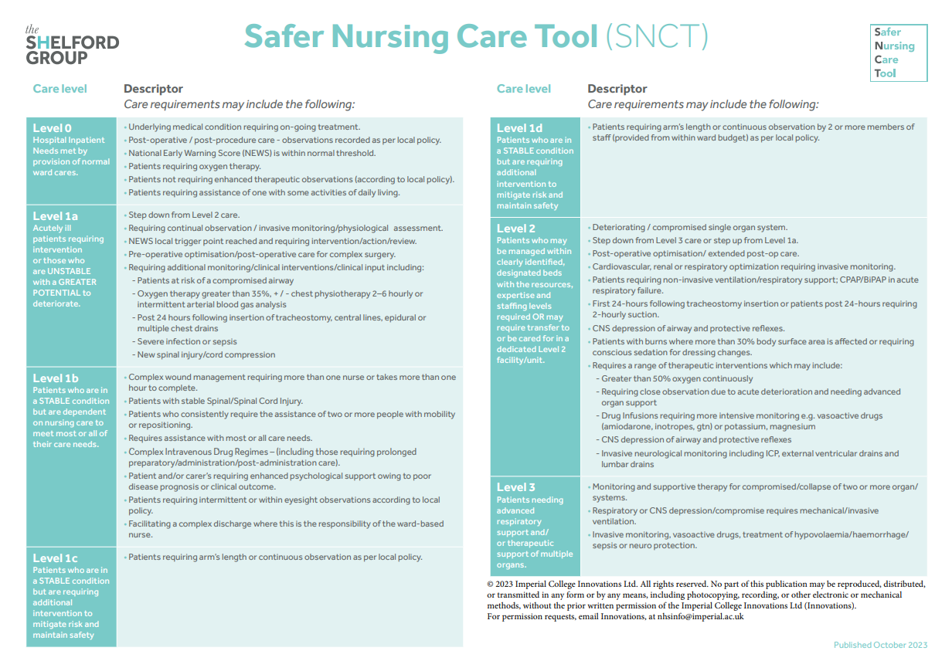

Appendix 3 SNST DECISION MATRIX CHILDREN AND YOUNG PEOPLE

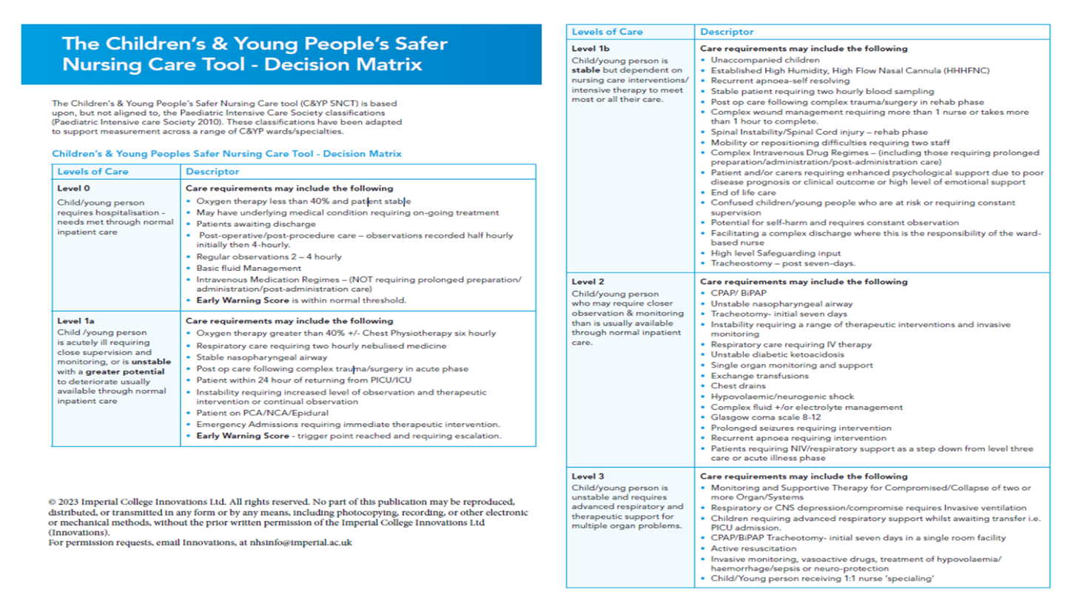

APPENDIX 4 - Professional Judgement

Team:
- Professionally do you agree with the proposed staffing establishment?
- Is the new recommended staffing establishment different from the current staffing establishment or the establishment of similar wards? If so, list reasons.
- Is the team operating with high number of vacancies, high staff turnover, sickness absence and/or using a high level of temporary staffing?
- Has there been any changes to the team since the last establishment review?
- Are the current staff being rostered properly?
- Does the team have a high patient turnover/throughput?
- Does the amount of work vary between times of day and day of the week?
- What is ‘usual’ care for the team?
- Are there any particular clinical skills required? Does the establishment allow for this?
- What is the level of skill and experience for the team as a whole?
- What shift patterns are used? Does this meet the ward requirement to build their roster?
- Any other anomalies for the team which need to be considered?
ESTABLISHMENT REVIEW PERIOD
DATE OF MEETING:
NAMES OF ATTENDEES:
Matron:
Lead Nurse:
Finance:
HR:
Dvisional submitted………………………………………………………………………………………………………………………………………………………………………

APPENDIX 5 – safer staffing summary report
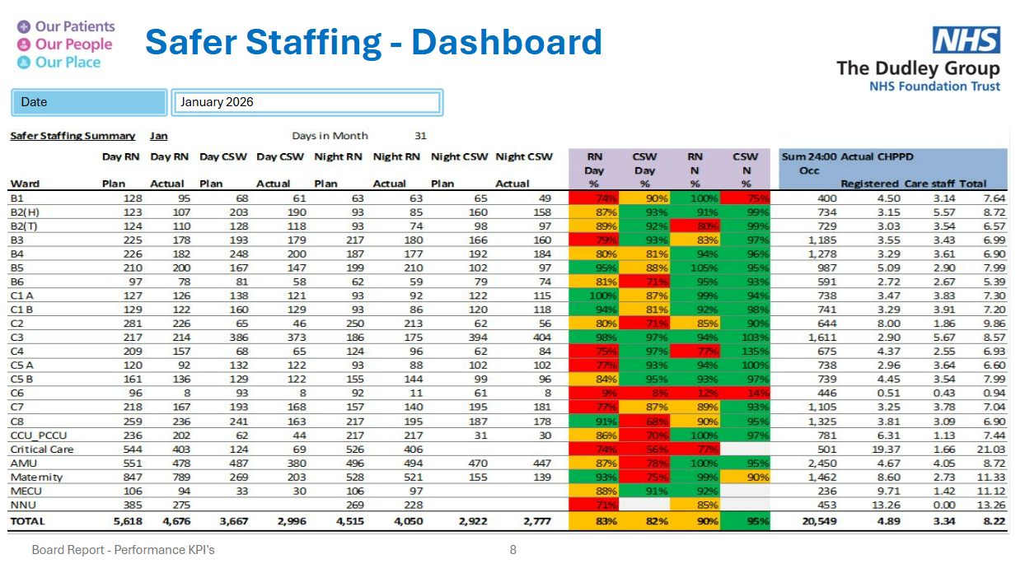

appendix 6 – Red flags reported – Jan 26

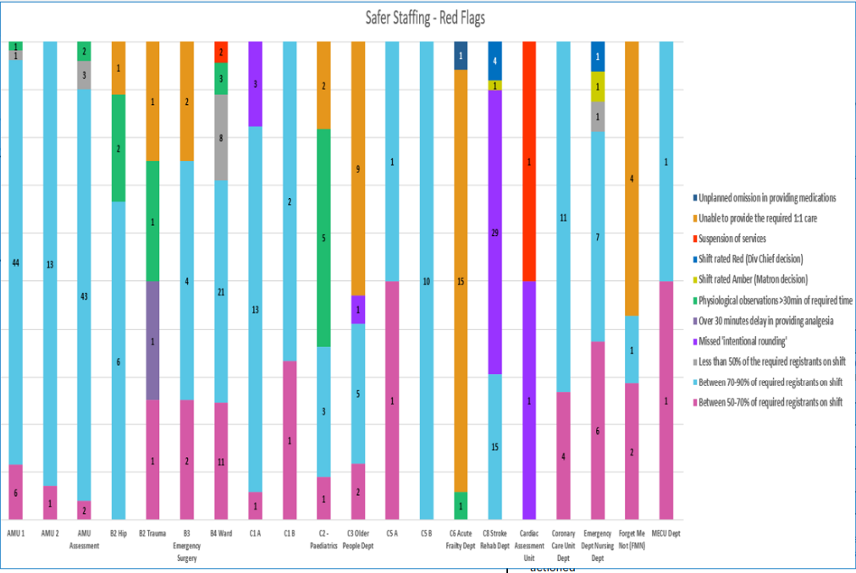

appendix 7 –NSI – INCLDUING DLEAYED OBSERVATIONJan AND MISSED OR DELAYED MEDIICATION jAN 26

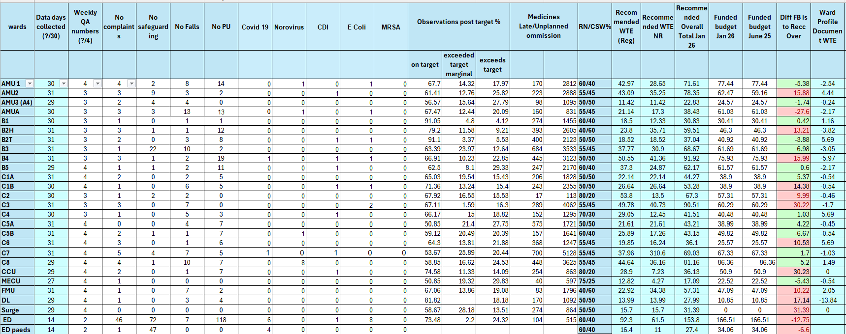

References

a. ‘Hard Truths’ Commitments NHS England http://www.england.nhs.uk/2014/04/01/hard-truths/ April 2014

b. Supporting NHS providers to deliver the right staff, with the right skills, in the right place at the right time - Safe sustainable and productive staffing. National Quality Board, July 2016 http://www.england.nhs.uk

c. Griffiths P, Ball J, Murrells T, Jones S, Rafferty AM (2016b) Registered nurse, health care support worker, medical staffing levels and mortality in English hospital Trusts a cross-al study. BMJ open 5:e008751

d. NHS England (2014) Five Year Forward http://www.england.nhs.uk/ourwork/futurenhs

e. NHS England (2016) Leading Change, Adding value: A framework for nursing, midwifery, and care staff http://www.england.nhs.uk/ourwork/leading-change.

f. NICE (2013) Safe staffing for nursing in adult inpatient wards in acute hospitals. http://www.nice.org.uk/guidance/SG1

g. NQB (2016) How to ensure the right people, with the right skills, are in the right place at the right time: A guide to nursing, midwifery and care staffing capacity and capability http://www.england.nhs.uk/ourwork/part-rel/nqb.

h. The Safer Nursing Care Tool The Shelford Group – 2023 Safer Nursing Care Tool - Shelford Group (used under licence for RWT).

i. Developing Workforce Safeguards – 2018 NHSI.

j. National Quality Board (2023) C, Griffiths P, Casey A, Chable R, Chapman H, Radford M, and Watts N (2023) Professional Judgement Framework: a guide to applying professional judgement in nurse staffing reviews. doi: 10.5258/SOTON/P1102 University of Southampton. Professional judgement framework: a guide to applying professional judgement in nurse staffing reviews - ePrints Soton

