
Sandwell & West Birmingham NHS Trust
The Dudley Group NHS Foundation Trust

Paper ref:

REPORT TITLE: |  | Group Perinatal Biannual Workforce paper
SPONSORING EXECUTIVE: |  | Melanie Roberts – Group Chief Nursing Officer
REPORT AUTHOR: |  | Claire Macdiarmid – Interim Group Director of Midwifery
MEETING: |  | Group Quality Committee |  |  |  |  |  | DATE: | 19 May 2026
Paper Type: (place an ‘x’) |  | Requested action: (place an ‘x’) |  | Applies to: (place an ‘x’)
 | Decision | X | Approve |  | X | Both Trusts
X | Assurance |  | Agree |  |  | Sandwell and West Birmingham NHS Trust
X | Discussion |  | Endorse |  |  | The Dudley Group NHS Foundation Trust
 | Information |  | Recommend
 |  |  | Discuss
 |  |  | Note

Suggested discussion points
Dudley Group
The Dudley Group NHS Foundation Trust has completed its biannual Midwifery, Obstetric, Anaesthetic and Neonatal Staffing Report in line with national requirements, providing assurance regarding compliance with Ockenden recommendations, Birthrate Plus, BAPM standards and the NHS Resolution Maternity Incentive Scheme. A full Birthrate Plus review completed in 2025 confirmed that current funded midwifery establishment remains aligned to workforce requirements, with birth activity and staffing levels remaining broadly stable. During the reporting period there were no occasions where 1:1 care in labour was not achieved and no occasions where the labour ward coordinator was not supernumerary.
Mandatory training compliance remains above required thresholds across all staff groups. Whilst some workforce pressures remain, including sickness absence and community staffing vacancies, active recruitment and operational mitigations continue to support safe service delivery. Neonatal medical staffing remains compliant with BAPM standards, and neonatal nursing staffing has achieved recommended staffing levels on 95.7% of shifts despite ongoing work to increase QIS-qualified workforce levels.
Sandwell and West Birmingham
The report demonstrates improved workforce position across the reporting period, with a significant reduction in midwifery vacancies, ongoing recruitment activity and continued compliance with key safety standards including anaesthetic staffing, neonatal medical staffing, one-to-one care in labour and supernumerary labour ward coordinator requirements for the majority of the reporting period.
Birth to midwife ratios remain within recommended levels and escalation processes were implemented during periods of increased acuity and staffing pressure to maintain safe care.
The report also highlights ongoing risks relating to sickness absence, community workforce pressures, specialist midwifery capacity, neonatal workforce resilience, reliance on locum staffing and low compliance with completion of the Birthrate Plus acuity tool. Further workforce planning work is underway through the ongoing Birthrate Plus review and forthcoming NHSE community review findings.
The Board is asked to note the assurances provided, acknowledge the ongoing workforce risks and support continued recruitment, retention and workforce improvement actions.

Alignment to our Vision [indicate with an ‘X’ which Strategic Objective[s] this paper supports]
Sandwell and West Birmingham NHS Trust
OUR PATIENTS | X | OUR PEOPLE | X | OUR POPULATION
The Dudley Group NHS Foundation Trust
PATIENTS | X | PEOPLE | X | PLACE/POPULATION

Previous consideration
Not applicable

Recommendation(s)
The Committee is asked to accept that systems and processes are in place to monitor and support safe midwifery, obstetric, anaesthetic and neonatal staffing in line with NQB, NICE (2017) and Maternity Incentive Scheme requirements.

Escalation
Should any element of this report be escalated: No
BAF Impact [indicate with an ‘X’ which governance initiatives this matter relates to and, where shown, elaborate in the paper]
Sandwell and West Birmingham NHS Trust |  | The Dudley Group NHS Foundation Trust
x | 001: Deliver safe, high-quality care. | x | 1.0: Failure to deliver right care, in the right place
 | 002: Make best strategic use of its resources |  | 2.0: Failure to recruit, retain, train, and develop workforce
 | 003: Recruit, retain, train, and develop workforce |  | 3.0: Failure to build innovative partnerships
 | 005: Deliver the MMUH benefits case (CLOSED) |  | 4.0: Failure to achieve financial plan
 | 004: Deliver on its ambitions as an integrated care Organisation |  | 5.0: Failure to achieve performance requirements
 | 006 (Joint): Failure by the Group to take sustained, ambitious action to optimise estates, facilities, digital, data
Is Quality Impact Assessment required if so, add date:
Is Equality Impact Assessment required if so, add date:

MIDWIFERY, OBSTETRIC, ANAESTHETIC AND NEONATAL STAFFING REPORT
- Background

It is a requirement that as NHS providers we continue to have the right people with the right skills in the right place at the right time to achieve safer nursing and midwifery staffing in line with the National Quality Board (NQB) requirements.

Organisational requirements for safe midwifery staffing for maternity settings (NICE 2017) states that midwifery staffing establishments develop procedures to ensure that a systematic process is used to set the midwifery staffing establishment to maintain continuity of maternity services and to always provide safe care to women and babies in all settings.

Previously, midwifery staffing data was included within the nurse staffing report. However, to meet the requirements of the NHS Resolution Maternity Incentive Scheme (MIS), a separate report is now presented, incorporating midwifery, obstetric, anaesthetic and neonatal workforce data.

- Executive Summary

This report provides assurance to the Quality Committee and Trust Board regarding the safety and effectiveness of maternity staffing in line with Ockenden recommendations and the Maternity Incentive Scheme (Year 8).

A full Birthrate Plus review was undertaken in summer 2025 and demonstrated that staffing requirements remain broadly stable compared to the 2022 assessment. Although patient acuity has increased, the expanded role of maternity support workers has mitigated the need for additional midwives.

Birth activity remains stable, with 3976, births in 2025/26 in comparison to 4063 in 2024/25. Safe staffing is monitored through the Birthrate Plus acuity tool, with good compliance. While some periods of increased acuity and staff absence resulted in shortfalls, safety-critical standards were consistently maintained.

There were:
- 0 occasions where 1:1 care in labour was not achieved
- 0 occasions where the labour ward coordinator was not supernumerary

Workforce levels are close to establishment, with ongoing recruitment expected to close remaining gaps. Fill rates, particularly during daytime and in community services, remain below baseline but are expected to improve following recent recruitment and staff returning from Maternity Leave.

Mandatory and maternity-specific training compliance remains above required thresholds, demonstrating continued compliance with MIS standards.

Sickness remains above Trust average in all areas of Maternity. Line managers are continuing to support staff with return to work in conjunction with HR and Occupational Health.

- Birthrate Plus Workforce Planning

A formal Birthrate Plus assessment was completed in 2025, reviewing acuity and workforce requirements.

This confirmed that the required establishment remains broadly aligned with the 2022 review, with:
- Recommended staffing: 173.79 WTE midwives
- Funded establishment: 172.98 WTE

This demonstrates that the midwifery staffing budget reflects the Birthrate Plus requirement, with a 22% uplift included and fully recruited to.

NICE (2017) recommends review every three years, the Trust remains compliant with this requirement.

Where there is a small variance between funded and in-post workforce, mitigation includes:
- Active recruitment (3.56 WTE interviewed and awaiting start dates)
- Use of bank staff
- Redeployment and escalation processes
- Support from specialist midwives and senior leadership

This position and workforce planning approach are reported through Trust governance structures and shared with commissioners as required.

- Planned Versus Actual Midwifery Staffing Levels

The following table outlines percentage fill rates for the Community and Inpatient areas by month.

Community

 | November | December | January | February | March | April
Fill Rate | 85% | 88% | 86% | 79% | 87% | 82%

The lower fill rates during this period were primarily due to vacancy and ongoing active recruitment. However, the staff recruited required a 6-month period of working in inpatient settings due to their experience. Recruitment into the Band 7 role, in February from the internal workforce meant the fill rate was significantly impacted along with capacity and rota coverage. Mitigations were implemented throughout this period, including active recruitment into the Band 7 post and operational workforce management measures to maintain service delivery and minimise disruption.

Inpatients

 | November | December | January | February | March | April
Fill Rate  Days | 78% | 76% | 78% | 77% | 77% | 78%
Fill Rate  Nights | 97% | 96% | 99% | 97% | 97% | 97%

Fill rates remained below baseline, primarily due to reduced daytime staffing. Night staffing remained consistently high.
Contributing factors include:
- Sickness absence (short-term and long-term)
- Maternity Leave (12.4 WTE)
- Recruitment lag for newly qualified staff and supernumerary time

Mitigations implemented:
- Redeployment of staff based on acuity
- Senior staff (Band 7+) working clinically, Ward Managers 2 days per week (not included in fill rates above)
- Specialist midwives supporting clinical areas on an escalation rota
- Use of bank staff
- On-call community midwives supporting labour ward

Newly qualified midwives commenced between November and December and completed supernumerary periods by December and January, it was anticipated that this would improve staffing levels and fill rates, however gap of 3.2WTE increased due to leavers or reduced hours January to April.

- Vacancy rates

Midwifery Vacancy is currently 5.04 WTE. Active recruitment is ongoing and 3.56 WTE have been interviewed and are awaiting start dates. The remainder of the vacancy remains in the Community setting and further recruitment is planned.

Maternity support workers vacancy is currently 2.59 WTE with active recruitment ongoing.
Birthrate plus staffing is inclusive of 22% uplift which is recruited into fully.
Turnover within the Midwifery and Maternity Support worker staffing groups remains low at 1.1% for Registered staff in comparison to 6% Trust average.
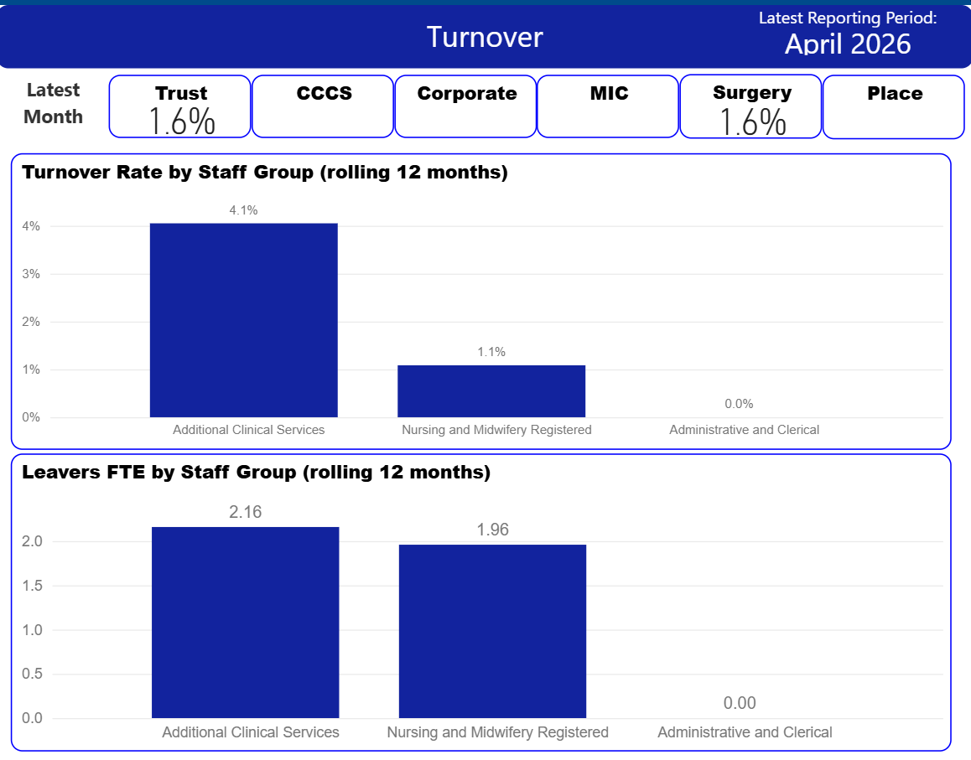
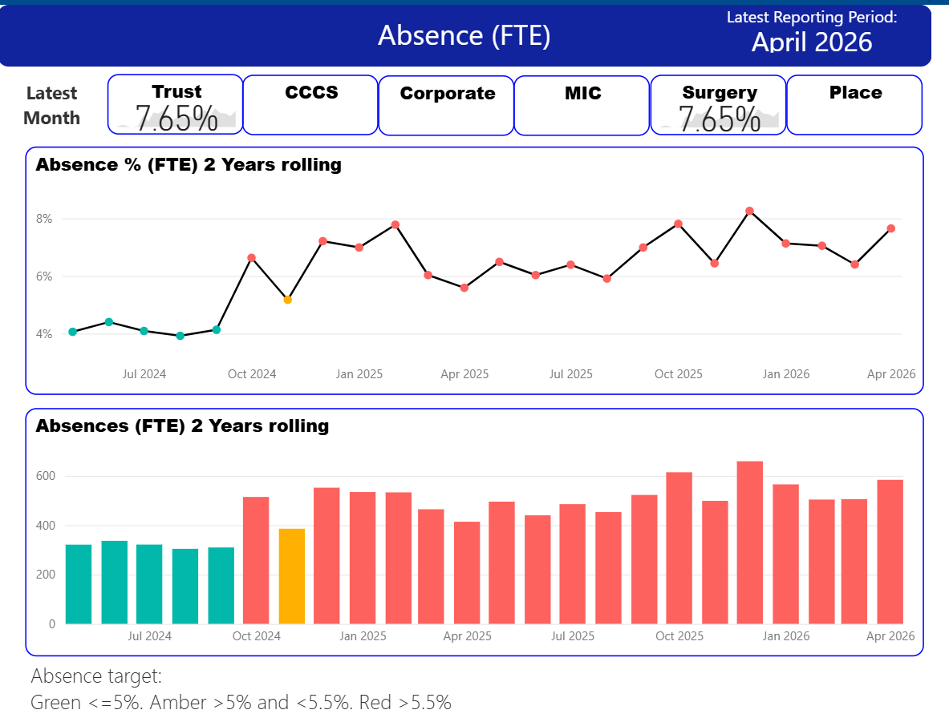
Sickness rates within Maternity have remained higher than Trust average at 7.65% over the reporting period. The most common reasons for Sickness and Absence are Stress / Anxiety and Pregnancy Related. The Stress/ Anxiety absences are predominantly none work related.
- Birth to Midwife Ratio in March was 1:30

This calculation takes into consideration the number of births for the month vs number of available midwives available to undertake direct clinical care (as per BR Plus calculations). Note this does not take into consideration the impact of deprivation, ethnicity or additional care needs. The recommended figure should be between 1:26 and 1:34

- Specialist Midwives

Birth Rate Plus recommends that 10–12% of the total midwifery establishment is supernumerary to the clinical workforce, to support management, leadership and specialist midwifery roles. The Trust continues to maintain all key leadership and specialist functions required to support safe and effective maternity services, with specialist midwives flexing their clinical and non-clinical time in line with service demand and operational pressures. Workforce modelling demonstrates a small variance against the recommended establishment, with the service currently 1.2 WTE below the Birth Rate Plus recommended position. As this calculation can fluctuate month to month in response to staffing levels and service activity, the position will continue to be monitored through routine workforce review processes.

- Birth Rate Plus Live Acuity Tool

Birthrate Plus is a tool for midwives to assess their ‘real time’ workload arising from the number of women needing care, and their condition on admission and during the processes of labour, delivery and postnatally. It is a measure of ‘acuity’, and the system is based upon an adaption of the same clinical indicators used in the well-established workforce planning system Birth Rate Plus.

The Birth Rate Plus classification system is a predictive/prospective tool rather than the retrospective assessment of process and outcome of labour used previously. The tool is completed four hourly by the labour ward co-ordinator. An assessment is produced on the number of midwives needed in each area to meet the needs of the women based on the minimum standard of one-to-one care in labour for all women and increased ratios of midwife time for women in the higher need categories. This provides an assessment on admission of where a woman fits within the identified Birth Rate Plus categories and alerts midwives when events during labour move her into a higher category and increased need of midwife support.

This safe staffing tool kit supports most of the components in the NICE Guidance (and is endorsed by NICE) on safe midwifery staffing for maternity settings necessary for the determination of maternity staffing requirements for establishment settings. It provides evidence of what actions are taken at times of higher acuity and use of the escalation policy when required.

Average compliance for the tool completion over the 6 month is 85%

The following graph shows the percentage acuity by month.

The green bar demonstrates the number of times the Maternity unit has had the correct number of staff for the number of patients and the complexity of their health needs. The amber bar evidences the percentage of shifts that are short staffed by up to 2 midwives, with the red acuity bar evidencing the percentage of shifts that were over 2 midwives short.

The increased Red and Amber Acuities in January are related to a significant increase in births during the month, with 344 births in comparison to 312 births the month previous.

Support from specialist midwives and non-clinical teams is obtained during periods of high acuity as well as clinical prioritisation and movement of staff within the maternity unit to maintain 1:1 care in labour.

Average compliance for completion over the 6-month reporting period for the ward is 46%, however the tool for the ward does not allow you to capture all inputs only those within the timeframe. The Labour Ward tool allows you to capture all inputs.

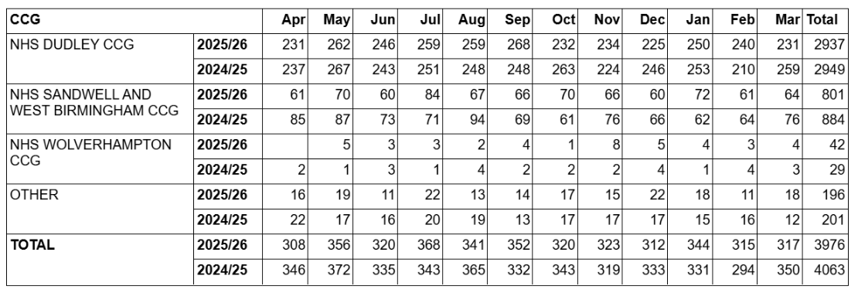

- Supernumerary Labour Ward Co-ordinator

Availability of a supernumerary labour ward co-ordinator is recommended as best practice to oversee safety on the labour ward. This is an experienced midwife available to provide advice, support, and guidance to clinical staff and able to manage activity and workload through the labour ward.

In the 6-month reporting period there have been no cases where a supernumerary labour ward co-ordinator has not been available. Compliance for the 6 months is therefore 100%

- One to One Care in Established Labour

Women in established labour are required to have one to one care and support from an assigned midwife. One to one care will reduce the likelihood of intervention and complications arising as well as facilitating recognition of early deterioration. Care will not necessarily be given by the same midwife for the whole labour.

In the 6-month reporting period there have been no cases where 1:1 care in labour has not been provided. Compliance for the 6 months is therefore 100%

- Red Flag Incidents

A midwifery red flag event is a warning sign that something may be wrong with midwifery staffing (NICE 2015). If a midwifery red flag event occurs, the midwife in charge of the service is notified. The midwife in charge will then determine whether midwifery staffing is the cause and the action that is needed. Red flags are collected through the live Birth Rate Plus acuity tool.

Month | Total number of red flags | 1:1 care in labour not met | Coordinator not supernumerary
November | 1 | 0 | 0
December | 9 | 0 | 0
January | 5 | 0 | 0
February | 1 | 0 | 0
March | 5 | 0 | 0
April | 0 | 0 | 0
The predominant category for red flags is RF2 Missed or Delayed Treatment which on review relates to women being delayed during the induction of labour process or for women having planned admissions for interventions such as steroids or Monifer delayed. There have been no adverse outcomes resulting from delays.

Training

During the 6-month reporting period, CNST Maternity Incentive Scheme training has remained over 90% for all staff groups. Compliance below is at the time of reporting.

Midwives Training | Fetal Monitoring | 97%
 | Obstetric Emergency Sim Training/PROMPT | 98%
 | Saving Babies Lives | 97%
Obstetrics Training | Fetal Monitoring | 95%
 | Obstetric Emergency Sim Training/PROMPT | 100%
 | Saving Babies Lives | 95%

- Obstetric staffing

Establishment and Vacancy

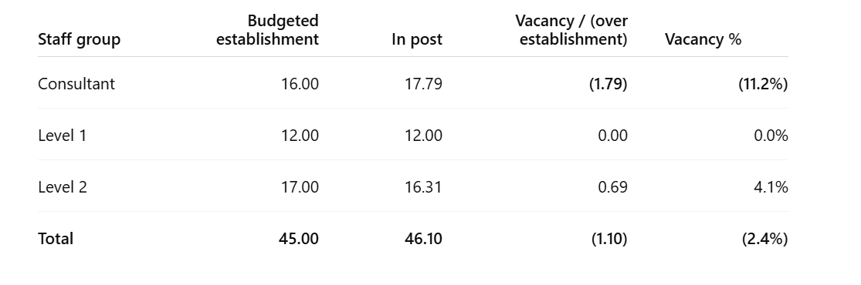

We have a 1:16 rota for consultants. 2 consultants are not on the on-call rota permanently due to health reasons. 1 consultant is temporarily not participating in on-call activity.
3 locum consultants are in post until August 2026 to support on call activity whilst a capacity and demand business case is submitted.

There is 1 Trust Grade level 2 post awaiting start date- when this person commences in post, there will be 17.31 WTE in post. We currently have 1WTE level 2 doctor not working independently on the rota.

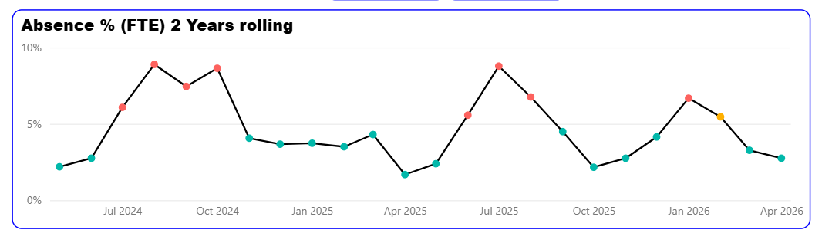The medical staff absence rate is currently 2.75%.

Consultant Attendance

The obstetric consultant team and maternity senior management team should acknowledge and commit to incorporating the principles outlined in the RCOG workforce document: ‘Roles and responsibilities of the consultant providing acute care in obstetrics and gynaecology’ into their service. This includes obstetric staffing on the labour ward and any rota gaps.

Trusts should monitor their compliance of consultant attendance for the clinical situations listed in the RCOG document when a consultant is required to attend in person. Episodes where attendance has not been possible should be reviewed at unit level as an opportunity for departmental learning with agreed strategies and action plans implemented to prevent further non-attendance. Trusts’ positions with the requirement should be shared with the Trust board, the board-level safety champions as well as LMNS.

There have been no Datix reported incidence of consultant non-attendance between November 2025 – April 2026.
This compliance aligns with the Trust’s Leadership on the Maternity Unit Guideline and the RCOG guidance.
Locums

Trusts should implement the RCOG guidance on engagement of long-term locums and provide assurance that they have evidence of compliance, or an action plan to address any shortfalls in compliance, to the Trust Board, Trust Board level safety champions and LMNS meetings.

All locums who are rostered in obstetrics are compliant with the RCOG guidance. This is reported to Maternity Safety Champions, as per the most recent report.

Trusts should implement RCOG guidance on compensatory rest where consultants and senior Speciality and Specialist (SAS) doctors are working as non-resident on-call out of hours and do not have sufficient rest to undertake their normal working duties the following day. Services should provide assurance that they have evidence of compliance, or an action plan to address any shortfalls in compliance, to the Trust Board, Trust Board level safety champions and LMNS meetings.

Evidence has been provided for assurance that compensatory rest is given to all consultants. This is demonstrated by the rota and by the job plans. This evidence is supported by the Trust Working Time Regulations Policy. This is reported to Maternity Safety Champions as per the above report.

- Anaesthetic staffing

For safety action 4 of the maternity incentive scheme evidence must be provided to demonstrate that a duty anaesthetist is immediately available for the obstetric unit 24 hours a day and should always have clear lines of communication to the supervising anaesthetic consultant. Where the duty anaesthetist has other responsibilities, they should be able to delegate care of their non-obstetric patients to be able to attend immediately to obstetric patients. (ACSA standard 1.7.2.1).

In the 6-month reporting period there have been no cases where this has not been achieved. Compliance for the 6 months is therefore 100%

- Neonatal medical staffing

To meet safety action 4 of the maternity incentive scheme the neonatal unit needs to demonstrate that it meets the British Association of Perinatal Medicine (BAPM) national standards of junior medical staffing.

The Trust can demonstrate BAPM national standards as evidenced by the junior medical staffing rotas for the department

- Neonatal nursing staffing

The neonatal nurse staffing establishment is as below and whilst currently only 48% of the workforce are QIS (qualified in speciality) as opposed to the requirement for 70% of the workforce based on 80% occupancy, the unit has met BAPM recommendations for 95.7% shifts over the past quarter. There are currently 2 Band 6 posts advertised and 7 staff due to complete the QIS course by September, which will further boost compliance.

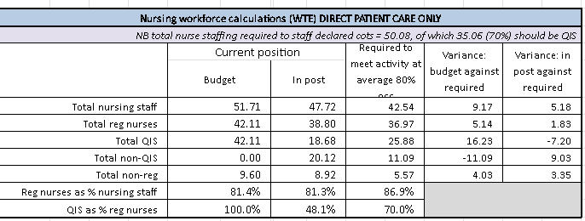

- Recommendations

The Board is asked to note assurance:

- That systems and processes are in place to monitor and support safe midwifery, obstetric, anaesthetic and neonatal staffing in line with NQB, NICE (2017) and Maternity Incentive Scheme requirements.
- That there have been no gaps in 1:1 care in labour and supernumerary labour ward coordinator compliance as per requirements of the Maternity incentive scheme.

The Board is also asked to acknowledge ongoing risks:
- Higher sickness absence rates across Maternity- absence is being managed as per trust processes and staff supported to return to work where possible.
- Community midwifery workforce pressures with mitigation in place to rectify the current position.
- Neonatal Nurse QIS below national expectation at 48%- mitigations and a trajectory are in place.

Sandwell and West Birmingham
Perinatal Bi-Annual Midwifery, Maternity and Neonatal Staffing Report.

Background

It is a requirement that as NHS providers we continue to have the right people with the right skills in the right place at the right time to achieve safer nursing and midwifery staffing in line with the National Quality Board (NQB) requirements.

Organisational requirements for safe midwifery staffing for maternity settings (NICE 2017) states that midwifery staffing establishments develop procedures to ensure that a systematic process is used. The midwifery staffing establishment is to be maintained to ensure continuity of maternity services and to always provide safe care to women and babies in all settings.

NHS Resolutions Maternity Incentive Scheme requires a separate bi-annual paper which includes staffing data on key groups, such as midwifery and neonatal staffing.

- Executive Summary

This report gives a summary of all measures in place with the aim of ensuring safe midwifery staffing; including workforce planning, planned versus actual midwifery staffing levels, the midwife to birth ratio, specialist hours, compliance with supernumerary labour ward coordinator, one to one care in labour and red flag incidents.

- Birthrate Plus Workforce Planning

A formal Birth Rate Plus assessment was completed in 2023, which reviewed the acuity of women who used maternity services, at Sandwell and West Birmingham NHS Trust. This review recommended a birth to midwife ratio of 1:19.4 across the Trust.

NICE (2017) recommend that an assessment is carried out every three years. Therefore, SWBH is currently undertaking a BR+ review, which will inform future workforce planning.
Birth Rate Plus Funded Establishment 2023:

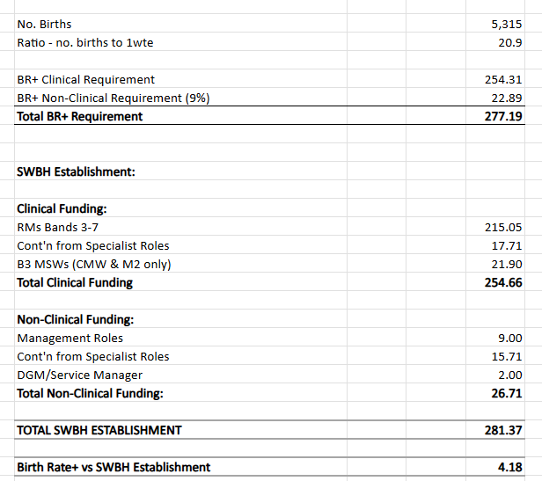

Overall, the SWBH funded establishment is in line with the most recent BR+ recommendations. However, a recent community services external review, undertaken by NHSE, has highlighted some shortfalls within the community workforce. Once the official report has been received by the organisation, it will also be used to inform community maternity service workforce planning.

Actions:
On receipt of the Community Report from NHSE and the Birth Rate Plus Assessment 2026, these will be utilised to inform further workforce planning. Potentially an increase in the workforce requirements will be necessary, particularly within the community workforce.

- Planned Versus Actual Midwifery Staffing Levels.

The following table outlines percentage fill rates for the inpatient areas by month.

 | Day qualified % | Night qualified %
Nov 25 | 74% | 76%
Dec 25 | 79% | 86%
Jan 26 | 86% | 92%
Feb 26 | 82% | 92%
Mar 26 | 82% | 90%
Apr 26 | 98% | 99%

The following table outlines percentage fill rates for the postnatal and antenatal wards by month.

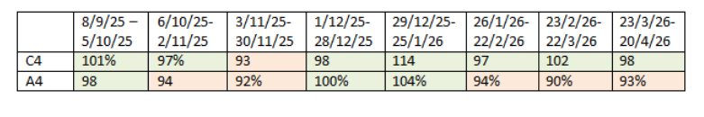
When staffing levels have fallen below the optimal requirement for each shift, the following measures were implemented in line with the escalation policy:

- Midwifery staff undertaking specialist roles were redeployed to support clinical care.
- Elective activity prioritised to align with available staffing capacity.
- Clinical managers at Band 7 level and above provided direct clinical support.
- Staff redeployed to ensure one-to-one care in labour was maintained, alongside the Labour Ward Co-ordinator remaining supernumerary.
- Additional support requested from the on-call midwifery manager where required.

In addition, a significant number of bank hours have been utilised across the service to support staffing gaps arising from Vacancy/ maternity leave, as well as sickness absences.

- Sickness Levels:

The below graph demonstrates the sickness levels of the Registered Midwives and Neonatal Nurses for the Perinatal services.

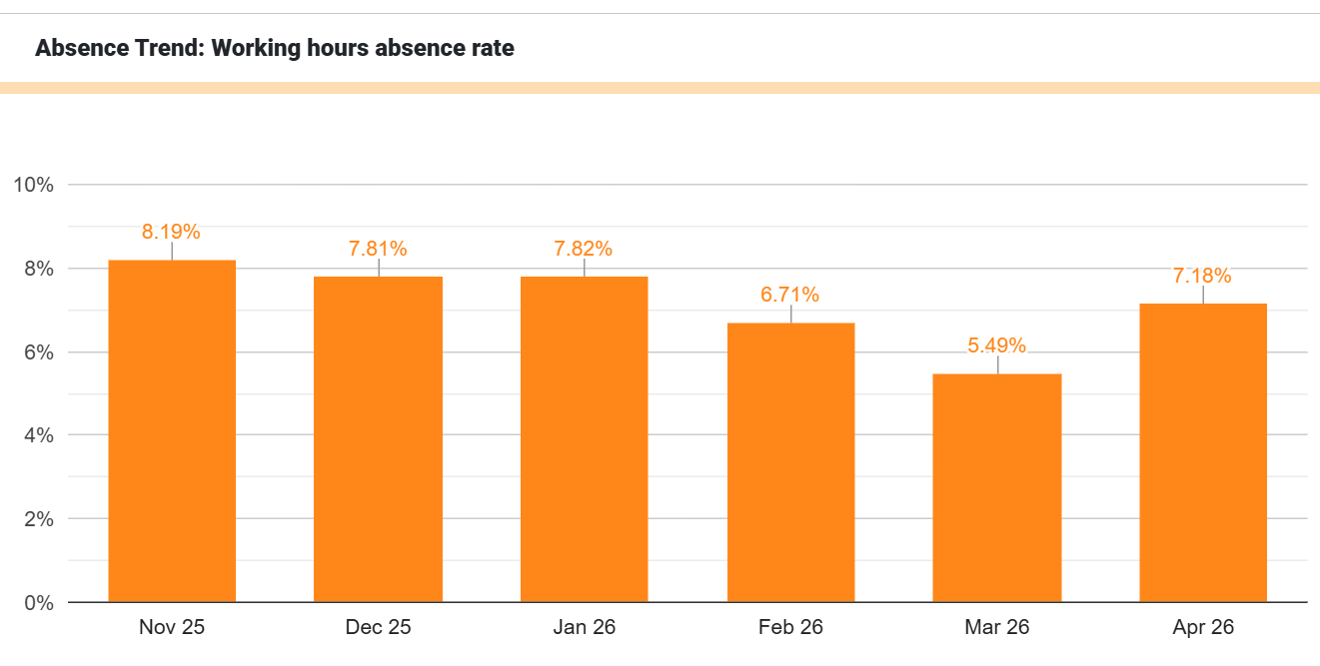

The top five absence reasons, as per Good Shape, are:

- Flu-like symptoms
- Coughs and Colds
- Complications with Pregnancy
- Gastro – Vomiting and Diarrhoea
- Gastro – Diarrhoea
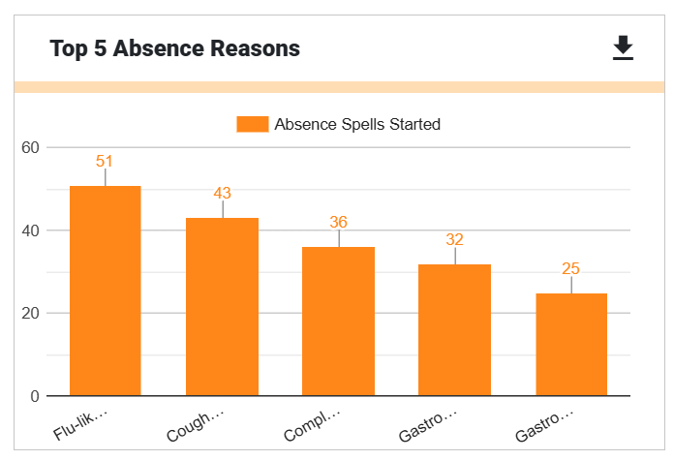

Sickness is managed as per the trusts ‘Attendance at Work Sickness Absence Policy’. Monthly ‘Confirm and Challenge’ meetings are undertaken with HR presence.

- Vacancy Rates

Vacancy Rate Table April 2026:

Month | Budget | WTE In-post | Nurses in maternity overspend | Vacancy
25-Jan | 250.12 | 211.1 | 3.33 | 35.69
25-Feb | 249.62 | 208.49 | 3.33 | 37.8
25-Mar | 249.62 | 213.07 | 3.33 | 33.22
25-Apr | 247.63 | 210.37 | 2.33 | 34.93
25-May | 247.63 | 210.84 | 2.33 | 34.46
25-Jun | 247.63 | 211.09 | 2.33 | 34.21
25-Jul | 247.32 | 211.33 | 2.33 | 33.66
25-Aug | 250.23 | 212.12 | 4.33 | 33.78
25-Sep | 250.23 | 211.7 | 5.33 | 33.2
25-Oct | 251.03 | 222.25 | 5.33 | 23.45
25-Nov | 251.03 | 228.11 | 5.29 | 17.63
25-Dec | 251.83 | 227.49 | 5.29 | 19.05
26-Jan | 251.89 | 230.72 | 6.29 | 14.88
26-Feb | 251.89 | 232.19 | 6.29 | 13.41
26-Mar | 251.89 | 231.71 | 6.29 | 13.89
26-Apr | 251.89 | 231.69 | 6.29 | 13.91
The table demonstrates a sustained improvement in maternity workforce position over the reporting period, with WTE in-post increasing from 211.1 in January 2025 to 231.69 in April 2026, alongside a significant reduction in vacancies from 35.69 WTE to 13.91 WTE, despite a gradual increase in the nursing overspend associated with maintaining safe staffing levels.

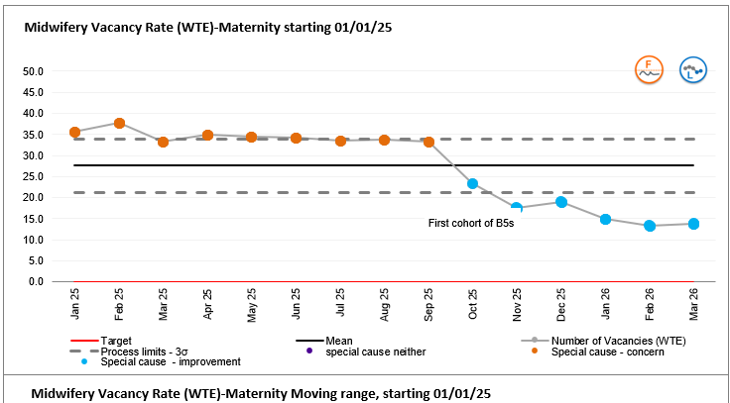

Recruitment:

- 0.6wte Domestic Abuse Specialist Midwife commenced on 23rd March 26.
- Antenatal Clinic Manger post has been recruited to and commenced.
- 10 Midwifery Support Worker positions were offered to successful candidates in April 2026, start dates to be confirmed.
- To cover long term sickness absence and maternity leave, Band 7 Labour Ward Coordinator interviews commenced May 2026.
- A further 2.82wte Band 5 midwives are due to commence in June 2026.
- 2wte positions have been recruited to for the Triage Core Team and await start dates. 1 wte internal move, and 1 wte awaiting confirmation of visa sponsorship.
- The Specialist Midwife for Female Genital Mutilation post is currently in the exec approval process and will be advertised imminently.
- A 12-month fixed term Governance Midwife role was recruited into in June 2025 to manage the Trust PMRT processes and ensure compliance with the requirements of the Maternity Incentive Scheme. Within this role, the postholder ensures compliance with all required reporting timelines, prepares cases for review within the twice monthly Perinatal Mortality Review Board and liaises with parents to ensure their perspectives of care form part of the review. A previous fixed term role was in place from December 2023 to December 2024 but the postholder moved to another Trust when the Directorate did not agree to extend the funding, leaving a 6 month gap during which the Saving Babies Lives Midwife covered the minimum requirements of PMRT to the detriment of the monitoring and implementation of the Saving Babies Lives Care Bundle. The current post was recruited to on a fixed term basis which ends in June 2026. Both PMRT and implementation of SBL (and now the Maternal Care Bundle) are required for achievement of MIS Year 8. A reduction in the number of midwifery hours available to deliver these elements would put compliance with Year 8 at risk, which will have an adverse financial impact on the Trust. Funding has been requested and approved by NHS Resolution to support the positions for a further year.
- Work is ongoing to scope the potential for a B4 Fetal Medicine Assistant Practitioner. Therefore, a job description and person specification has been compiled to reflect the duties that are required. These are awaiting job matching with Human Resources. The Fetal Medicine Unit’s budget will require realigning to reflect an uplift from the Band 3 MSW post to a Fetal Medicine Assistant Practitioner post (Band 4). Funding to be agreed.

Staff Support:

- Job application guidance and interview preparation for internal candidates has been provided by the Retention Midwife.
- TRiM was launched on the 5^{th of} May 2026. (peer support for all staff following potential trauma).

Wellbeing Improvement cell
- Relaunch of PNA and PMA role
- Review of staff burnout, and scoping of coping strategies to be offered.
- Mental health first aiders qualified.
- Staff survey – re: look how we communicate to staff. ‘Myth buster’

- Birth to Midwife Ratio

The birth to midwife ratio is calculated monthly using Birth Rate Plus methodology and the actual monthly delivery rate. The table outlines the real time monthly birth to midwife ratio.

 | Nov | Dec | Jan | Feb | Mar | Apr
Birth to midwife ratio | 1:28.6 | 1:28.9 | 1:28.3 | 1:27.7 | 1:27.5 | 1:27.9

- Specialist Midwives

Birth Rate Plus recommends that 10-12% of the total establishment are not included in the clinical numbers, with a further recommendation of this being 11% for multi-sited Trusts. This includes management positions and specialist midwives. The current percentage for SWBH is calculated to be 9.5%. A further Birth Rate plus assessment is ongoing, which will inform future planning.

- Birth Rate Plus Live Acuity Tool

The Birth Rate Plus Live Acuity Tool is a tool for midwives to assess their ‘real time’ workload arising from the number of women needing care, and their condition on admission and during the processes of labour, delivery and postnatally. It is a measure of ‘acuity’, and the system is based upon an adaption of the same clinical indicators used in the well-established workforce planning system Birth Rate Plus.

The Birth Rate Plus classification system is a predictive/prospective tool rather than the retrospective assessment of process and outcome of labour used previously. The tool is completed four hourly by the labour ward co-ordinator. An assessment is produced on the number of midwives needed in each area to meet the needs of the women based on the minimum standard of one-to-one care in labour for all women and increased ratios of midwife time for women in the higher need categories. This provides an assessment on admission of where a woman fits within the identified Birth Rate Plus categories and alerts midwives when events during labour move her into a higher category and increased need of midwife support.

This safe staffing tool kit supports most of the components in the NICE Guidance (and is endorsed by NICE) on safe midwifery staffing for maternity settings necessary for the determination of maternity staffing requirements for establishment settings.

Average compliance with completion of the acuity tool over the six-month period was 54%. Further education and engagement with teams is required to improve the frequency and consistency of data entry, which will strengthen confidence in the reliability of the data.
The graph below shows monthly maternity acuity. The green bar represents occasions when staffing levels met the required establishment for the number of women and babies and the complexity of care required. The amber bar represents shifts where staffing was short by up to two midwives, while the red bar represents shifts where staffing was more than two midwives short.

- Supernumerary Labour Ward Co-ordinator

Availability of a supernumerary labour ward co-ordinator is recommended as best practice to oversee safety on the labour ward. This is an experienced midwife available to provide advice, support, and guidance to clinical staff and able to manage activity and workload through the labour ward.

The following table outlines the compliance by month:

 | Number of non- compliant days per month | Number of shifts per month | Compliance
November | 0 | 31 | 100%
December | 1 | 31 | 97%
January | 0 | 31 | 100%
February | 0 | 28 | 100%
March | 2 | 31 | 94%
April | 0 | 30 | 100%

During March, there were two occasions where, due to service demand and staffing pressures, the Labour Ward Coordinator was required to provide one-to-one care to women in labour and therefore was not supernumerary. Each of these events occurred whilst the shift coordinator was reallocating staffing resource across the perinatal service, ensuring supernumerary status. This impacted the ability to maintain the coordinator role in a fully supervisory capacity.

Escalation processes were enacted to prioritise safe care, including redeployment of staff, utilisation of on-call support, and dynamic review of workload and acuity across the unit. Women requiring higher levels of care, continued to be prioritised, and clinical oversight was maintained despite the challenges.

These occasions highlight the responsiveness and flexibility of the team in maintaining safety under pressure. On-going recruitment, increased establishment, and continued use of bank staff are contributing to improved resilience, alongside a focus on strengthening escalation pathways and preserving the supernumerary coordinator role wherever possible.

- One to One in Established Labour

Women in established labour are required to have one to one care and support from an assigned midwife. One to one care will increase the likelihood of the woman having a vaginal birth without interventions and will contribute to reducing both the length of labour, the number of operative deliveries and improving experience.

If there is an occasion where one to one care in labour cannot be achieved, then this will prompt the labour ward co-ordinator to follow the course of actions within the acuity tool. These may be clinical or managerial actions taken.

The following table outlines compliance by Month.

 | Nov | Dec | Jan | Feb | Mar | Apr
Birth Centre | 100% | 100% | 100% | 100% | 100% | 100%
Labour Ward | 97% | 100% | 97% | 100% | 97% | 100%

In November, January and March, one incident per month was identified where one-to-one care during established labour was not maintained, resulting in a red flag event. Each of these events occurred whilst the shift coordinator was reallocating clinical midwifery staff across the perinatal service, to realign with the provision of one-to-one care. This occurred in the context of increased clinical acuity and demand, with midwives caring for more than one woman due to high acuity.

Immediate mitigating actions focused on maintaining safety through dynamic staff redeployment, prioritisation of women requiring higher acuity care and strengthened senior oversight.

Escalation processes have been reinforced, with clear guidance for staff and access to on-call and cross-site support. Workforce resilience is being enhanced through increased establishment, active recruitment, and use of bank staff to address gaps.

Ongoing monitoring is in place to support compliance with one-to-one care standards and to ensure timely escalation, providing assurance that risks are being actively managed

- Red Flag Incidents

A midwifery red flag event is a warning sign that something may be wrong with midwifery staffing (NICE 2015). If a midwifery red flag event occurs, the midwife in charge of the service is notified. The midwife in charge will then determine whether midwifery staffing is the cause and the action that is required. Red flags are collected through the live Birth Rate Plus acuity tool.

The following tables demonstrate red flag events at SWBH:

Month (2026) | Total Number of Red Flags. | Breakdown of red flags: | 1:1 Care in labour not met. | Delivery Suite Coordinator is not Supernumerary.
April | 5 | 2 x Delayed or cancelled time critical activity.  3 x Missed or delayed care | 0 | 0
March | 10 | 5 x Delayed or cancelled time critical activity.  3 x Missed or delayed care.  1 x Delivery Suite Co-ordinator is not supernumerary and provides 1:1 care.  1 x Delivery suite co-ordinator is not supernumerary and is NOT providing 1:1 care | 1 (Whilst awaiting reallocation of clinical midwives). | 2 (Whilst awaiting reallocation of clinical midwives on the same shift).
February | 3 | 3x Missed or delayed care. | 0 | 0
January | 6 | 3x Missed or delayed care and labour.  2x Delay between admission for induction and beginning of process.  1x any occasion when 1 midwife cannot provide continuous one to one care and support to a woman during established labour. | 1 (Whilst awaiting reallocation of clinical midwives). | 0
December | 3 | 1x Delayed or cancelled time critical activity.  1x Missed or delayed care  1x Delivery suite co-Ordinator is not supernumerary | 0 | 1 (Whilst awaiting reallocation of clinical midwives on the same shift).
November | 5 | 3x Missed or delayed care.  1xDelay between admission for induction and beginning of process.  1x Any occasion when 1 midwife is not able to provide continuous one-to-one care and support to a woman during established labour | 1 (Whilst awaiting reallocation of clinical midwives). | 0

- Obstetric staffing:

Consultant Staffing:

- The Obstetric rota is covered by 11 consultants who practice Obstetrics. There are vacancies in the rota currently covered by locum consultants.
- Since 2024, there are 2WTE gaps in the rota covered by locum consultants
- FMU lead role vacancy - The recruitment process is on-going. There has been a delay in getting the posts filled due to shortage of Fetal Medicine trained consultants nationwide.
- There is a 0.5 WTE gap due to the job share options.
- There is also a gap due to long term sickness.
- Currently a business case is being completed to increase the consultant workforce - increase the number of consultants practicing Obstetrics by 3.0. This will ensure an equitable rota (bench marked with the other NHS Trusts).

Middle Grade doctors:

- The middle grade rota operates on a 1 in 8 rota that is compliant with training.
- We are providing 12-hour middle grade- Registrar level to ensure the women attending Triage are reviewed in the right time frame as per BSOTS standards. The triage registrar cover for 12 hours from Monday to Sunday is provided by Trust bank locum currently.
- Plans to increase the number of middle grades to sustain the Triage cover. Business case in progress.

An audit of consultant attendance was completed using a reference period of Q1 (April to June) 2025/26. A total of 22 cases were identified using the Trust incident reporting system, Electronic Patient Records, and the Maternity and Neonatal Safety Investigation (MNSI) programme notification system. Consultant attendance was confirmed in 82% (18/22) cases, with attendance unable to be confirmed in the remaining four cases due to a lack of documentation. Audit findings were presented to clinical teams at the Directorate Quality Improvement Half Day in October 2025 with a focus on improving standards of documentation and reinforcing the scenarios where Consultant attendance is mandatory.

Audit findings and confirmation of compliance with the minimum standard of consultant attendance at 80% of cases was shared with the Perinatal Safety Champion Group and Trust Quality Committee in October 2025. Progress towards meeting compliance for Safety Action 5 of Year Seven of the Maternity and Neonatal Incentive Scheme was shared with the Local Maternity and Neonatal System through quarterly updates in August and November of 2025.

A review of both short- and long-term locums employed by the Trust in Year Seven of the Maternity and Perinatal Incentive Scheme confirmed that the Trust is compliant with the requirements of the scheme. The final position was shared with the Maternity and Neonatal Safety Champions Group and Trust Board sub-committee in the Maternity Incentive Scheme paper in December 2025. Progress towards meeting compliance for Safety Action 5 of Year Seven of the Maternity and Neonatal Incentive Scheme was shared with the Local Maternity and Neonatal System through quarterly updates in August and November of 2025

- Anaesthetic staffing

For safety action 4 of the maternity incentive scheme evidence must be provided to demonstrate that a duty anaesthetist is immediately available for the obstetric unit 24 hours a day and should always have clear lines of communication to the supervising anaesthetic consultant. Where the duty anaesthetist has other responsibilities, they should be able to delegate care of their non-obstetric patients to be able to attend immediately to obstetric patients. (ACSA standard 1.7.2.1).
The following demonstrates compliance with this standard by month.

Month | Nov | Dec | Jan | Feb | Mar | Apr
% compliance | 100 | 100 | 100 | 100 | 100 | 100

- Neonatal medical staffing

To meet safety action 4 of the maternity incentive scheme the neonatal unit needs to demonstrate that it meets the British Association of Perinatal Medicine (BAPM) national standards of junior medical staffing. There should be an indication whether the standards not met is due to insufficient funded posts or no trainee or / suitable applicant for the post (rota gap) alongside a record of the rota tier affected by the gaps

BAPM standards are based on level of unit and activity. MMUH Neonatal Unit is a Local Neonatal Unit with high activity. Standards for this are detailed in table below:

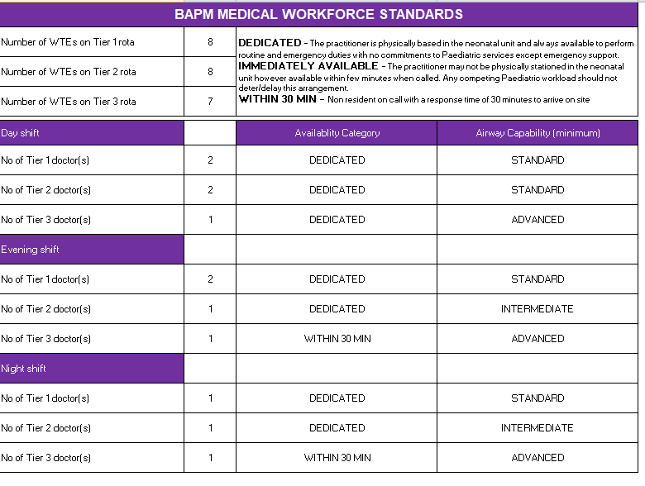
MMUH medical rotas meet BAPM compliance as detailed in the self-assessment table below. This table has been shared with the WMNODN Workforce Leads in Dec 2025 (via email) and is discussed at the quarterly WMNODN workforce meetings.

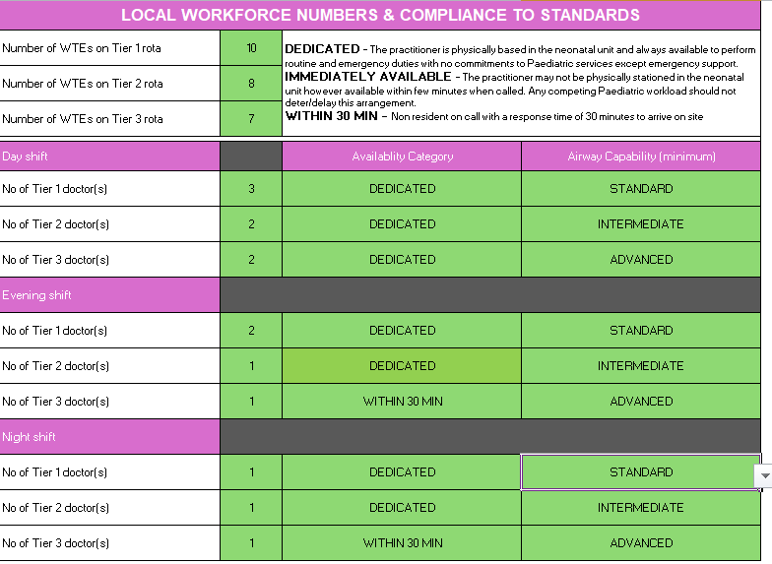

Tier 1: 1 in 9 rota
From 04.03.26-01.05.26 there was 1.0 WTE gap at ST1 level due to maternity leave, with vacant shifts filled by locums. Rota currently full

Tier 2: 1 in 8 rota
From 11.09.25 there has been 1.0 WTE gap due to long term sick leave of ANNP, but they commence a 6 week phased return on 11.05.26. Vacant shifts are filled by locums

Tier 3: 1 in 7.5 rota
From 01.11.25 0.5 WTE gap due to retiree, filled with locum consultant. Another 0.25 WTE consultant is retiring 31.10.26. Neither of these consultants contributed to the on-call rota or acute work. However, these PAs are being combined to have another substantive consultant on the team who does acute work and therefore rotas will move to 1 in 9.

Please note that although rotas are BAPM compliant, the activity on MMUH Neonatal Unit is significantly above the BAPM high activity criteria and as such workforce is stretched with resident doctors regularly completing incident forms and exception reports for breach of hours/ lack of breaks. The Paediatric School QA visit to Neonates 10.02.25, identified significant concerns with the neonatal medical workforce with adverse impact on both education & training and health & wellbeing of resident doctors.

A medical workforce expansion paper is being finalised to address these concerns and will be submitted to Group for initial review by end of May 2026

- Neonatal nursing staffing

To meet safety action 4 of the maternity incentive scheme the neonatal unit needs to demonstrate that it meets the service specification for neonatal nursing standards.

The Trust is required to formally record to the Trust Board minutes compliance to BAPM Nurse staffing standards annually using the Neonatal Nursing Workforce Calculator (2020). For units that do not meet the standard, the Trust Board should agree an action plan and evidence progress against any action plan previously developed to address deficiencies. A copy of the action plan, outlining progress against each of the actions, should be submitted to the LMNS and Neonatal Operational Delivery Network (ODN)

 | Neonatal QIS trajectory action plan
 | Action |  | Progress
Recruitment
B7 (external QIS) started 3/11/25 (recruitment cleared)
B7 (external QIS) started 1/12/25
1 x internal promotion from B6 non-clinical to clinical B7 (promotion from B6 non-clinical role to fulltime QIS clinical)
1 External B6 QIS started 1/12/25
 |  |  | Complete
 |  |  | Complete
 |  |  | Complete
 | QIS training plan  - 1 staff member qualified (consolidating with SN currently)  - Cohort 1 - 2 staff members course ended Feb 2026  - Cohort 2 - 2 staff commenced December 2025 |  | Consolidating
 |  |  | Cohort 1
 |  |  | Cohort 2
Skill mix plan
Skill mixed Band 5s to 'grow our own' which although long term is helpful in the short term dilutes our QIS staff pool. Gained additional 5WTE into funded establishment.
2 x Band 7 new starters
 |  |  | B7 – Sept 2025
 | Ongoing culture work to support retention  - Improvement teamwork/OD support  - Perinatal Culture Board (starting 18/5/2026)  Current substantive QIS staff/team offered increase in hours - completed |  | Ongoing
 |  |  | Completed, x3 staff supported and authorised (all QiS)
 | Scope if ANNP Nursing shifts/non-clinical Nursing roles can be included and would contribute to direct nursing support for QIS in Q3/Q4 return |  | 1 x ANNP (8a) contracted to 0.66wte Nursing rota/education

- Recommendations

The Board is asked to note assurance:

- That systems and processes are in place to monitor and support safe midwifery, obstetric, anaesthetic and neonatal staffing in line with NQB, NICE (2017) and Maternity Incentive Scheme requirements.
- That there has been demonstrable improvement in fill rates, vacancy reduction and maintenance of key safety standards including 1:1 care in labour and supernumerary labour ward coordinator compliance.

The Board is also asked to acknowledge ongoing risks:

- Ongoing workforce pressures within the community midwifery workforce, pending the outcome of the NHSE review.
- Residual midwifery vacancy gap, despite improvement, with continued reliance on bank staffing.
- Neonatal workforce stretch, particularly medical staffing, associated with activity levels exceeding BAPM thresholds.
- Birthrate plus workforce calculations remain outstanding and this may alter the recommendations further.
- Obstetric consultant gaps, currently mitigated through locum provision.
- Risk to Maternity Incentive Scheme (MIS) compliance should governance and specialist roles not be sustained.

